PROPOSAL TO CONDUCT A
COMPREHENSIVE MANAGEMENT AUDIT
- Of
National Fuel Gas Distribution Corporation
(Case 11-G-0580)

Submitted to the
New York State Public Service Commission
Three Empire State Plaza
Albany, NY 12223-1350

March 1, 2012

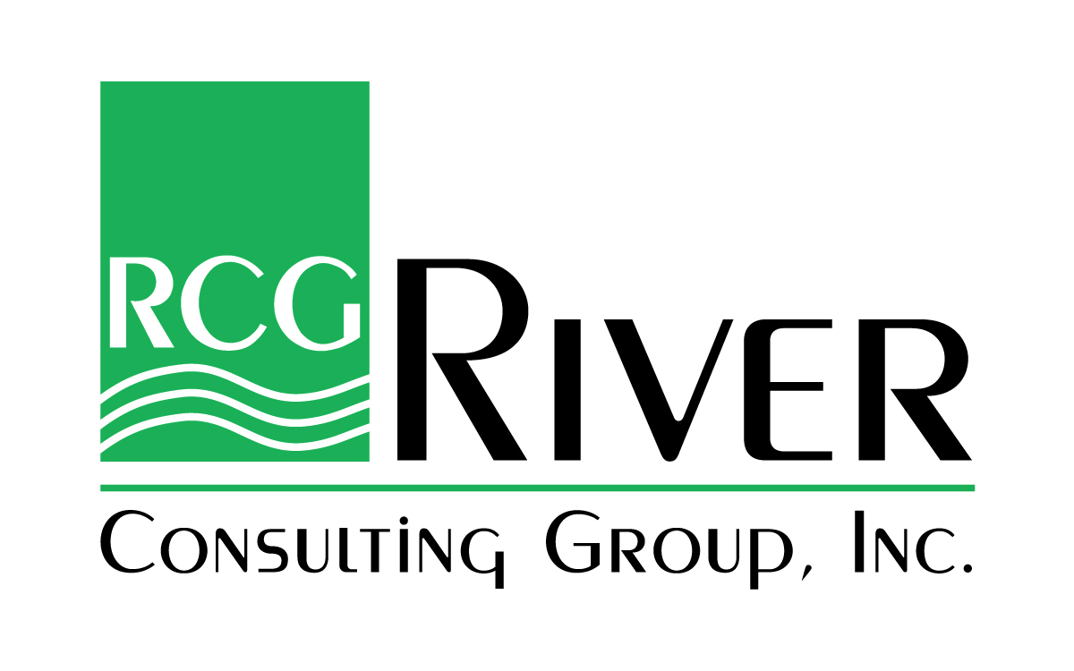

March 1, 2012
Mr. Jeremy Routhier-James
Project Manager
New York State Department of Public Service
3 Empire State Plaza
Albany, NY 12223-1350
Email: recordsaccessofficer@dps.ny.gov
secretary@dps.ny.gov
RE: Proposal to Conduct a Comprehensive Management Audit of National Fuel Gas Distribution Corporation Case 11-G-0580
Dear Mr. Routhier-James:
The River Consulting Group (RCG) is pleased to provide our proposal to the New York State Department of Public Service (DPS) to perform a comprehensive management audit of the National Fuel Gas Distribution Corporation (Company or NFGDC). Our proposal is fully responsive to all requirements outlined in the Request for Proposal (RFP) associated with Case Number 11-G-0580. The full proposal with cover letter, the Submission Form and the work samples have been electronically sent to the recordsaccessofficer@dps.ny.gov. The cover letter has been sent to both the Project Manager, Mr. Jeremy Routhier-James at Jeremy.RouthierJames@dps.ny.gov and the secretary@dps.ny.gov.
Following are RCG’s guiding principles:
- Promote a positive atmosphere during the audit process to facilitate the smooth transfer of data and information from the Company;
- Use only highly experienced professionals whose understanding of the utility industry goes far beyond performing consulting assignments. We understand the dynamic nature of the eight elements and their interrelationships;
- Minimize logical and factual errors during the audit process by adhering to a proven methodology and a formal quality review process;
- Develop positive recommendations which are the product of a thorough evaluation and that lead to tangible savings for the Company;
- Ensure that the DPS and its audit team are kept abreast of the audit’s progress and the evolving conclusions and recommendations;
- Use an experienced project management team that understands the audit objectives, deliverables, and milestones and will meet them;
- Foster the development of a meaningful and reasonable implementation plan for the recommendations which support NFG’s strategic goals; and
- “What you see is what you get” -- the experienced principals proposed are the ones you get at competitive rates.
We have prepared our proposal in light of these principles and embodying them; we believe they will ensure the successful outcome of this critical management audit. RCG stands ready to discuss our proposal in detail and certifies that:
- RCG and its team are committed to perform the work as outlined in the RFP and this proposal;
- RCG and its team are in compliance with the requirements set forth in the RFP;
- The information contained in our proposal is accurate; and
- The proposal is valid for 180 days from the submittal date of March 1, 2012.
Robert (Bob) Grant will be the primary contact for RCG and this proposal and his contact information is:
77 Wilson Bridge Lane
Clayton, GA 30525
770-331-1941
rivercg@aol.com

Per New York State’s Public Officer’s Law §87(2)(c), we are requesting that the attached proposal be treated in its entirety as confidential information. We request such exception from public disclosure until the Public Service Commission selects a winning proposal for this investigation. Public disclosure of this proposal prior to selection by the Commission would impair present or imminent contract awards for this engagement.

We stand ready to answer any questions you and your team may have.

Yours truly,

Robert M. Grant
President

PROPOSAL TO CONDUCT A
COMPREHENSIVE MANAGEMENT AUDIT
National Fuel Gas Distribution Corporation
(Case no. 11-G-0580)
Table of Contents
I. INTRODUCTION 1
II. SCOPE AND OBJECTIVES 5
A. Introduction 5
B. Scope 7
C. Objectives 9
III. APPROACH, METHODS AND PROJECT MANAGEMENT 11
A. Introduction 11
B. Audit Approach 12
Stage I - Planning and Orientation 12
Stage II - Fact Finding and Analysis 15
Stage III –Development of Conclusions and Report 17
Stage IV - Recommendation Development 19
Stage V - Develop Final Report 20
C. Methods 20
Interview Technique 22
Sampling Techniques 22
Cost/Benefit Analyses 23
D. Deliverables 25
E. Project Management 27
IV. AUDIT AREAS AND ISSUES 30
A. Introduction 30
B. Audit Element Area Work Plans 31
Element No. 1: Corporate Mission, Objectives, Goals and Planning, Affiliate transactions and Cost allocations 31
Element No. 2: Load Forecasting 37
Element No.3: Supply Procurement 41
Element No. 4: System Planning 45
Element No. 5: Capital and O&M Budgeting 50
Element No. 6: Program and Project Planning and Management 54
Element No. 7: Work Management 61
Element No. 8: Performance and Results Measurement 67
V. PROJECT TEAM AND RESPONSIBILITIES 74
A. Introduction 74
B. Organizational Structure 74
C. Team Member Qualifications 76
RCG Audit Managers 76
RCG Lead Consultants 77
RCG Supporting Consultants 78
VI. SCHEDULES AND BUDGETS 80
A. Introduction 80
B. Schedule 80
C. Budget 83
D. Invoices 85
VII. EXPERIENCE AND QUALIFICATIONS 86
A. Introduction 86
B. Experience and Qualifications of Individual Consultants 86
C. Experience and Qualifications of the Partner Firms 89
➢ River Consulting Group, Inc. 90
➢ Blue Ridge Consulting Services, Inc. 93
➢ Energy Tactics & Services, Inc. 95
D. Conflicts of Interest and Ethical Conduct 97
E. Sample Audit Work Product 97

LIST OF EXHIBITS

Exhibit II-1 Construction Feedback System 9
Exhibit III-I Four Quadrant-Recommendation Triage 24
Exhibit IV-1 Dual Program Management Missions 56
Exhibit IV-2 Tactical Project Approach 57
Exhibit IV-3 Performance and Results Management 68
Exhibit IV-4 Illustrative KPI and Metric “Blueprint” 69
Exhibit V-1 RCG Organizational Chart 75
Exhibit V-2 Audit Assignments Shared by Key Team Members 79
Exhibit VI-1 Management Audit Schedule 82
Exhibit VI-2 RCG’s Project Hours, Fees, and Expenses 84

APPENDICES

Appendix A: Initial Data & Interview Requests A-1
Appendix B: RCG Team Résumés B-1

INTRODUCTION

River Consulting Group (RCG) is pleased to respond to the New York State Public Service Commission’s (the “Commission”) Request for Proposal for a Management Audit of National Fuel Gas Distribution Corporation (the “Company”or NFGDC) (Case 11-G-0580) dated January 19, 2012 (the “RFP”). RCG has extensive experience with the planning and implementation of utility management and operations audits (demonstrated in Chapter VII of this proposal), and will act as Engagement Director and contract manager for this proposal.
As recommended in the RFP, RCG has engaged and is prepared to manage an elite team of highly experienced industry professionals capable of providing the Commission, New York State Department of Public Service staff (DPS Staff), and the Company with valuable insights into Company operations and management that will eventually produce real and measureable benefits for New York State ratepayers. The subcontractors in our team are Blue Ridge Consulting Services, Inc. (BRCS) and Energy Tactics & Services, Inc. (ET&S).
By teaming with BRCS and ET&S, RCG provides an interdisciplinary team with in-depth expertise that addresses all areas required to complete a comprehensive audit of NFGDC. Together, the three firms and their chief executives bring unique and valuable skill sets to this audit:
- Through its president, Bob Grant, RCG offers nearly four decades of expertise in the utility sector serving over 100 utility clients globally and, most notably, with the types of large and complex management audits that are the subject of this proposal;
- BRCS, led by its principals Michael J. McGarry, Sr. and Donna H. Mullinax, provides more than 60 years of regulatory, utility, and manufacturing industry experience. Since 2004 BRCS has conducted ten major management, operational, and rate case audits. As a member of the elite RCG team, BRCS is dedicated to providing exceptional value-added services using a cost-effective, commonsense approach. The hallmark of BRCS’s consulting practice is its ability to deliver comprehensive results on a timely basis.
- ET&S principal, Howard Solganick, has been working in the utility sector for more than 35 years as a senior manager of both a public utility and independent power producer and as a consultant. His specializations include management and regulatory audits, rate design and cost allocation, load forecasting, performance and process management, energy procurement, environmental and regulatory compliance and strategic planning – including the preparation of expert testimony addressing all of these areas.
RCG’s overriding goals in this proposed audit are to:
- Provide the highest-quality, balanced assessment possible of the Company’s management and operations;
- Develop the assessment through a positive process that captures the perspectives and needs of all parties with an interest in the outcomes; and
- Deliver a final report that provides a clear, independent, and objective evaluation of the Company; demonstrates and promotes a clear understanding of Company’s operations; and offers concise, cost-effective recommendations that assist the Company in improving the manner in which it delivers safe, reliable, and cost-competitive energy services to its New York State customers.
The RFP presents an audit scope of eight interconnected elements. These, in essence, form a closed-loop process that leads sequentially from strategy through implementation and the monitoring of results, and then returns as feedback to corporate mission, objectives, goals, and planning. This loop has both short- and long-term implications for the operation of the business and the safe, reliable and cost-effective delivery of Commission-regulated services to customers.
The eight interconnected elements that will be evaluated and included in an audit feedback loop and form the foundation of the audit report are:
- Corporate mission, objectives, goals, and planning;
- Load forecasting;
- Supply procurement;
- System planning;
- Capital and O&M budgeting;
- Program and project planning and management;
- Work management; and
- Performance and results measurement.

In fulfilling the scope of work for this project, the RCG team will focus on NFG’s gas construction program planning, operational efficiency, and performance, including reliability, as required by New York State Public Service Law. In so doing, RCG will identify required changes and make recommendations to ensure that:
- The corporate strategy, missions, objectives, goals, and planning are aligned with the needs of NFGDC’s New York State customers, and with policy directives and orders adopted by the Commission;
- The Company is focused on maintaining or improving the reliability and quality of services delivered to its New York State customers;
- The Company is maintaining a reasonable balance between maintenance and construction expenditures so as to promote the lowest rates possible for its services while managing and maintaining the safety and integrity of its gas distribution system;
- The Company’s ‘plan-design-build’ and ‘operate-maintain’ processes are prudent and consistent with its customer base and the age of its infrastructure;
- The Company is making appropriate use of new technology to support its strategic objectives for managing costs and improving customer service;
- The Company’s customer service philosophy and practices are consistent with Commission policy and promote consumer equity; and
- The final management audit report provides reasonable and practical recommendations that address the strategic and operational needs of the Company and its New York customers, and offers a clear and well-informed roadmap for improving Company operations.
RCG has designed its team and approach to promote an in-depth analysis, by highly experienced professionals, of each of the eight elements included in the scope of work. This approach enables development of high-quality recommendations that meet quantitative and qualitative cost-benefit measures approved by DPS Staff as a component of the audit work plan.
Because it is critical to the overall quality of the audit, team members have been cross-assigned to form sub-teams that are managed by the element’s assigned lead consultant (the “Lead Consultant”) to consider the impact an individual element may have on the others. Moving through the process, this approach will ensure that opportunities for critical communication through a feedback loop are captured between sub-teams, and that element-specific objectives and plans are being modified as new information emerges.
RCG’s review will evaluate the efficiency and effectiveness of each element and will identify opportunities for improving them. In reviewing each of the loop’s elements, the RCG team also will be evaluating the value that each of these elements brings to the project stakeholders, which include the Commission and DPS Staff as well as the Company and the customers of NFG. Throughout the management audit, RCG will comply with the standards contained in the General Accountings Government Auditing Standards (GAGAS), commonly known as the “Yellow Book”, and the “Consultant Standards and Ethics for Performance of Management Analysis” published by the National Association of Regulatory Utility Commissioners.
The remaining chapters of this proposal describe RCG’s approach, preliminary work plan, firm and individual consultant experience, schedule, and budget estimates.
- Chapter II – Scope and Objectives details RCG’s understanding of the scope and objectives for this audit.
- Chapter III – Approach, Methods and Project Management discusses RCG’s approach to this audit and its management, including a description of project deliverables.
- Chapter IV – Audit Areas and Issues provides RCG’s preliminary work plan, including the list of element areas to be reviewed with evaluative criteria and a list of work tasks to be performed for each element.
- Chapter V – Project Team and Responsibilities provides the structure of the RCG team’s consulting assignments and the background of assigned personnel.
- Chapter VI – Schedule and Budgets itemizes professional staff fees and out-of pocket expenses, and provides RCG’s total “not-to exceed” cost to perform the audit. It also provides a complete work schedule and an elapsed time estimate for each task in the work plan.
- Chapter VII – Experience and Qualifications presents RCG’s experience and provides a list of relevant projects with client names and references for RCG and for the key team members.
These chapters are organized consistent with the requirements of set forth in “The Guide.”

SCOPE AND OBJECTIVES
This chapter contains a brief background of National Fuel Gas Distribution Company, and confirms the scope and objectives for the management audit as defined in the RFP and the Audit Guide.

Introduction
River Consulting Group is pleased to respond to the January 19, 2012 Request for Proposal (RFP) from the Commission to perform a Comprehensive Management Audit of NFGDC (CASE 11-G-0580). Our proposal responds to the Commission’s specific requirements, as expressed in its RFP, and makes use of our extensive knowledge of the gas utilities industries to expand those requirements.
NFGDC is a local distribution company serving approximately 728,000 natural gas customers in a defined service territory in western New York State and northwestern Pennsylvania. Approximately 517,000 of these customers are in New York State where NFGDC’s service territory includes parts or all of Allegany, Cattaraugus, Chautauqua, Erie, Genesee, Livingston, Monroe, Niagara, Ontario, Steuben, and Wyoming counties.
NFGDC is wholly owned by National Fuel Gas Company (NFGC), a utility holding company. Incorporated in 1902, NFGC is a diversified energy company operating in four business segments:
- Utility (National Fuel Gas Distribution Corporation)
- Pipeline and Storage (National Fuel Supply Corporation)
- Exploration and Production (Seneca Resources Corporation)
- Energy Marketing (National Fuel Resources, Inc.).
NFGC’s other direct wholly owned subsidiaries are:
- Highland Forest Resources, Inc.
- Horizon Energy Development, Inc.
- Horizon Power, Inc.
- National Fuel Gas Midstream Corporation.
NFGDC’s headquarters is located in Williamsville, New York. In addition to its headquarters, the Company has additional offices in Buffalo, Cheektowaga, and Jamestown, New York, and in Erie and Oil City, Pennsylvania. As of September 30, 2010, NFGDC had 1902 employees.
In 2010, NFGDC reported operating revenues of $819.8 million, operating income of $127 million, net income of $62.5 million, capital expenditures of $58 million and total assets of over $2 billion.
The Commission is seeking an independent consultant to perform a comprehensive management audit of NFGDC’s New York gas business. The audit of NFGDC will be performed in accordance with Public Service Law, § 66(19) which states that:
“The Commission shall have power to provide for management and operations audits of gas corporations and electric corporations. Such audits shall be performed at least once every five years for combination gas and electric companies, as well as for straight gas corporations having annual gross revenues in excess of two hundred million dollars.”
The Law also states that:
“. . . the audit shall include, but not be limited to, an investigation of the company’s construction program planning in relation to the needs of its customers for reliable service and an evaluation of the efficiency of the company’s operations.”
The audit described in the RFP provides a unique opportunity for the Commission and the Department of Public Service (DPS) Staff to gain valuable insight into NFGDC’s operations and management from objective, third-party experts. It is a retrospective review to project the prospective impact of their operations on the cost, benefits, and safety to their New York customers. Any review must include a detailed focus on the critical areas of a NY gas distribution company operation, such as:
- Gas safety issues
- Pipeline integrity verification plan
- Load forecast
- Supply mix
- Emergency planning
- Cast iron pipe replacement
- Cathodic protection program
- New business response
- Retail access
- Call center performance

As indicated in the RFP, the framework of the audit scope is a series of elements or functions that are generally sequential in nature and which can be viewed as a feedback loop. The scope elements and their components are:
- Corporate mission, objectives, goals, and planning
- Load forecasting
- Supply procurement
- System planning
- Capital and operations and maintenance (O&M) budgeting
- Program and project planning and management
- Work management
- Performance and results measurement.
The elements, although generally sequential, require feedback from one or more of the latter elements to allow for revisions, adjustments, and other changes, over both the short and the long term. For example, the framework begins with the element of “corporate mission, objectives, goals, and planning” and ends with “performance and results measurement” -- an “end” which is also the means by which the flow of the elements is connected to the first element. The feedback typically facilitates changes and improvements that will result in better future performance. Therefore, in reviewing these elements using the primary PSC criteria, and the subordinate topics, we will evaluate the construction program’s feedback system and affiliate transactions. Our audit will also assess NFGDC’s efficiency and effectiveness in meeting its performance goals, and regulatory and safety requirements, as well as the extent to which there are opportunities for future cost-effective improvements.
We believe that the audit should be conducted in a constructive manner, characterized by frank and open discussion of findings, conclusions, and recommendations. RCG’s final report will provide an independent and objective evaluation of NFGDC’s current performance, specifically with respect to its construction program planning. To that end, RCG has developed an audit proposal that incorporates a project scope and objectives that are intended to:
- Provide the highest-quality assessment possible of the Company’s management and operations;
- Develop that assessment through a positive process that captures the perspectives and needs of all parties with an interest in outcomes; and
- Deliver a final report that provides a clear, independent, and objective evaluation of the Company’s operations; demonstrates and promotes a clear understanding of Company’s strengths; and offers concise, cost-effective recommendations that assist the Company in improving the manner in which it delivers safe, reliable and cost-competitive natural gas services to its New York State customers.

Scope
RCG’s management audit will provide a comprehensive analysis of NFGDC’s gas operations, focusing on the eight elements of the planning-execution process defined in the RFP, and any additional concerns that DPS Staff deem appropriate. The eight audit elements of the planning-execution process, as defined in the RFP, are: (1) corporate mission, objectives, goals, and planning including affiliate transaction and cost allocations; (2) load forecasting; (3) supply procurement; (4) system planning; (5) capital and O&M budgeting; (6) program and project planning and management; (7) work management; and (8) performance and results measurement.
Within the context of each of these eight elements, RCG’s work scope includes an analysis of the following generic components:
- Purpose, mission, planning, goals, and strategies;
- Functions, processes (including inputs and outputs), policies, practices, and systems;
- Organizational design;
- Staffing, responsibilities, and accountabilities;
- Cost control, cost oversight, and cost analysis;
- Efficiency and effectiveness;
- Minimization of impacts to other elements and Company operations to prevent sub- optimization elsewhere;
- Results and performance measurements, including how the results are used;
- Opportunities for improvements, including “leading practices” based on the experience and research of the RCG team, that are appropriate to NFGDC’s New York State operating environment; and
- Cost-effective recommendations for implementing the improvements, described in detail later in this proposal.
The audit scope also includes an assessment of NFGDC’s effectiveness in fulfilling its mission, particularly meeting its performance goals, and the extent of opportunities for improvement.
The eight elements described above form the core of a successful natural gas business model. Without formal business and technical planning processes it is extremely difficult for utility management to navigate their rapidly evolving environment and take full advantage of new technology and management tools. Specifically, new technology allows management to address some of the most pressing industry issues, such as knowledge management in an increasingly complex delivery system and managing an increasingly diverse customer base with widely varying needs.
Enhanced management processes and systems allow the Company’s leadership to ensure that the right resources are employed cost-effectively. Without formal feedback mechanisms, it is difficult to evaluate progress against goals that are set during the planning process; these mechanisms also enable management to fine-tune their processes with a full understanding of implications to reliability, safety, and cost.
The audit scope includes an assessment of the entire Company’s effectiveness in meeting mission and planning goals, particularly identification of opportunities for improvement.
Finally, RCG’s audit scope includes an evaluation of NFGDC’s construction program feedback system. The eight elements that form the foundation for RCG’s audit are integrated, and generally support strategic planning efforts by providing needed inputs to the planning process and information to adjust plan objectives over time. This process loop begins with the element of “corporate mission, objectives, goals, and planning” and completes the cycle with “performance and results measurement,” as illustrated in Exhibit II-1.
EXHIBIT II-1
Construction Program Feedback System
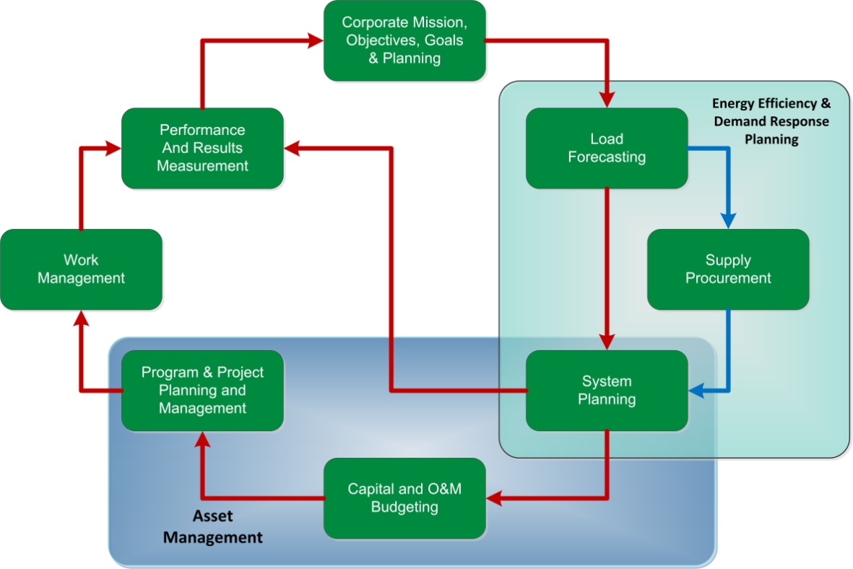
When executed properly, the results will yield continuous performance improvements by allowing management to modify objectives based on the information gathered as it cycles through the process.

Objectives
RCG’s objectives for this management and operations audit are those specifically set forth in the Audit Guide:
- To identify specific opportunities, as needed, for improving planning, organizational design, business processes, management practices, systems, and operations. This applies to work elements inside the eight audit element areas and those that are tangential to them.
- To identify, as needed, specific opportunities to improve performance, including operational productivity, operational reliability, organizational effectiveness, cost controls and savings, work quality, customer service, safety, and other measurable elements. This objective includes the impact of new technology on effectiveness and efficiency.
- Develop recommendations, as needed, for implementing changes or undertaking the studies necessary to achieve performance improvements. Where feasible, recommendations will be supported by risk/benefit and cost/benefit analyses. Where possible, the consumer should benefit from recommended performance improvements.
In addition to these objectives, RCG contends that a key objective of this engagement is to deliver a balanced final report, which is clear and concise, and accurately portrays both strengths and major opportunities for improvement. In addition, RCG’s objective is always to produce a road map of high quality, mutually agreed to recommendations that include a cost/benefit discussion and timetable developed by RCG in collaboration, where appropriate, with the Company, and approved by DPS Staff.

APPROACH, METHODS AND PROJECT MANAGEMENT

This chapter explains RCG’s approach and philosophy to management audits. It presents an in-depth description of the process RCG uses to show its compliance with the required scope of work, including how RCG personnel will plan, implement supervise, and manage the audit, and the philosophy behind RCG’s approach to each step.

Introduction
RCG’s approach is designed to complete a comprehensive management audit of the Company in the most efficient and effective manner, and with the least amount of disruption to Company operations. RCG’s consistent ability to meet the commitments of its audit schedules and to produce effective results relies on the following approach:
- Development of a formal work plan with clearly defined deliverables;
- Use of only experienced, senior professionals, who possess the appropriate combination of professional maturity, utility knowledge, audit work experience, and, whenever possible, a previous working relationship with the assigned Project Manager or Lead Consultants;
- Use of both quantitative and qualitative data to evaluate actual performance;
- Development of conclusions that are consistent with generally-accepted auditing standards, which require thorough documentation of the facts that support the findings relied on for those conclusions;
- Continuously reviewing how conclusions reached in one area of an audit framework may impact other areas, and determining how overall performance may be improved through a clearer understanding of those connections;
- Employment of a formal, interlocking, quality control process to ensure accurate results;
- Proper maintenance of work papers in a manner that supports the documentation of findings,
- Use of one senior editor to ensure that draft and final reports are clear and consistent; and
- Ensuring that the concerns of the DPS Staff are being addressed.
A simple philosophy stands behind RCG’s audit approach: we are convinced that open and constructive communication between audit parties produces the strongest conclusions and, as a result, the most effective recommendations. Although RCG will perform an independent and objective management audit of the Company, communication is at the heart of the project. This means that RCG will conduct an audit that:
- Maintains open and positive communications with all parties to the audit--this improves results by minimizing factual, logical, and process errors, and ensuring that there are no surprises;
- Uses a formal process to address any concerns the DPS Staff may have and early in the process incorporates them into the work plan as appropriate;
- Works jointly with the DPS project manager to develop a clear and concise work plan embodying and focusing on the DPS Staff’s objectives;
- Coordinates schedules with the DPS Staff and the Company’s Audit Team for interviewing Company personnel;
- Holds regular bi-weekly briefings with the DPS staff to ensure they are informed of RCG’s activities and preliminary observations; and
- Ensures that RCG’s approach integrates the ethics and practices contained in both the Federal “Yellow Book” and National Association of Regulatory Utility Commissioner’s “Consultant Standards and Ethics for Performance of Management Audits.”

Audit Approach
RCG’s approach is a five-stage process that includes: planning and orientation, fact-finding and analysis, conclusion and report development, recommendation and cost/benefit development, and development of a final report. These stages are detailed below.

Stage I - Planning and Orientation
The Stage I objectives are:
- Understand the audit objectives and scope;
- Use a formal process to identify and incorporate DPS Staff’s expectations into the audit;
- Finalize contractual, project reporting, and other administrative processes;
- Understand the current operations, organization, and key management processes of Company; and
- Develop and gain approval of an initial detailed work plan (the “Work Plan”).
The RCG engagement director (Engagement Director) and Project Manager will meet with DPS Staff and Company project managers to complete logistical and contractual arrangements. Those arrangements will include, but not necessarily be limited to, policies and processes for:
- Additional DPS Staff issues or concerns; and
- Initial data request response;
- Office requirements, security, and access;
- Requesting and tracking interviews and data;
- Setting and meeting agreed-to response times;
- Managing confidential information;
- Adhering to auditing standards;
- Managing working papers and documentation requirements;
- Managing the quality control and reporting processes.

Tracking and managing the tremendous amount of information generated in the audit process is essential to its effectiveness. The RCG team has significant experience in effectively managing this process and has demonstrated expertise in handling the volumes of information expected. We have a computerized interrogatory tracking process that allows us to ensure that all interrogatories are answered in a timely fashion. This tool has been invaluable in helping our consultants ensure that they are getting the information they need to support their analyses. It can also be used to track interviews and resulting data requests from those interviews.
We will minimize costs and increase the productivity of the team by working with the Company to retrieve and download discovery information electronically. This will limit costs to only those items that are not in a suitable electronic format and we require an exact copy.
If the Company commits to the delivery of critical information on its businesses, processes, organization, and operations as early as possible in the Stage I process, a positive audit atmosphere is fostered and understandings are advanced. To further this objective, RCG will, during the orientation stage:
- Present an initial set of data requests to the Company to be delivered to and be reviewed by the appropriate RCG team members prior to the beginning of on-site interviews;
- Meet with DPS Staff to understand emerging issues and concerns;
- Use the Company’s document management system or if required use RCG’s system;
- Attend the Company’s audit kick-off presentation and, where practical, conduct initial executive interviews shortly thereafter;
- Schedule and conduct additional interviews once the work plan is finalized;
- Review and analyze all the initial data and information received;
- Identify potential topics for a collaborative approach for the review;
- Refine the initial work plan to reflect this new information;
- Refine initial analyses of audit requirements with respect to the eight audit elements and determine how the final work plan applies to the process for completing work related to each element; and
- Obtain the approval of DPS Staff to proceed with the final work plan.
Because the development and delivery of an initial data request is a critical element of launching RCG’s Stage I approach, the RCG team has completed a preliminary draft of these documents and included them in Appendix A of this proposal. RCG has already identified the individuals or positions within the Company that will be interviewed initially. Final initial interview guides and schedules will be prepared once an orientation meeting has been scheduled by the Company. RCG stands ready to provide a working session to present its approach and work methods if DPS Staff wishes to become more familiar with this approach. This exercise would be conducted by RCG’s Engagement Director and Project Manager.
The RFP identified a reasonable time schedule for the consultant to issue a draft report to Staff in February 2013. Chapter VI – Schedules and Budgets contains RCG’s proposed schedule, which is consistent with that shown in the RFP. The RCG project team is committed to meeting the milestones set by this initial schedule.
To enable the RCG team to refine the work plan, and thus to foster adherence to schedule, we will use the data and information provided by the Company (in response to our initial data request and initial executive interviews) to give the individual RCG team members a deeper understanding of the Company’s approach to the eight elements. As stated previously, the preliminary data requests and initial interviews, subject to DPS Staff approval, are included in Appendix A to this proposal. RCG’s ability to meet the proposed schedule will require the Company to be responsive to data and interview requests on a timely basis.
To that end, after the initial data request, RCG recommends that a turnaround schedule of three working days as the standard for the return of Company reports and existing data. RCG will negotiate delivery times for specially requested analysis, reports, and data. This approach helps support on-time delivery of high-quality work products.

Stage II - Fact Finding and Analysis

During Stage II, RCG will perform the primary data gathering and analysis for each of the eight audit elements. This process will incorporate the following activities:
- Develop a task report outline of the potential issues to be addressed for each of the eight audit elements and other areas identified by the DPS Staff or RCG during Stage I activities;
- Review and enhance the criteria for each audit element (See, Chapter IV: Audit Areas and Issues for a list of initial criteria developed for each of the eight audit elements);
- Develop a set of questions and data requirements to support the formation of findings and conclusions addressing each of the potential issue area’s criteria;
- Identify and request individuals or positions for interviews that will allow RCG to better understand the strategic deployment, policies, and processes used by the Company to conduct business;
- Prepare interview guides to be distributed to intended interviewees, allowing adequate preparation time to facilitate a smooth and accurate transfer of information;
- Determine if the DPS Staff wishes to attend specific interviews;
- Document all interviews in standardized, accessible, summary format using Microsoft Word;
- Issue additional data requests required to support further analyses;
- Perform and document field observations;
- Perform data sampling to quantitatively evaluate criteria;
- Arrange for additional or follow-on interviews;
- Review all assembled data against criteria for each issue and form a set of initial findings applying known industry best practices and comparisons;
- Reference all findings against data responses and interview summaries;
- Draft initial conclusions;
- Subject conclusions to the RCG quality verification process;
- Conduct three-party fact verification sessions;
- Review results with DPS Staff; and
- Prepare and forward task reports.
Depending on the subject area, some of the above steps may be combined or rearranged to facilitate a more complete understanding of a process or issue. It is important to understand that the task report outline is critical to managing both the schedule and the budget. This outline permits the Lead Consultants and their teams to focus on what is most important for the specific element’s analysis. In this manner, only the required data is gathered and the interviews remain focused. This process allows the leads to identify other opportunities as they emerge during the discovery effort.
As a function of this audit, RCG specifically expects to identify:
- Opportunities to combine functions to reduce expenses;
- Asset management strategies and programs that are consistent across both service territories;
- Opportunities to use technology to drive cost from the business and improve reliability;
- Opportunities to appropriately integrate capital and O&M planning to more efficiently manage costs and optimize reliability; and
- Opportunities to adjust Company management practices to improve senior and board level attention to the tasks of delivering safe and reliable service to the Company’s New York gas customers at a reasonable cost.
It is RCG’s policy to focus team attention on critical and substantive issues. In this manner Company management can focus post-audit efforts on the implementation of recommendations that will yield the greatest returns for their New York customers.

Stage III –Development of Conclusions and Report

On engagements of this size, RCG’s practice is to perform an additional review of the conclusions by RCG’s Quality Committee. Comprised of the team’s most senior consultants, this committee is charged with ensuring that the quality of each conclusion and recommendation meets the audit standards expected by the DPS Staff. The Engagement Director will also rely on this committee’s feedback when analyzing the overall continuity of all audit conclusions relative to the DPS Staff’s stated objectives.
During Stage III, RCG also will perform the following activities:
- Complete task report outlines that contain findings and preliminary conclusions;
- Convert the completed outlines into task reports that contain the following information:
  - Description of the task and the audit element or area;
  - Description of industry leading practices;
  - Evaluation criteria and metrics used, if applicable;
  - Description of the Company’s performance in the element or area;
  - Findings and conclusions, including detailed supporting annotations; and
  - Identification of potential rough cost and benefit levels associated with each conclusion area.

  - Performance of a quality verification review on each task report by key senior members of the RCG team, including identification of items that require further analysis be conducted;
  - Edit the completed task report for clarity and consistency; and
  - Forward completed task reports to the DPS Staff for review, comment, and release when Staff concurs with the report.
Task reports that are approved by the DPS Staff will be assembled into an overall report framework by the RCG editor, without recommendations. RCG will provide “a general health statement”-- a concise and frank condition summary after a thorough examination is completed -- for each chapter of the draft audit report.
As a matter of course, RCG will apply the “reasonable person” test to all its conclusions to ensure that the ensuing recommendations are sound, fair, cost-effective, and consistent with leading practices and existing regulation.
To foster the desired results, RCG will include the following activities:
  - Formal team meetings upon start-up of the project;
  - Attendance by all team members at the Company’s orientation session, either in person or remotely;
  - Preparation of a draft and final work plan for each audit element by that element’s Lead Consultant with the assistance of the supporting consultants engaged for that area, including formal written signoffs;
  - Development of a detailed style sheet for the draft and final report by the audit editor;
  - Approval of the draft and final work plan for each audit element by the Project Manager, Engagement Director, and editor, including formal written signoffs;
  - Ongoing document tracking and reporting by the Project Manager;
  - Approval of each interview summary by the Lead Consultant for that audit element and by the Project Manager, including a formal written signoff;
  - Formal cross-cutting team meetings led by the Project Manager;
  - Approval of each task report by the Project Manager, Engagement Director, and editor, including formal written signoffs;
  - Approval of the draft report by the quality committee and editor, including formal written signoffs;
  - Approval of each preliminary recommendation and potential costs and benefits levels by the Project Manager and Engagement Director, including formal written signoffs,
  - Approval of the final report by the quality committee and editor, including formal written signoffs; and
  - All documents supporting signoffs will be maintained by the editor.

Stage IV - Recommendation Development
During Stage IV, the RCG team will develop recommendations that satisfy conclusions that are approved by the DPS Staff. RCG recognizes its responsibility to develop independent recommendations; however, there may be several areas of focus where collaboration with the DPS Staff and NFGDC may accelerate acceptance. It is important to obtain Company support of these recommendations so that the benefits may be expeditiously delivered to customers.
The RCG team will meet with the DPS Staff and the Company to forge workable recommendations that the Company can begin to implement as soon as practical. This will be achieved through collaboration with the parties to develop acceptable recommendations with achievable timetables. To facilitate this outcome, RCG will perform the following activities:
- Reach consensus on conclusions and order of value;
- Develop recommendation options for each conclusion or group of conclusions, including the performance of an initial cost-benefit analysis of the options;
- Present this information to the DPS Staff and the Company as a starting point for discussion;
- Conduct frank and open discussions with Company management and, if necessary, with International Brotherhood of Electrical Workers Union (IBE) as to how to best achieve the desired results;
- Refine the recommendations and cost-benefit analyses, where applicable; and
- Develop an initial implementation schedule that may be reasonably achieved by the Company and monitored by the DPS Staff upon receipt of a Commission order.
RCG’s key outcome measures for its internal evaluation of this audit task are: (1) each delivered recommendation must be founded on solid conclusions that are data-driven; (2) each delivered recommendation must serve, at a minimum, the best interest of the Company’s New York State customers; and (3) no recommended solution will cost the Company’s customers more to implement than it can deliver in measurable and meaningful results. These are the only criteria that RCG believes that the Commission will accept when presented with the final audit report for this project.

Stage V - Develop Final Report

During Stage V, RCG will assemble a draft of the final report in a form that is consistent with the eight defined audit elements presented in the RFP, and any additional areas of review that are requested or approved by DPS Staff. The draft report will be reviewed by DPS Staff first and, subsequently, by the Company for the verification of facts.
Each element or area will be presented in the following chapter format:
- Introduction, including a description of the subject area and its importance to the strategic planning loop, a graph representation of the manner in which this element or subject area impacts the construction feedback model, and a concise list of recommendations that will be presented in detail in that chapter.
- General Health Statement, RCG’s overall opinion of the element’s status as compared to leading practices or other accepted performance measures.
- Chapter-by-Chapter Discussion of Individual Recommendations (as agreed to by all parties) will include an introductory description of the recommendation; properly annotated discussion of the supporting conclusions, findings, and facts; a cost-benefit discussion and analysis, as appropriate; and an implementation timeline. Where it makes sense, RCG may outline several options for consideration and will evaluate each option, citing the advantages and disadvantages of each. Based on the current capabilities of NFGDC, we can then outline the best option. In some instances, audited clients may disagree with the recommended option and, through further exploration, RCG may incorporate their concerns and refine the recommended options so that they are viable for implementation.
In addition to the element and area chapters, the final report will include an executive summary and a recommendation roadmap chapter.

Methods
The methodology behind RCG’s management audit proposal is built on four essential elements:
- Facts - Facts are data or other information that can be reasonably proved as an actual depiction of some characteristic of the Company. Generally these are gleaned from one or more of the following sources:
    - Hard financial, reliability, staffing, or other performance data that is non-disputable;
    - Interview results that are captured and are verifiable by data, observations or other interviews; and
    - Physical observation of field or process related activities.
- Findings - A finding is reached after reviewing a summary of the facts; it depicts the auditor’s best judgment based on a reasonable analysis.
- Conclusions - A conclusion is a determination reached after reviewing a summary of findings; it requires the auditor to form an overall opinion about a specific topic based on analysis against relevant criteria and industry leading practices, and suggests some form of action.
- Recommendations - A recommendation is an actionable and prescriptive statement based on a number of conclusions and some level of cost/benefit analysis, and is generally time-bound.
Because accurate retrieval of facts is the basis for developing findings, conclusions, recommendations, and measurable results, RCG requires its consultants to have multiple sources for fact verification. It is the responsibility of the Project Manager and Lead Consultants to ensure that reasonable support exists for all the facts presented in the audit report. The Engagement Director will participate in any and all reviews to promote consistent results that align with the DPS Staff’s objectives.
RCG embeds its factual references within the draft report (generally as footnotes) to allow for efficient verification of facts. This is an essential quality verification tool used by RCG to ensure report accuracy, minimize errors, and, ultimately, to help to create confidence in the recommendations that are presented due to the ability to expeditiously respond to questions and concerns. Consistent with DPS Staff practices or requirements, the footnotes may be removed or retained in the final report.
RCG will be responsible for developing its findings and conclusions, and will take the lead on developing reasonable recommendations. All recommendations remain subject to the approval of DPS Staff and may be developed collaboratively with the Company to craft workable solutions and timetables. Should the Company be restricted from or unwilling to collaborate on a specific recommendation, RCG will independently develop appropriate and reasonable recommendations for review by the DPS Staff first and will bring those that the DPS Staff believe are most promising to the Company at that point.
Another critical component of conducting an effective management audit is the approach used to conduct interviews, data sampling, cost/benefit analyses, and the organization of data elements. The methodologies used by RCG in this regard are presented below.

Interview Technique
With a task report outline in hand, RCG team members will develop a list of questions necessary to gain insights into each of the audit element being evaluated by that consultant. These questions will be assembled into interview guides, which will be used to manage the individual interviews; further, these questions are used to identify additional data requests before the interview.
Interviewees will be provided with an interview guide summary one week in advance of the interview so they may adequately prepare complete and accurate responses. Interviewees will be advised that additional topics may be covered during the interview process as issues unfold.
Further, RCG encourages the individuals being interviewed to present samples, flowcharts, and other documentation to support their answers. The goal of RCG’s interview approach is to gain a fair, accurate, and complete picture of the facts in order to produce high-quality findings. DPS Staff is also encouraged to attend and observe interviews, either in person or by telephone. We believe this approach promotes a better understanding of the Company’s operations at a more granular level.
Interview guides will be tailored to the level and special duties of the individual who will be interviewed to ensure a productive session. For example, the RCG team would discuss strategy and policy with senior-level managers but focus on process at the supervisory and line levels. In this manner, it is possible to test the validity and effective implementation of management strategies or policies all the way through the organizational chain to determine the true value and effectiveness to the Company.

Sampling Techniques
Data will be sampled to quantify impacts to the business and validate what RCG is being told by Company personnel. Sampling methodology depends on the topics under analysis but, in all cases, the sample will follow the following approach:
  - Identify data sources required to address and test the criteria stated in the task report outline;
  - Determine if the sampling will be by past performance data, process review, or physical observation;
  - Determine sampling techniques and representative sample populations using the population that best reflects the full range of available data;
  - Obtain approval from both the Lead Consultant and Project Manager as part of RCG’s quality verification process;
  - Request the data from the Company or arrange for physical observations;
  - Analyze the sample data and develop findings; and
  - Validate the findings by comparing and contrasting those findings with other information sources, such as interview notes.
Sampling and trend data may:
- Represent a range of capital projects or maintenance programs by both type and dollar value;
- Represent capital projects at different stages in the life cycle;
- Cover a specific period of time, for example five years of historical budget and actual data;
- Represent gas distribution project performance;
- Review the Company’s back-cast load and supply forecasting to verify accuracy of the tools, methodologies or strategies used;
- Depict major capital spent on vendors; and
- Represent staffing and retirement trends.

Cost/Benefit Analyses
The Guide provided with the RFP defines DPS Staff expectations for performing cost/benefit analyses. RCG concurs with this approach and will apply it to those potential recommendations where cost justification is reasonable and appropriate. RCG will approach identifying the cost/benefit of specific recommendations in two phases. First, we will develop a relative ranking of recommendations for each of the of the eight scope elements using a four-quadrant diagram which depicts both the potential cost to implement and benefit to the ratepayer (sample provided in Exhibit III-1 below). This presentation format provides a clear and concise illustration of the impact of a group of recommendations. It is particularly effective in facilitating the comparison of no- or low-cost recommendations with the more expense and/or capital intensive recommendations where further cost/benefit analyses is required.

Exhibit III-1 Four Quadrant – Recommendation Triage
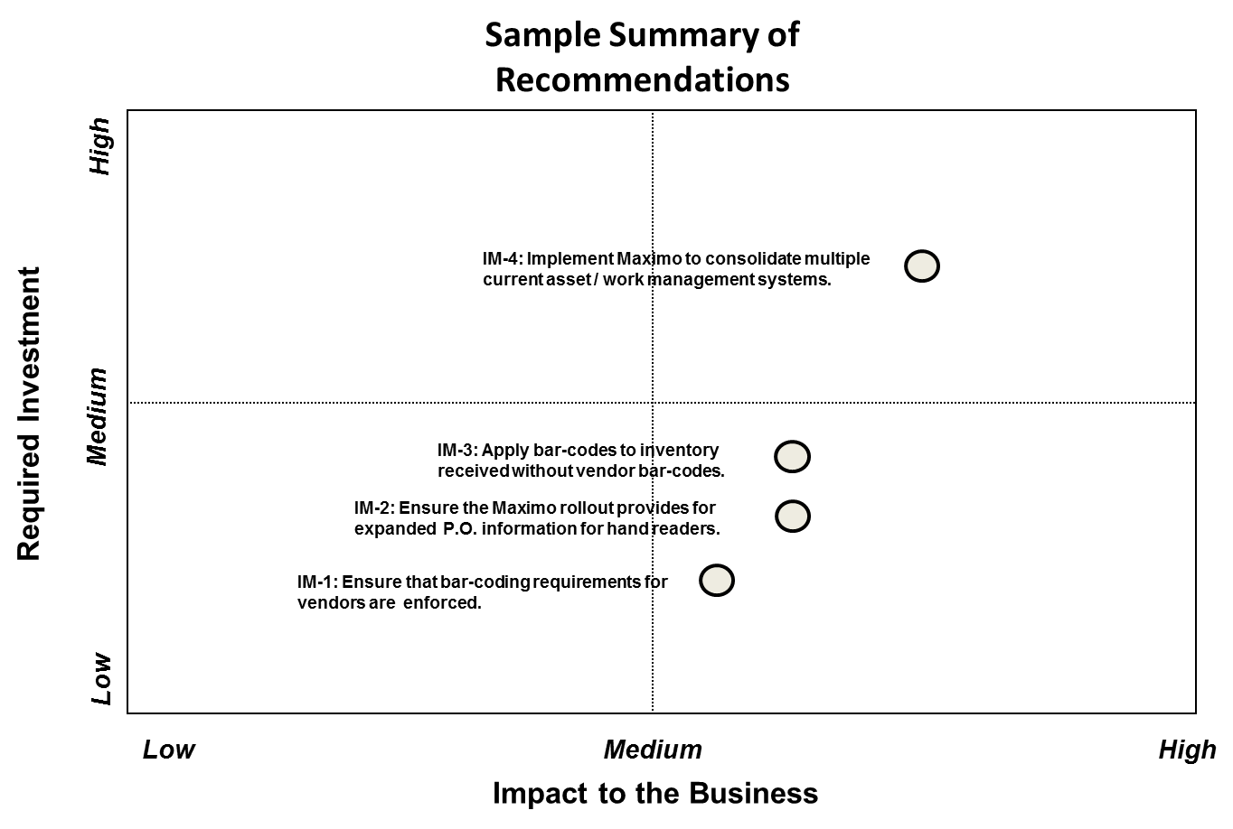
Prior to finalizing the list of recommendations and the need for cost/benefit analysis, RCG will work with the DPS Staff to vet the recommendations and agree upon those which need to have cost/benefit analysis.
Second, RCG will apply a SMART methodology to the development of recommendations. Each recommendation must be Specific, so that the intent and purpose is clear to all concerned; where appropriate, the results must be Measureable to demonstrate a change that produces a benefit to customers; the recommendation must be Achievable by the Company, otherwise the costs will not be offset by benefits; the recommendation must be Relevant, so that one or more of the benefit component considerations will be positively changed; and, the recommendation must be Traceable to ensure that a specific Company executive or organization will be responsible for successful execution.
To enhance “buy-in,” RCG will request, review and test the Company’s cost/benefit template (or model) for reasonableness and completeness, including standard assumptions for inflation, overhead costs, and other non-specific inputs. The cost/benefit analysis will be computed using the Company’s template for ease of communication. RCG consultants will apply their specific utility experience to apply the benefit component considerations to the individual recommendations. In the event the Company doesn’t have a formal template, RCG will use its own methodology.

Deliverables
The audit process will generate a large number of documents and work plans through the delivery of the final audit report. Those documents and plans will need to be available to the DPS Staff during and after completion of the audit. The RFP defines a range of deliverable products related to this project. RCG’s technique to approaching these documents and the documentation of an audit is provided below.
- Work Plan - RCG will work closely with DPS Staff during the creation of an initial audit work plan. During the process of developing that plan, DPS Staff comments, suggestions and concerns will be integrated into the document. RCG’s project manager will be responsible for submitting initial and final draft work plans to the project manager for the DPS Staff. In addition to the items included in the RFP scope for the work plan RCG will include the tools it proposes to use to analyze data and findings, and a detailed schedule of with objectives and milestones associates with each audit element. DPS Staff approval of the work plan will signal the RCG team to begin Stage II work. Because no successful plan is ever static, but rather a dynamic tool which adapts to circumstances, the audit work plan may be modified during the course of the audit if RCG finds a significant issue with ramifications to customers that was not covered in the work plan, and DPS Staff agrees that the issue merits a modification to the original plan.
- Briefings - RCG will provide regular briefings to DPS Staff on the progress of the audit and will identify emerging issues. DPS Staff will be encouraged to bring up any issues that they feel RCG needs to place additional focus on and not leave these types of issues to the draft report stage. It is possible that, as the audit progresses, RCG may be required to provide preliminary assessments of findings to the Commission or senior members of the Commission’s DPS staff or other government offices. These briefings can be conducted in person, by telephone, or with written reports, as requested by the DPS Staff project manager. In all cases, the briefings will be documented and become part of the audit work papers.
- Briefing Reports - The final work plan will define a schedule for RCG to provide formal report briefs to the DPS Staff and others identified by the project manager for the DPS Staff. These formal progress reports will be become part of the audit work papers. RCG expects to have these briefings every two weeks during periods of high activity.
- Draft Reports - The preliminary schedule for delivery of the initial draft audit report is February 2013 as set forth in Chapter VI of this proposal. This initial draft report, which is intended to be representative of the final audit report, will be reviewed by DPS Staff, who will comment on the draft. RCG will edit the initial draft and present a revised initial audit report to DPS Staff, who will authorize RCG to send the revised draft report to the Company for a factual review when the DPS Staff is satisfied with the product. It is expected that there will be two passes at the draft report to address DPS Staff issues and the Company’s factual concerns.
- Final Report - A final report is scheduled to be delivered to the DPS Staff by June 2013. DPS Staff will document RCG’s evaluation of each aspect of the audit work scope, as outlined in the RFP and in this proposal. All audit work papers will be made available for DPS Staff review on DVDs. The costs for printing and delivery of draft and final reports have been included in RCG’s not-to-exceed cost. Staff will release the final report.
In addition to the deliverables set forth in the RFP, RCG will be preparing and maintaining the following documents:
- Data Requests - RCG will generate written requests for documents and other data that will be distributed by the RCG project manager. These document requests will clearly identify the data, analysis, or documents being requested, and the individual or department that has been requested to provide it. Data requests, like interview requests, will be assigned a unique number for document-tracking purposes and will be maintained as audit work papers.
- Data Request Report - This metric report will identify data and documents that have been requested, the date of the request, the Company individual or department responsible for responding to the request, the agreed delivery date, and the date of delivery. RCG will use the Company’s own document-tracking system or its own Microsoft Access-based tool. RCG will accommodate the Company’s preference in this regard but strongly recommends that only one system be used for tracking audit requests.
- Interview Requests & Summaries - RCG uses a formal interview request form that acts as a record of the request. All interview requests will be assigned a unique number, either by the Company or by RCG. This approach supports an organizational system that permits RCG to track the Company’s responsiveness, and provides a formal reference that will be used to track the task, and to document RCG’s findings in the draft and final reports. RCG also will prepare a formal interview summary that includes: a unique document reference number, the name of the individual interviewed, that individual’s title and affiliation, the interviewer, the interview date and time, interview facts and observations, potential issues, and any follow-up required, including the preparation of subsequent data requests resulting from the interview. Typed summaries will become a permanent part of the audit work papers. As a general rule, RCG does not include findings or conclusions in interview summaries to avoid snap judgments or unsupported conclusions.
- Interview Schedules - A weekly document presenting a schedule of upcoming interviews and observation visits will be provided to the DPS Staff and Company program managers. The notice will contain the name of the individual to be interviewed, the name of the interviewer, the area of focus, and the date, time and location of the interview. RCG reserves the right to conduct observation visits without specifying the date or time determined for that visit. This potent tool allows RCG consultants to form clear opinions about actual management practices that may not be observable during planned visits.
- Task Reports - RCG will complete regular task reports for each of the eight audit element areas. The task reports will be provided to the DPS Staff project manager and will form the basis for the draft reports to follow. Task reports give the DPS Staff an early and informal look at the issues and conclusions that are being developed by members of the RCG team.
- Project Management Reports - A monthly progress report that includes person-days expended during the past month and any audit-related expenses will be provided to the DPS Staff project manager by the 10th day of the following month. This report will record this information by activity and individual team member. It will be presented alongside the approved work plan and budget, and will calculate the percentage of completed at that point in time. Any deviations, delays or remediation needs will be captured in this monthly report.
All of the above documents, together with analyses and any other information gathered as part of this management audit will be considered to comprise the engagement working papers. Consistent with the requirements set forth in the Audit Guide, these documents will be organized into a neat and concise electronic package, and will be provided to the DPS Staff at the time that RCG delivers the final audit report.

Project Management
Effective project management begins with a logical, effective and efficient work plan that is clearly understood and accepted by the parties. The Engagement Director and Project Manager will be responsible for crafting and managing the overall work plan. In engagements of this magnitude, the Project Manager will devote reasonable effort to managing both the audit costs and schedule using acceptable project management tools.
RCG’s Project Manager is responsible for the day-to-day execution of the work plan and schedule, while the Engagement Director focuses on the development of the central issues, budget management and the management of key relationships. Both the Project Manager and Engagement Director have a long and productive working relationship relative to management audits assignments.
A key aspect of RCG’s approach to process control is to limit contact for audit process decisions to the Project Managers assigned by RCG and its client, which in this case is a representative assigned by DPS Staff, who is RCG’s primary client, and an additional representative assigned by the Company. RCG welcomes DPS Staff and Company personnel as active participants in the audit review process, and will work through its Project Manager to accommodate requests throughout the course of the audit.
The Project Manager will also make any or all RCG team members available to DPS Staff to discuss emerging issues, as needed. Using quality audit tools and experienced consultants, together with maintaining open and honest communication between project managers, will lead to a positive audit experience for all parties involved in the process. Again, RCG understands the travel limitations of the DPS Staff and, therefore, will make use of structured conference calls as much as possible.
A significant benefit to this approach is that it prevents surprises by encouraging an open, ongoing, informal dialogue. RCG also has pulled together an experienced team of professionals who understand how to minimize the disruption of a client’s normal activities and when it is important to reach out with information or for advice.
Nevertheless, RCG will rely heavily on the knowledgeable and experienced of RCG’s Engagement Director and Project Manager, whose responsibilities, in part, are outlined below:
- Defining the tasks to be performed for each audit element and assigning those tasks to the most experienced team member where that experience is necessary to outcome quality;
- Determining, with the aid of the Lead Consultants, what must be studied, what facts must be gathered to support credible and verifiable findings, and how those facts should be gathered;
- Determining dependencies, and implementing the plans and discipline that will support the successful operating of an efficient construction program feedback loop in order to ensure that a comprehensive audit is completed;
- Identifying any duplication of tasks across areas of study before they take place, and assigning single responsibility for the performance of related analytical tasks;
- Determining the level of effort required to gather, analyze, and report on each element under study, and to manage the process in conformance with the work plan and audit budget;
- Conducting regular sessions among the RCG team to explore cross-cutting issues, and to report findings to the DPS Staff;
- Managing the schedule aggressively to ensure milestones are met and the momentum is maintained;
- Discovering and reporting any budget variances of time and expenses in order to expedite and implement corrective action;
- Reviewing all findings and conclusions for completeness and proper documentation;
- Ensuring that working papers are managed and identified according to established outcome standards, requiring, at a minimum, that they be clear and neat, complete and accurate, assigned a control number, identifiable by source, and digitally backed up;
- Ensuring that an audit trail is maintained at all times;
- Preparing and submitting recommended adjustments to the work plan should developments warrant the need to do so; and
- Conducting ongoing discussions and meetings with the RCG team and DPS Staff to minimize surprises.
The Project Manager will be responsible for conducting bi-weekly briefings, in person or by conference call, with the project manager selected to represent DPS Staff and his assigned audit team. At a minimum, these briefings will follow the following agenda:
- Summary of the team’s progress, including audit metrics;
- Discussion of emerging issues, observations, preliminary findings and potential conclusions, when appropriate;
- Discussion of open data or interview requests;
- Review of process issues encountered; and
- Discussion of budget versus earned progress status.

AUDIT AREAS AND ISSUES
This chapter provides a detailed description of audit elements and issues that have been assigned to individual members of the RCG team. This information includes name of the individual(s) assigned to each task and RCG’s estimate of the level of effort that will be required to complete each audit element identified in the RFP.

Introduction
As set forth in the RFP, RCG’s management audit will focus on eight elements related to NFGDC’s gas distribution operations:
- Corporate mission, objectives, goals, and planning with affiliate transactions and cost allocations
- Load forecasting
- Supply procurement
- System planning
- Capital and O&M budgeting
- Program and project planning and management
- Work management
- Performance and results measurement
RCG will evaluate these elements or functions according to the construction program feedback system recommended by the DPS Staff in the RFP. In each section of our work plan we illustrate how the element under examination functions in a feedback loop.
This audit will assess the Company’s effectiveness in meeting its mission, particularly with meeting its performance goals, and the extent to which there are opportunities for improvement that would benefit the Company’s New York State customers. RCG’s audit will focus on the Company’s construction program planning, operational efficiency and performance, including reliability.
We believe that any utility’s maintenance program can significantly affect important aspects of its distribution capital program. Reviewing the capital and O&M programs holistically thus gives the review the character of a formal asset management strategy, which not only impacts capital spending, but O&M expenses and overall system reliability and safety.
RCG contends that, by optimizing these two areas of spending within its New York State operations, the Company will produce the best results for customers. As the RCG team reviews each of the eight audit element areas, incorporating “leading practices” identified in past assignments will be one of RCG’s primary objectives. (RCG deliberately chooses to define these practices as “leading” because using the term “best practices” tends to imply that only one company has achieved an optimum approach or that only one approach can the best for all utilities. But industry benchmarks must consider the variables in different utility environments that can prevent true “best practices” from producing effective results in certain situations. We therefore use “leading practices” as our benchmark term to indicate that a number of utilities have achieved positive results with various practices independent of a unique or shared environment.)
To provide a complete and understandable picture of RCG’s evaluation of each audit area and the issues presented within the context of the proposed audit of NFGDC, RCG has provided a draft audit work plan based on descriptions of each audit element area that include the following information:
- RCG’s perspective on the audit element;
- RCG’s staffing assignments and estimated hours required to complete assigned audit tasks for each element;
- Evaluation criteria that RCG recommends in addition to those set forth in the RFP; and
- A list of initial work tasks to be included in the draft work plan.
RCG has also included initial data and interview requests in Appendix A to this proposal. These data requests address each audit element and should be considered part of RCG’s draft initial work plan for this audit.

Audit Element Area Work Plans
RCG proposes the following preliminary work plans for each of the eight audit element areas.

Element No. 1: Corporate Mission, Objectives, Goals and Planning, Affiliate transactions and Cost allocations
The Company’s Board of Directors and Executive management team, while addressing all its other businesses, must spend an appropriate and proportionate level of time on ensuring NFGDC is moving in the right direction. This task area examines the corporate structure and function of the utility’s executive management and the ability of both its Boards of Directors and its management to anticipate and respond to opportunities and problems. In addition, it contains the DPS’s requirements for evaluating Affiliate Transactions.

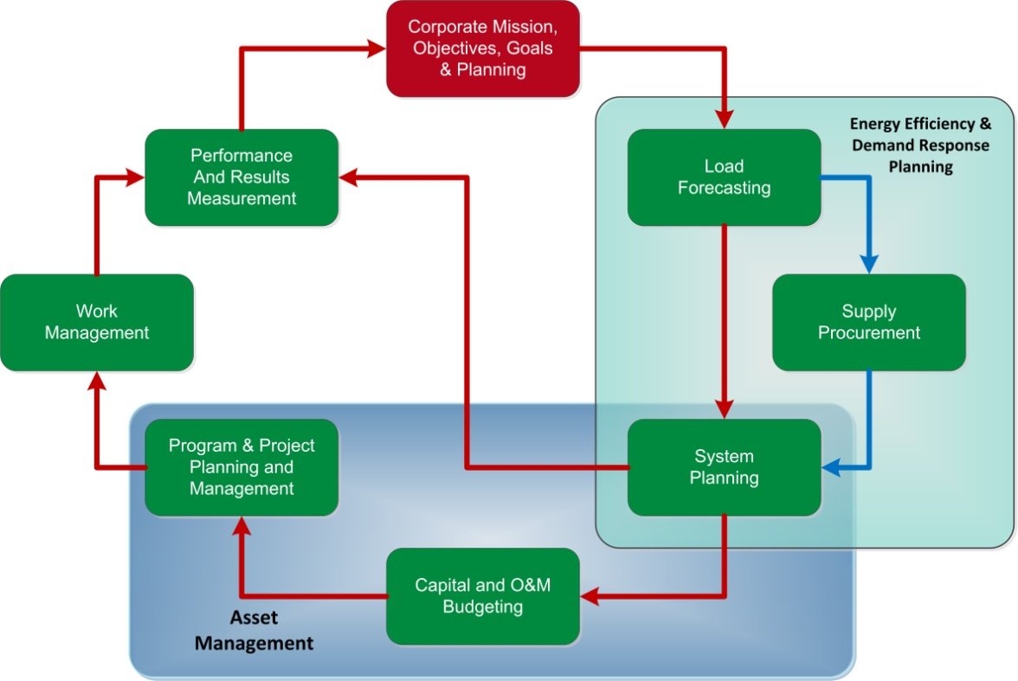
RCG contends that an effective board of directors, executive management, and governance approach should have the following attributes:
- An experienced and knowledgeable board of directors with appropriate committees to provide effective oversight and direction that benefit New York State customers;
- At least one board member who has specific knowledge of the history and environment that New York State utility operate within;
- An executive management structure with the right people focusing on the needs of New York State customers;
- A management team and strategic planning process properly focused on delivering the best service at a reasonable cost to New York State customers;
- A set of strategic plans and objectives grounded in delivering safe and reliable services at competitive prices to New York State customers;
- An effective corporate management process for addressing operational, legal, and regulatory issues with formal performance reporting;
- A process for developing management talent and filling key positions with highly-qualified individuals; and
- A uniform process for managing and operating across its service territory.

The Commission’s Evaluation Criteria:
The DPS has clearly defined the critical criteria by which the consultant is to evaluate the Company. RCG acknowledges the following RFP evaluation criteria as the principal areas of investigation and the foundation for this element’s chapter in the final report.
  - Are governance, organizational structure, missions, and relationships within NFGDC appropriate as they relate to the construction program planning process?
  - Are organizational responsibilities for planning priorities and budgeting allocations reasonable and appropriate?
  - Are the Board of Directors and executive and senior management appropriately involved in the development of budgeting guidelines and periodic budget reviews and approvals for the Company?
  - Are there adequate controls in place to prevent affiliate transaction abuses? This review of affiliate transactions should include, but not be limited to;
    - Identifying all affiliate transactions between NFGDC and its subsidiaries and mapping out transactions NFGDC has with NFGC and its subsidiaries. At minimum they should address the following:
      - Are the common cost allocation factors reasonable?
      - Are affiliate transactions priced in/out at reasonable costs?
      - Are there effective internal controls in place for managing and controlling levels of service and costs of services between and among regulated and non-regulated entities? If so, are they being applied?
      - Are the companies permitted to utilize the most cost-effective means to procure goods and services?
      - Is NFGDC paying an appropriate share of the parent company's costs and is employee time being fairly allocated?

  - Does NFGDC management use appropriate measurable goals, metrics, key performance indicators, etc. to achieve the corporate mission and objectives, and the performance improvement process at successive levels of management?
  - Does management’s performance comply with procedures and practices related to the scope of this audit (i.e., internal controls, internal audit function, and the Sarbanes Oxley Act) and are performance and compliance accurately reported?
  - Are management performance and compensation programs in alignment with the corporate mission, objectives, and goals at all organizational levels?
Note: NFGDC provides centralized services for regulated and non-regulated affiliates. However, NFGDC is not designated as a centralized service company under FERC rules and regulations and therefore does not file FERC Form 60 annual reports for centralized service companies and does not maintain a separate set of books and records and general ledger for this activity. RCG will consider this fact in its review of affiliate transactions.
  - Does NFGDC appropriately and accurately factor its financial position and the level of its rates into the budgeting process?
  - What is NFGDC’s approach to competitive issues for new markets (such as natural gas vehicles); i.e., what new markets are being considered by the Company, how would the costs for entry into those markets be funded, and would the Company's entry into those markets serve to help or hinder competition in those new markets?
Proposed Staffing Assignment
Audit Area Staff Assignment – Corporate Mission, Objectives, Goals and Planning
Lead Consultant | Bob Grant
Consultant(s) | Joe DeVirgilio, Donna Mullinax, Mike McGarry
Total Hours | 296

RCG Subordinate Criteria:
To enhance the RFP criteria, RCG recommends that the following subordinate criteria be included in the work plan adopted for this audit element:

- Is the corporate strategy documented? Is it forward thinking – visionary?
- Are the planning assumptions defined? Do they consider multiple scenarios – potential best, most likely, or worst scenarios for the future?
- Is the mission clear? Understood and embraced by employees?
- Are the values defined? Do employees understand what these values mean and what behaviors they should cultivate to be consistent with these values?
- Have the major strategic priorities been defined? Do the strategic priorities address such areas as fiscal viability and profitability, public trust, customer service, process improvements, organizational change, economic development for the region, environment, and initiatives to sustain continuous improvement and learning within the workforce?
- Are the plans updated to reflect changes, accomplishments, and lessons learned?
- Does the Company maintain formal and effective cost allocation policies, procedures, and related manuals that apply approved costing principles for transactions?
- Are methods of allocating overhead costs appropriate and reasonable?
- Are management time distributions used by the utilities and their affiliates to charge for services to and from affiliates validated regularly?
- Do overhead charges align with the business unit's use of the service function?
- Are controls regarding cost allocation and assignment, and other affiliate transactions, effective?
- What is the policy regarding the use of direct charges versus allocation for services obtained from or provided to affiliates?
- Is there clear executive responsibility for monitoring and controlling affiliate transaction policies and procedures?
- Has the Company demonstrated that services obtained from and provided to affiliates are comparable to those of qualified providers and obtained at favorable terms and conditions on a service-by-service basis?

Work Tasks:
- Review Corporate Mission, Objectives, Goals, and Planning tasks and initial data requests based on feedback from DPS Staff review of proposal and the structured Staff input process.
- Review initial data request responses related to Corporate Mission, Objectives, Goals, and Planning. Identify missing data, evaluate quality and completeness, and engage management as needed.
- Develop initial high-level interviews to clarify and verify understanding of the Corporate Mission, Objectives, Goals, and Planning process in NFGC and NFGDC.
- Develop Corporate Mission, Objectives, Goals and Planning chapter outline, next level of interview guides and data requests.
- Review charging processes to understand documentation and process flows between and within business units.

- Track a sample of transactions of costs allocated between NFGDC’s regulated and NFGC’s non-regulated entities, including payroll transactions.

- Determine if all applicable transactions are being captured.

- Determine if shared resources and charges are consistent and reasonable.

- Examine the transfer-pricing methodology to ensure that transactions between the Company and its affiliates are accurate and reasonable.

- Determine records accuracy, the nature of the transaction, and if the transaction is in compliance with policies, procedures, and regulatory requirements.

- Determine whether the costs of shared services, facilities, and equipment are allocated appropriately.

- Determine if services obtained from and provided to affiliates are comparable to qualified providers, and are obtained at favorable terms and conditions on a service-by-service basis.

- Compare all affiliate transaction findings against the DPS-approved methodology and identify any that are inconsistent or have not been included.
- Coordinate with audit teams to determine the extent of Company coordination and consistency of assumptions, strategies, and execution of a corporate mission, objectives, goals, and planning.
- Determine how the Company assesses the success of its corporate mission, objectives, goals, and planning process. Review key performance indicators (KPI) for corporate mission, objectives, goals, and planning.
- Review how the Company benchmarks its corporate mission, objectives, goals, and planning practices and how results compare with industry and other New York State utility performance.
- Compare the overall corporate mission, objectives, goals, and planning process to leading practices.
- Complete analysis of the overall corporate mission, objectives, goals, and planning process, including cost implications, where possible.
- Verify facts.
- Prepare the Corporate Mission, Objectives, Goals, and Planning Task Report.
- Submit the Corporate Mission, Objectives, Goals, and Planning Task Report for RCG quality review.

Element No. 2: Load Forecasting
A utility’s load forecast is the foundation for all tactical aspects of its planning process. RCG’s diagram below illustrates that the forecast should support supply procurement, system planning, and financial planning and recognize strategic planning issues and concerns. The utility needs to ensure that its gas load forecasting provides accurate and timely commodity and demand requirements so management can make prudent “downstream” operational decisions regarding supply procurement options, transmission capacity requirements and procurement, distribution system requirements, risk management, and financial and regulatory strategies.
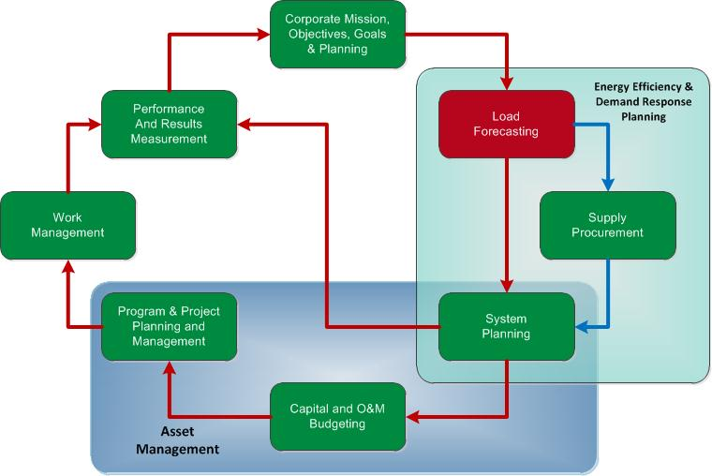

Key factors for developing accurate load forecasts include tested models, relevant inputs, and incorporation of energy efficiency, demand-side management, and projected weather requirements. A high-level measure of the effectiveness of the load forecasting function can be determined by comparing forecasts with weather-adjusted actual consumption, but the forecasting process must be broad enough to recognize emerging trends and/or rapid discontinuities (“Black Swan” events) and therefore customer research, sensitivity studies, and para-analytical techniques should be part of the forecasting process.
Evolving challenges in forecasting include the estimation of retail choice and the impact of distributed gas-fired generation, natural gas vehicles (NGV), and other emerging technologies along with volatile prices for competitive fuels and rapid changes in economic conditions.
Commission Evaluation Criteria:
The DPS has clearly defined the critical criteria by which the consultant is to evaluate the Company. RCG acknowledges the following RFP evaluation criteria as the principal areas of investigation and the foundation for this element’s chapter in the final report.
  - What are the models, assumptions and key drivers, and other inputs used to forecast local and system-wide load requirements?
  - What are the inputs, including demand-side management (demand response, etc.), energy efficiency, and other initiatives that are factors in the forecasting process?
  - Are the organization and staffing of forecasting functions reasonable?
Proposed Staffing Assignment:
Audit Area Staff Assignment – Load Forecasting
Lead Consultant | Howard Solganick
Consultant(s)
Total Hours | 126

RCG Subordinate Criteria:
To enhance the RFP criteria, RCG recommends that the following subordinate criteria be included in the work plan adopted for this audit element:
  - Does the Company perform customer research?
  - Does the Company statistically test and backcast its forecasting models and routinely compare its forecast to actual sales and peak?
  - What does the information gleaned from audit work tasks tell us about how this audit element is enhancing or detracting from the effective operation of the construction feedback loop?

Work Tasks:
- Revise load forecasting tasks and initial data requests based on feedback from the DPS Staff review of the proposal and the structured Staff input process.
- Review initial data request responses related to the load forecasting process. Identify missing data, evaluate quality and completeness, and engage management as needed.
- Develop initial high-level interviews to clarify and verify understanding of the load forecasting process within NFGDC.
- Develop a load forecasting task report outline, the next level of interview guides and data requests.
- Assess the overall planning process including recent changes. Consider whether the process is centralized across NFGDC (particularly the New York business units), well documented and tested appropriately and updated as needed.
- Assess the models used to forecast commodity and peak. Consider whether the forecast does (and should) consider geography and customer classes appropriately.
- Assess how non-traditional forecasting techniques such as sensitivity studies, para-analytics, environmental scanning, and emerging trends are considered in the forecasting process.
- Determine how demand response, energy efficiency, gas-fired distributed generation, and other customer-facing programs are integrated into the forecast.
- Assess the inputs, assumptions, key drivers, and other inputs to forecast local and system-wide load requirements that the Company uses within its forecast process. Consider whether customer research is used (or needed). Assess how customer choice is estimated and integrated into the forecasting process.
- Assess the forecast review and approval process.
- Assess the organization structure, costs, and staffing that provide the inputs, support the modeling, and review the forecast.
- Determine whether the forecast is used for supply procurement, system planning, and financial (revenue) planning.
- Determine if the forecast is used within the regulatory process including rate cases.
- Assess the Company’s comparisons of each forecast (2006 through 2010) to weather-adjusted consumption. Review the post-forecast analysis process.
- Coordinate with the Corporate Mission, Objectives, Goals, and Planning; Supply Procurement; System planning; and Performance and Results Management audit teams to determine the extent of Company coordination and consistency of assumptions, strategies, and execution.
- Determine how the Company and load forecasting process management group assesses the success of the load forecasting process. Review the KPI for the load forecasting process.
- Review how the Company benchmarks load forecasting practices and results with industry and other New York State utility performance.
- Compare the overall load forecasting process to leading practices.
- Complete an analysis of the load forecasting process, including cost implications, where possible.
- Verify facts.
- Prepare the load forecasting task report.
- Submit the load forecasting task report for RCG quality review.

Element No.3: Supply Procurement
Supply procurement is generally the single largest expense a New York State gas utility faces. Errors in supply procurement strategy or its execution can therefore have significant financial implications to the Company and the customers. Securing competitive and reliable gas supply (i.e., energy, pipeline capacity, ancillaries, and storage) to serve mass market default supply option (“DSO”) customers in a deregulated competitive marketplace has become an increasingly challenging activity fraught with many inter-dependent risk factors. A utility’s DSO customer peak usage and load volumes are subject to fluctuations as energy users respond to regulatory and competitive market changes.
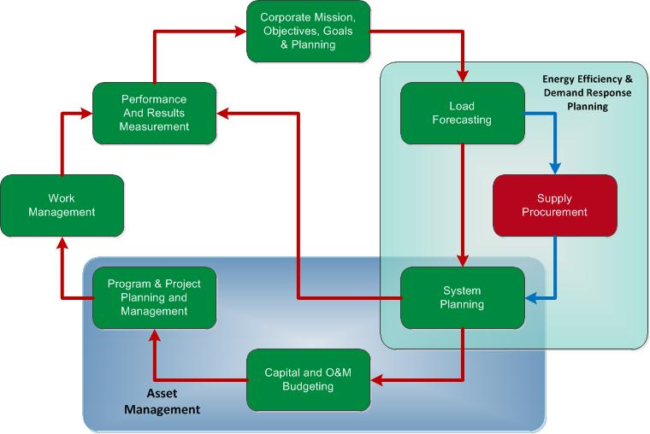

To constrain price volatility, utilities hedge a portion of their natural gas obligations with a combination of fixed and floating (indexed) supply purchase contracts, both physical and financial and with varying terms; they purchase the balance on spot markets. In some cases, utility affiliates also own production fields and transmission resources and other legacy gas purchases that can be included in the supply portfolio under various pricing and term structures. This increasingly sophisticated and complex supply process requires coordinated planning and execution with senior management attention, clear goals and objectives, and effective risk management and controls, all with an eye toward future developments and trends.
A successful gas supply strategy also includes executing the contracts on a daily basis. Depending on the mix of customer load profiles (residential, residential heating, commercial, manufacturing, weather sensitivity, interruptible, critical use, etc), and the resultant seasonal, daily, and hourly diversity, the gas supply procurement strategy can vary considerably from one local gas distribution company to another. Even within the same state, different hedging or customer tariff approaches may be designed to deal with specific supply procurement concerns and mandates. The pursuit of price stability may certainly be in conflict with a desire for “market-driven” customer price signals. A demonstrated ability to foresee and test a much larger variety of possible market conditions and or events will be necessary to navigate both today’s and future markets.
The need for management of risk across a corporate structure has received much attention and nowhere more so than in energy supply procurement. A robust risk management policy directly related to the energy supply procurement process is a basic expectation. Such a policy must set clear and precise expectations around policy development, governance, oversight, execution, record keeping and retention, role clarity and separation, accountability, and periodic evaluation and auditing,
Moreover there must be clear evidence that the policy is communicated, understood, reviewed, adjusted, and executed consistently and effectively through the organization. A system of key controls and systems supported and championed by senior management is essential to an effective risk management approach.

Commission Evaluation Criteria:
The DPS has clearly defined the critical criteria by which the consultant is to evaluate the Company. RCG acknowledges the following RFP evaluation criteria as the principal areas of investigation and the foundation for this element’s write-up in the final report.
  - Are the supply portfolio principles, goals, and objectives for mass market default customers reasonable and appropriate to ensure continuity of supply?
  - Are the risk management strategies and practices appropriate for a gas operation of this size?
  - What are the supply procurement strategies, policies, processes, and methods?
  - Are NFGDC’s financial and physical hedging practices reasonable and appropriate?
  - Does NFGDC’s use performance benchmarking with other utilities as part of its supply strategy?
  - What are NFGDC’s portfolio performance goals?
  - Are portfolio oversight and controls appropriate?
  - How are demand management/response, energy efficiency, and migration of retail customers to competitive suppliers integrated into both the portfolio and procurement processes?
  - How are the management of local production assets (such as gas wells in the NFGDC service territory) and the resulting impact of drilling in the Marcellus region impacting the supply planning?
  - What is the gas market power in the capacity market and the effect of NFGDC’s buying power on other suppliers for capacity and supply in and around the Niagara market?
Staffing Assignment:
Audit Area Staff Assignment – Supply Procurement
Lead Consultant | Howard Solganick
Consultant(s) | Mike McGarry
Total Hours | 176

RCG Subordinate Criteria:
To enhance the RFP criteria, RCG recommends that the following subordinate criteria be included in the work plan adopted for this audit element:
  - Review the Company’s management and reporting structures, staffing, accountability, and experience to determine if they are consistent with the goals and objectives of the procurement process.
  - Examine whether the Company has adequately considered the pace of the economic recovery on wholesale prices and their gas procurement process.
  - What does the information gleaned from audit work tasks tell us about how this audit element is enhancing or detracting from the effective operation of the construction feedback loop?

Work Tasks:

- Revise Supply Procurement tasks and initial data requests based on feedback from the DPS Staff review of the proposal and the structured Staff input process.
- Review initial data request responses related to the Company’s supply procurement process. Identify missing data, evaluate quality and completeness, and engage management as needed.
- Develop initial high-level interviews to clarify and verify understanding of the supply procurement process in NFGDC and NFGC’s business units.
- Develop the supply procurement task report outline and the next level of interview guides and data requests.
- Review and evaluate the Company’s strategic plan, including goals and objectives. Examine the process and procedures used to communicate, execute, and control wholesale market transactions and supply operation practices. Determine if proper counterparty, execution platform, and market contacts are identified and effectively used to provide appropriate transaction options and information feedback. Evaluate the extent to which the Company protects the short- and long-term interests of its retail customers.
- Review the supply procurement process, strategies, policies, processes, and methods. Assess consistency with Company goals and objectives, risk management, and other internal and external requirements, including customer benefits and New York Commission regulations. Review modeling, related calculations, and key drivers utilized by the Company Identify and evaluate documentation and performance of the required inputs.
- Evaluate the organization structure and management roles, responsibilities and accountability with respect to the supply procurement process. Identify the effectiveness of the communication and feedback processes involved.
- Identify and evaluate the adequacy and effectiveness of the Company’s decision-making process, and the organizational location of key decision-makers and the criteria used to reach them.
- Determine the adequacy and timeliness of the supply procurement process in identifying, prioritizing, and developing alternative strategies in response to emerging market issues and regulatory requirement changes within the current process.
- Determine and review the management of the mass market default supply arrangements. Examine alternatives considered by the Company and the decision process. Understand the impact of the underlying goals and objectives.
- Review back-, mid-, and front-office organization, processes, and procedures. Determine if transactions are properly captured, audited, and reported, and if any changes are identified, processed, and reported. Evaluate documentation and performance including ability to respond to data requests and meet internal and external requirements in a timely and efficient manner.
- Evaluate the effectiveness and integration of risk management strategies and practices in the supply procurement process.
- Coordinate with the Corporate Mission, Objectives, Goals and Planning; Load Forecasting; System Planning; and Performance and Results Management audit teams to determine the extent of Company coordination and consistency of assumptions, strategies, and execution.
- Determine how the Company and the supply procurement process management team assess the success of the supply procurement process. Review the KPI for the supply procurement process.
- Review how the Company benchmarks supply procurement practices and results with industry and other New York State utility’s performance.
- Compare the overall supply procurement process to leading practices.
- Complete the analysis of the supply procurement process, including cost implications, where possible.
- Verify facts.
- Prepare the Supply Procurement Task Report
- Submit the Supply Procurement Task Report for RCG quality review

Element No. 4: System Planning
System planning is the cornerstone of the utility’s effort to ensure adequate, safe, and reliable gas energy delivery. It must be consistent with the Company’s strategic plan and will impact customer satisfaction. The resulting planning efforts drive a utility’s capital and O&M budgeting process. Specifically, the system planning process will have the following impacts:
- Plans the company’s capital construction program which
  - Minimizes equipment failures and leaks of all types,
  - Addresses the replacement of aging infrastructure, particularly cast iron and bare steel mains,
  - Ensures adequate gas supply to new and existing customers, and
  - Minimizes the need for excessive corrective maintenance actions;
- Supports the development of a formal asset management strategy and plan;
- Encourages a proactive maintenance plan to optimize O&M spending;
  - Minimizes overlapping spending caused by uncoordinated capital and maintenance efforts;
  - Allows management to identify the appropriate staffing levels for maintaining the system; and
  - Permits management to determine the most cost-effective means for executing its capital plan.
RCG has seen a number of companies that have chosen to outsource this critical function -- with less than desirable results. RCG will closely evaluate the Company’s approach to system planning.
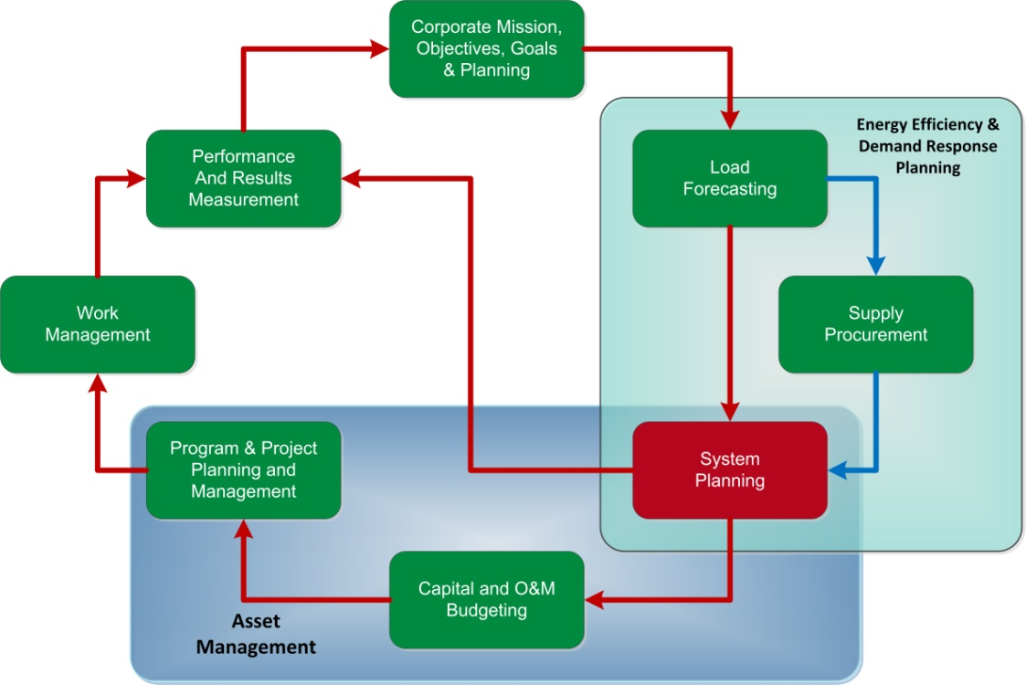

Commission Evaluation Criteria:
The DPS has clearly defined the critical criteria by which the consultant is to evaluate the Company. RCG acknowledges the following RFP evaluation criteria as the principal areas of investigation and the foundation for this element’s chapter in the final report.
  - Are infrastructure planning and engineering functions appropriately staffed and aligned to support system planning?
  - Are there appropriate priorities, guidance, and other instructions for evaluations, tradeoffs, and decision-making in place? Specifically do they address:
    - An asset condition and management process?
    - Input from the asset health review process?
    - Linking asset management decisions (e.g., predictive failure analyses) to improve reliability and performance?

  - Does the Company prepare system forecasts and develop infrastructure requirements?
  - Is there consideration of other load and infrastructure factors, such as advanced metering and energy efficiency initiatives, in the planning process?
  - Are there formal processes for identifying, developing, and justifying the need for major projects (e.g., gas lines, regulator stations, etc.)?
  - Are there a formal process and criteria for making decisions regarding replace- versus-repair, including how the overall construction program planning process is affected?
  - Are there planning processes for: (a) reliability versus new business tradeoffs, and (b) regional versus central planning dynamics?
  - To what extent are benefit/cost analyses and risk analyses considered in the decision-making process; and are the specific types of benefit/cost and risk analysis methodologies assessed?
  - Are trade-offs optimized with respect to the replacement of older technology with newer technology and the resulting impact on the useful lives and depreciation assumptions of the existing infrastructure, cash flow, and system reliability?

Staffing Assignment:
Audit Area Staff Assignment – System Planning
Lead Consultant | Bob Grant
Consultant(s) | Joe DeVirgilio
Total Hours | 200

RCG Subordinate Criteria:
To enhance the RFP criteria, RCG recommends that the following subordinate criteria be included in the work plan adopted for this audit element:
  - How are distribution problem areas included in the system planning process?
  - Are planning results adequately back-casted for accuracy and model manipulation?
  - What is the impact to maintenance planning in terms of programs and spending?
  - How has the Company’s gas main and service line replacement plan changed over the last five years? What is the projected capital spending for the next five years?
  - What tools and models are used to project gas main replacement? How are the results verified?
  - Does the Company plan to increase gas storage over the next five years? What drives storage decisions?
  - What does the information gleaned from audit work tasks tell us about how this audit element is enhancing or detracting from the effective operation of the construction feedback loop?

Work Tasks:
- Revise System Planning tasks and initial data requests based on feedback from the DPS Staff review of the proposal and the structured Staff input process.
- Review initial data request responses related to system planning. Identify missing data, evaluate quality and completeness, and engage management as needed.
- Develop initial high-level interviews to clarify and verify understanding of the system planning process within NFGDC.
- Develop a System Planning task report outline, and the next level of interview guides and data requests.
- Assess the system planning process and how it integrates planning, forecasting, engineering, operations, standards, construction, and supply chain.
- Identify the key drivers (e.g., reliability, safety, operability and new business) to identifying new capital projects and the section process.
- Determine the adequacy of the system planning process for identifying, prioritizing, and developing corrective projects for chronic system problem areas.
- Understand how risk management is formally integrated in the process.
- Review the project ranking tools and processes for reasonableness.
- Determine how the Company allocates the capital budget between gas transmission and distribution.
- Review Company use of standards for equipment and system design. Where possible, determine the impact of replacing old technology on spending, staffing, and reliability.
- Determine where and who sets the annual budget within the Company’s organization.
- Assess the assumptions and accuracy of the planning models used.
- Determine if demand response, energy efficiency, smart grid, and alternative resources are adequately incorporated into the system planning process.
- Assess the reasonableness of equipment repair-vs.-replace decision process.
- Review the asset management strategy and supporting organization to ensure safe and reliable energy delivery systems.
- Identify where the ultimate decisions are made on the system planning and the criteria used to reach them.
- Determine the frequency of the validation process.
- Coordinate with the Corporate Mission, Objectives, Goals, and Planning; Load Forecasting; Supply Procurement; Capital and O&M Budgeting; and Performance and Results Management audit teams to determine the extent of Company coordination and consistency of assumptions, strategies, and execution.
- Determine how the Company and system planning management assesses the success of the system planning process. Review the KPI for system planning.
- Review how the Company benchmarks its system planning practices and results with industry and other New York State utility performance.
- Compare the overall system planning process to leading practices.
- Complete analysis of the system planning process, including cost implications, where possible.
- Verify facts.
- Prepare the System Planning Task Report
- Submit the System Planning Task Report for RCG quality review

Element No. 5: Capital and O&M Budgeting
Having a sound budgeting process in place is the core of managing any business. Good budgets allow managers to manage, in part, to the numbers. This limits surprises as the fiscal year comes to a close. Successful capital and O&M budgeting have the following traits:
- A clear and defined budgeting process with a formal timetable and criteria;
- Built-in bottom-up input and top-down limits;
- Formal time-based targets;
- A clear understanding of the budget by managers and recognition that the they will be judged on budget performance;
- A formal performance reporting and monitoring mechanism;
- Regular executive and Board-level visibility of capital budgets;
- Clearly defined accountability for delivering results relative to budgets;
- Formal capital committee oversight and regular evaluation of the rate of spending, and budget adjustments for unforeseen events;
- A system planning process tied to capital budgets, as well as expected new business growth predicted by load forecasting;
- Clearly articulated budgets reflecting the O&M needs of the gas T&D systems, generally expressed in formal programs (repair, cathodic protection, gas leak survey, etc.);
- Integrated capital and O&M budgets that are based on business needs and not focused on labor utilization; and
- Indirect linkage to work management systems and processes to provide detailed information on spending.
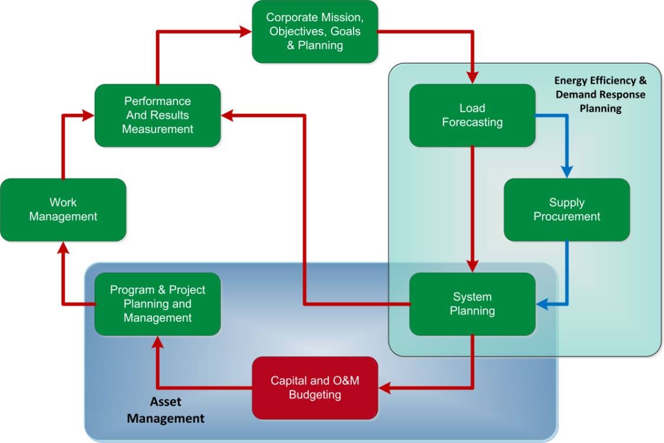
Commission Evaluation Criteria:
The DPS has clearly defined the critical criteria by which the consultant is to evaluate the Company. RCG embraces the following RFP evaluation criteria as the principal areas of investigation and the foundation for this element’s chapter in the final report.
  - What are the roles of the Board of Directors, and executive and senior management in the budgeting process? What processes are used by the Board to oversee both the capital and O&M budgets? What is the level of budget detail the Board sees and what are their responsibilities with regard to the budgets?
  - What is construction/capital priority-setting process?
  - How are incremental O&M expenses associated with new construction factored into the budgeting process?
  - What are the effects of allowed revenues/rates and financing opportunities or constraints on budget levels and priorities?
  - What are the relationships among planned/budgeted expenditures, rate case proposed expenditures, and actual expenditures?
  - How does the capital budgeting process (including project authorization, project appropriation, increase/decrease of authorization/appropriation, capital budget status reporting, validation in advance of appropriation, funding controls, and other elements of the capital budgeting process) function in NFGDC?
  - What are the budgeting guidelines, practices, and procedures, including “zero–based” and other alternative methods?
  - What the roles of and relationships between regional and centralized planning and budgeting functions?
  - What is the methodology for prioritizing and determining which capital projects get approved (including an examination of modeling software for capital and O&M budgeting)?
  - How does management oversee and control of capital budgeting? Including the methodologies used to control and manage program and project capital costs in the near and long term; the annual process for reviewing and determining whether total capital and O&M planned expenditures are adequate; cost control systems and processes from both a top-down and bottom-up perspective; controls to ensure that increases and decreases to the construction budget/expenditures are justified and appropriately approved)?
  - What are the bottom-up and top-down processes for developing the budgets for capital/construction classifications and categories?
Staffing Assignment:
Audit Area Staff Assignment – Capital and O&M Budgeting
Lead Consultant | Donna Mullinax
Consultant(s) | Joe DeVirgilio, Bob Grant, Mike McGarry
Total Hours | 236
RCG Subordinate Criteria:
To enhance the RFP criteria, RCG recommends that the following subordinate criteria be included in the work plan adopted for this audit element:
  - Is budgeting formally linked to strategic initiatives?
  - Is there clear and independent oversight of both the capital and O&M budgets all the way up to and including the BOD?
  - Is there a formal process for handling emergency spending and integrating results into existing capital or O&M budgets?
  - How does NFGDC’s capital and O&M spending compare with other New York gas utilities?
  - How will new technology impact the O&M budgeting numbers?
  - What does the information gleaned from audit work tasks tell us about how this audit element is enhancing or detracting from the effective operation of the construction feedback loop?
Work Tasks:
- Review Capital and O&M Budgeting tasks and initial data requests based on feedback from DPS Staff review of the proposal and the structured Staff input process.
- Review responses to the initial data requests related to capital and O&M budgeting. Identify missing data, evaluate quality and completeness, and engage management as needed.
- Develop initial high-level interviews to clarify and verify understanding of the capital and O&M budgeting processes in NFG.
- Develop the capital and O&M budgeting task report outline, and the next level of interview guides and data requests.
- Determine if the Company’s approaches to developing and controlling budgets are effective.
- Evaluate the board of directors’ roles and responsibilities with respect to the capital and O&M budgeting processes.
- Determine if the board of directors is exposed to the right level of detail to make informed decisions on budgets.
- Understand where both the initial and final decisions on budgets are made within the NFGDC organization.
- Evaluate the adequacy of management oversight of budgets over the course of a year.
- Determine the role and responsibilities of the capital project manager.
- Identify adjustments to annual maintenance program budgets and the reasons.
- Determine the annual variances in budgets and the associated reasons.
- Evaluate sample capital projects that fall into the following categories: new proposed projects, projects underway, and completed projects.
- Determine if the Company uses models to plan budgets.
- Understand how management deals with multi-year project run rates, which exceed annual budget targets during the life of the project.
- Evaluate the capital budget priority-setting process and its reasonableness.
- Determine how management balances capital and O&M budgets when one deviates widely from its plan.
- Determine if allowances for capital projects are integrated into the O&M budgets.
- Understand if ratemaking or allowed revenues affect the capital budgeting process.
- Coordinate with the Corporate Mission, Objectives, Goals, and Planning; Supply Procurement; System Planning; Program and Project Planning and Management; and Results Management audit teams to determine the extent of Company coordination and consistency of assumptions, strategies, and execution.
- Determine how the Company and its capital and O&M budgeting management assess the success of the capital and O&M budgeting process. Review the KPI for capital and O&M budgeting.
- Review how the Company benchmarks the capital and O&M budgeting practices and results with industry and other New York State utility performance.
- Compare the overall capital and O&M budgeting process to leading practices.
- Complete an analysis of capital and O&M budgeting process, including cost implications, where possible.
- Verify facts.
- Prepare the Capital and O&M Budgeting Task Report
- Submit the Capital and O&M Budgeting Task Report for RCG quality review

Element No. 6: Program and Project Planning and Management
Program and project planning and management (P&PPM) provide significant benefits to senior management, customers, and other key stakeholders, such as shareholders and regulators. P&PPM address both capital projects and O&M programs (main and regulator inspection and replacement, DOT pipeline safety, etc.) These benefits include:
- Integrated Strategic View: P&PPM is designed to take a larger and more comprehensive view of the organization's activities to ensure that the multiplicity of capital projects and O&M programs are working across an organization toward common strategic goals and objectives while avoiding conflict and duplication of effort.
- Consistency: In many projects, the project leader must take time at the beginning to outline the process, rules, and methods of communication. With a well-developed P&PPM infrastructure, these are defined for all projects in advance and are consistent from project to project. This means that employees can move right into team-forming and not have to spend initial meetings discussing how the process is going to work. The end result is that there are fewer communication mix-ups.
- Cost Savings: The program management office evaluates all new requests and groups them so that efficiencies of scale can be achieved when allocating limited budgetary and staffing resources. Strong project management fundamentals ensure that projects stay on track and that variances are addressed quickly and economically.

Risk Mitigation: Proactive risk management anticipates potential project risks so they may be avoided entirely or mitigated by minimizing consequences early.

Stakeholder Value: Through effective P&PPM approaches, senior management have more cohesive information to provide to key stakeholders about the Company's general processes, growth, customer service, strategic initiatives, compliance, and other relevant facts requested by stakeholders. This focus on communication ensures that management stays informed of key issues and events.
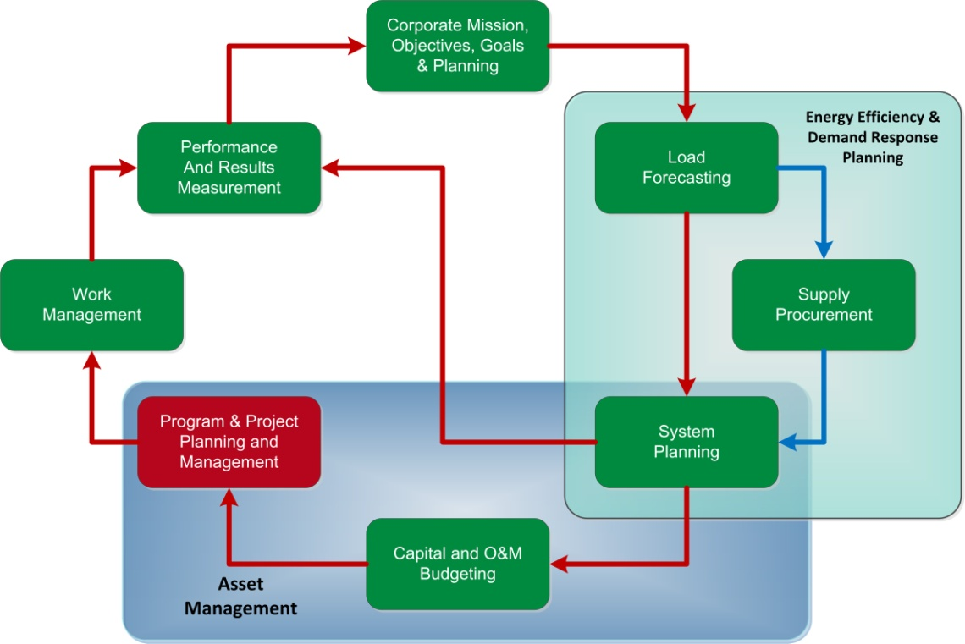
Program Planning and Management
Exhibit IV-1 shows that program planning and management has two distinct missions: strategic and tactical. The strategic role is essential in ensuring that strategic goals and initiatives promulgated by senior management are translated into discrete, tangible projects, and that final deliverables are in line with management’s strategic vision and objectives. As projects progress, the program planning and management function continues to monitor compliance with strategic objectives, including mid-course corrections that may arise from shifts in strategic focus or tactical drift.
EXHIBIT IV-1
Dual Program Management Missions
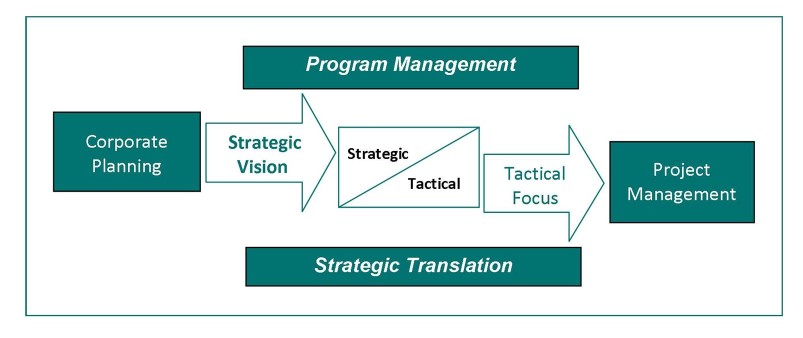
The tactical program management mission aligns budgetary and resource allocation decisions with management’s strategic objectives and values. A key aspect of this is the development of realistic budgets and schedules for capital projects to maintain the integrity and safety of existing infrastructure, and to expand system capacity and capabilities. These budgets and schedules become the basis for planning and coordination of requisite engineering, procurement, contracting, quality control, and construction activities.
Program management also provides a common framework of tools, policies and procedures, and services that help to ensure that various teams assigned to a project or projects are effectively working together. Day-to-day responsibility and decision-making for projects remain with project managers within the overall program management framework.
Project Planning and Management
Project planning focuses on the specific requirements needed to successfully complete individual projects within the scope, schedule, and resources allocated through the program planning process. Exhibit IV-2 shows the critical components of project planning. The initial step in the project planning task is to define and document the project scope and requirements for an individual project. Assumptions and resource allocations adopted during the program planning phase are reviewed and revised as necessary. The final project scope, schedule, and budget are documented prior to the initiation of an individual project.
EXHIBIT IV-2
Tactical Project Approach
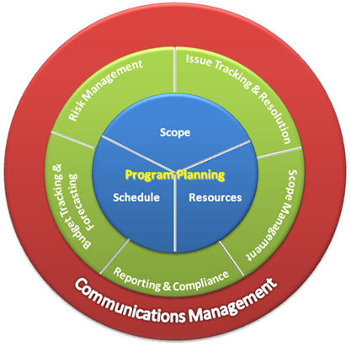
If a project is to be managed to its completion within the planned scope, schedule, and resource constraints, project management must involve several key activities:
- Scope Management - Throughout the duration of a project, scope management is critical to manage both cost and delivery.
- Budget Tracking and Forecasting - Project expenditures are tracked against budgeted amounts, and updated forecasts are compiled using standardized templates and formats. Significant variances may require revisiting the program planning process to resolve issues such as resource contention between projects.
- Issue Tracking and Resolution - As project issues inevitably arise an Issue Log must be maintained to track open issues and associated action plans through resolution during the course of a project.
- Risk Management - Project managers should proactively identify, monitor, and evaluate project issues and risks, and develop preventative and/or mitigating measures, as appropriate. A Risk Register should be maintained.
- Reporting & Compliance - Routine project reporting requirements typically include the following information, which is provided on a frequent and regular basis:
  - Status reports, with master program schedule reporting and maintenance;
  - Milestone summaries;
  - Burn rate/hours expended by company and contractor resources;
  - Project risk and risk status reports;
  - Late tasks and possible remediation plans;
  - Pending or new change requests; and
  - A document repository and collaboration tool is useful to provide a document-management.
- Communications Management - An effective communications framework is key to the success of any project. The importance of a communications framework increases in proportion to the scale and complexity of the project. A formal communication plan should be developed for each project and be circulated to executive managers, general managers, section heads, and project managers that will be impacted by the project.
Commission Evaluation Criteria:
The DPS has clearly defined the critical criteria by which the consultant is to evaluate the Company. RCG embraces the following RFP evaluation criteria as the principal areas of investigation and the foundation for this element’s chapter in the final report.
  - What is the process for conversion of capital and O&M plans and budgets into specific programs and projects?
  - What is the process for prioritization and approvals over various time horizons?
  - How are program and project planning, design, estimating, engineering, costing, scheduling, and execution integrated and accomplished?
  - How is planning and management of materials, equipment, transportation, and other logistical support for programs and projects integrated into the overall process?
  - What is the analysis and decision-making for determining tradeoffs to optimize the use of in-house workforce versus contractor labor?
Staffing Assignment:
Audit Area Staff Assignment – Program and Project
Planning and Management
Lead Consultant | Tom Hurley
Consultant(s) | Charlie Fijnvandraat
Total Hours | 244
RCG Subordinate Criteria:
To enhance the RFP criteria, RCG recommends including the following subordinate criteria in the work plan adopted for this audit element:

  - Does the Company use a formal Program Management Office (PMO) for program management or an ad hoc approach?
  - Has the Company developed a standardized program and project management infrastructure, including standardized policies and procedures, budget and reporting templates, project and collaborations tools, etc.?
  - Is there one project owner or does ownership shift as the project progresses?
  - Is there a formal training program or certification in place for project managers?
  - How are issue resolutions incorporated into project manager training and future project designs?
  - Is there a formal project review committee?
  - Is there a formal and consistent process for coordinating with state and municipal highway agencies to coordinate projects?
  - What does the information gleaned from audit work tasks tell us about how this audit element is enhancing or detracting from the effective operation of the construction feedback loop?

Work Tasks:
RCG will develop a profile of planned, in-progress, and recently completed construction projects in the Company’s service area. RCG will then select a representative sample of these projects for detailed review of the Company’s program and project management performance, including:
- Revise P&PPM tasks and initial data requests based on feedback from the DPS Staff review of the proposal and the structured Staff input process.
- Review initial data request responses related to the P&PPM process. Identify missing data, evaluate quality and completeness, and engage management as needed.
- Develop initial high-level interviews to clarify and verify understanding of the P&PPM process in NFGDC.
- Develop the P&PPM process task report outline, and the next level of interview guides and data requests.
- Coordinate with the Corporate Mission, and Capital and O&M Budgeting audit teams to determine process coordination handoffs, consistency of assumptions, and areas of focus and execution.
- Review how capital and O&M plans and budgets convert to specific programs and projects.
- Assess how programs and projects are prioritized and approved over various time horizons.
- Define and review program and project planning, design, estimating, engineering, costing, scheduling, and execution.
- Evaluate how materials and equipment, transportation, and other logistical support are planned and managed for programs and projects.
- Evaluate how projects for the same infrastructure are coordinated.
- Review project management training materials for completeness.
- Determine how tradeoffs are analyzed and decisions made in order to optimize the use of in-house workforce versus contractor labor.
- Examine contractor and engineering bidding processes.
- Evaluate how construction contractor projects are planned and managed.
- Examine quality assurance and quality control at the program and project level.
- Examine contractor management, and project program management, including accountability, goals, objectives, and performance measurement.
- Examine methodologies for tracking costs, work units, and work quality for specific programs and projects.
- Determine if the typical variances among original, budgeted, and actual capital expenditures and work units are justified.
- Assess how the Company tracks and minimizes variances in order to improve cost control, efficiency, productivity, and work quality.
- Determine how issues are managed from a knowledge management perspective and converted into future learning tools.
- Determine how the Company and P&PPM management assess the success of the P&PPM process. Review the KPI for P&PPM.
- Review how the Company benchmarks, P&PPM practices, and results with industry and other New York State utility performance.
- Coordinate with the Corporate Mission Objectives, Goals and Planning; Capital and O&M Budgeting; Work Force Management; and Performance and Results Management audit teams to determine the extent of Company coordination and consistency of assumptions, strategies, and execution. Complete analysis of P&PPM, including cost implications where possible.
- Determine how the Company and P&PPM managers assess the success of the P&PPM process. Review the KPI for P&PPM.
- Review how the Company benchmarks its P&PPM practices and results with industry and other New York State utility performance.
- Compare the overall P&PPM process to leading practices.
- Complete analysis of P&PPM, including cost implications, where possible.
- Verify facts.
- Prepare the P&PPM Task Report
- Submit the P&PPM Task Report for RCG quality review.

Element No. 7: Work Management
Most utility companies aspire to achieve operational excellence in such areas as system reliability and customer service, but many have fallen short of identifying and implementing industry leading practices in the management of workers and work processes required to realize those goals. Excellence in work management requires well-planned, properly scheduled, and effectively executed work tasks using the proper resources and skill sets, and a formal means to monitor progress.
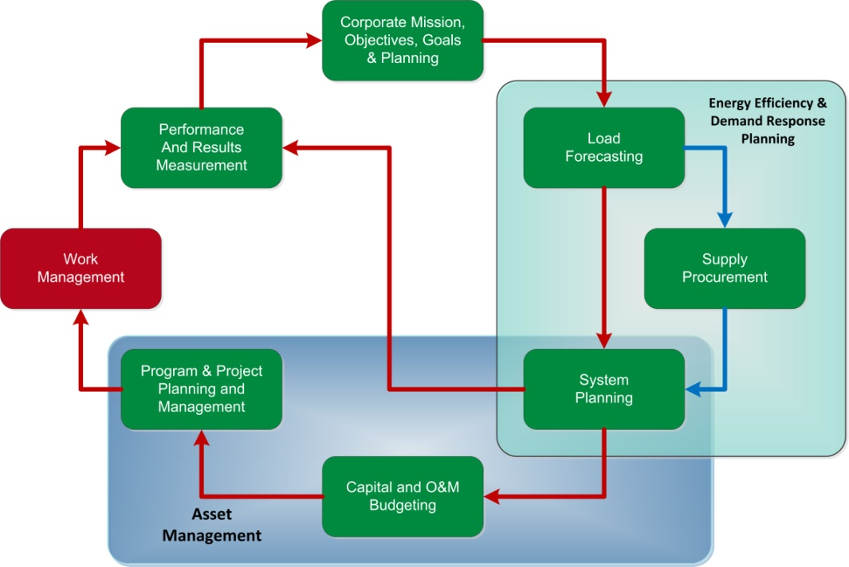
Work properly prepared and managed in this fashion enhances operational efficiency and is accomplished more effectively with higher quality, lower cost, greater safety, and greater job satisfaction than work performed without proper preparation. Successful application of these leading practices in work management ultimately leads to better system reliability and customer service, and cost-effective utilization of resources.
An organization trending toward excellence is one that has transitioned from a reactive to a proactive approach to assigning and executing work. It has effectively integrated planning, coordination, and scheduling into day-to-day work activities. It has developed a culture of quality, continuous improvement, and pride in its performance.
Specifically, the Work Management processes will:
- Assure that work required for long-term system performance is completed in a timely manner and is not deferred due to emergency and emergent work;
- Improve the efficiency and effectiveness of human resources thereby reducing overall costs;
- Process track rework, failures, repair history, and corrective actions; track productivity, quality, schedule adherence; and identify areas for performance improvement;
- Provide an annual review of work staffing and skills requirements to assure that sufficient human resources (with the proper skills) are available for day-to-day operations and for emergencies to meet customer service, service quality, safety, and reliability standards;
- Integrate the annual work plan with emergent work, and with monthly, weekly, and daily work schedules, enabling determination of the optimum work force for each work area, and coordination of capital jobs with maintenance jobs to reduce duplicative work;
- Promote monthly work schedules that are resource-constrained to identify the tasks that cannot be accomplished with in-house resources, including a rational decision methodology for determining tasks that will be outsourced, contracted, or deferred, enabling improved utilization and efficiency of the in-house work force;
- Use an aggressive backlog management process with a priority system that differentiates urgent from important work tasks, assuring that emergency work does not distract from the longer-term programs that improve overall system performance;
- Continuously improve work force efficiency and effectiveness by upgrading tools and methods with new technology;
- Promote a robust work management information system that supports leading practice work processes, and proactively plans work, manages backlogs, and monitors performance;
- Use a work management information system that creates schedules, develops resource requirements, and produces metrics to track key performance areas, such as schedule attainment, planned versus unplanned work, labor productivity, actual costs versus budgets, and non-productive time caused by work delays;
- Use a work management plan that includes full-time and part-time employee crewing and contractor labor/crewing, resulting in staffing flexibility during peak and lean work periods; supplement staffing during emergencies through mutual aid.
- Use the work management system to manage on-site contractors and track outsourced work, allowing improved oversight and supervision of contractors; and
- Use data from the work management system to benchmark against other utility companies.
Commission Evaluation Criteria:
The DPS has clearly defined the critical criteria by which the consultant is to evaluate the Company. RCG embraces the following RFP evaluation criteria as the principal areas of investigation and the foundation for this element’s chapter in the final report.
  - How are planning, conversion, and execution of programs and projects into short-term and day-to-day work accomplished?
  - What work management systems are used to schedule and manage field crews, including transportation, equipment, and materials?
  - What are the roles and responsibilities of project managers, supervisors, and inspectors?
  - How are quality assurance and quality control maintained?
  - What is the process for managing employee availability, utilization, efficiency, productivity, and effectiveness?
  - How is management of program and project schedules accomplished on a day-to-day basis?
  - How is information about rework, failures, repair history, etc. translated into corrective actions, and how are infrastructure aging analysis and repair-versus-replace decisions performed?
  - How is feedback of work management systems used to identify performance improvement opportunities?
Staffing Assignment:
Audit Area Staff Assignment – Work Management
Lead Consultant | Tom Hurley
Consultant(s) | Charlie Fijnvandraat
Total Hours | 204
RCG Subordinate Criteria:
To enhance the RFP criteria, RCG recommends that the following subordinate criteria be included in the work plan adopted for this audit element:

  - Are highly visible metrics used to track progress toward organization goals? Do goals include such topics as safety, productivity, quality, budget, schedule adherence, and backlog?
  - Do aggressive backlog management processes incorporate a priority system that differentiates among urgent (emergency) work, important (corrective, replacement, and upgrade) work, and routine (PM/PdM) tasks?
  - Is there a logical linkage among asset management, long-range work planning, capital vs. O&M work schedules, budget development, and day-to-day work schedules?
  - Do annual workload forecasts identify planned tasks and resources required?
  - What does the information gleaned from audit work tasks tell us about how this audit element is enhancing or detracting from the effective operation of the construction feedback loop?

Work Tasks:

- Revise Work Management tasks and initial data requests based on feedback from the DPS Staff review of the proposal and the structured Staff input process.
- Review responses to the initial data requests related to work force management. Identify missing data, evaluate quality and completeness, and engage management as needed.
- Develop initial high-level interviews to clarify and verify understanding of the work force management process within NFGDC.
- Develop the Work Management task report outline, and the next level of interview guides and data requests.
- Assess work force management processes and how they integrate with system planning, asset management, maintenance planning, construction planning, customer service, and supply chain.
- Examine how planning and execution of programs and projects are converted into short-term and day-to-day work planning and management.
- Determine how work force management systems are used to schedule and manage field crews, including transportation, equipment, and materials.
- Review the roles and responsibilities of project managers, supervisors, and inspectors.
- Determine how NFGDC measures and manages employee availability, utilization, efficiency, productivity, and effectiveness.
- Evaluate how work program and project schedules are managed on a day-to-day basis.
- Determine if information about rework, failures, and repair history gets translated into corrective actions, infrastructure aging analysis, and repair-versus-replace decisions.
- Determine if workforce and work management systems feed back into performance improvement opportunities?
- Analyze staffing trends for the past five years by functional area and compare to work load and backlogged work.
- Analyze workforce planning and management information system tools.
- Assess key work backlogs by functional area.
- Review the work prioritization tools and processes for reasonableness.
- Coordinate with the Corporate Mission Objectives, Goals and Planning; Program and Project Planning and Management; and Performance and Results Management audit teams to determine the extent of Company coordination and consistency of assumptions, strategies, and execution.
- Determine how the Company and work force managers assess the success of the work force management process. Review the KPI for work force management.
- Review how the Company benchmarks its work force management practices and results with industry and other New York State utility performance.
- Compare the overall work management process to leading practices.
- Complete an analysis of work management, including cost implications, where possible.
- Verify facts.
- Prepare the Work Management Task Report
- Submit the Work Management Task Report for RCG quality review

Element No. 8: Performance and Results Measurement
Performance and results management is an ongoing process of identifying and achieving targeted strategic and operational performance improvements.
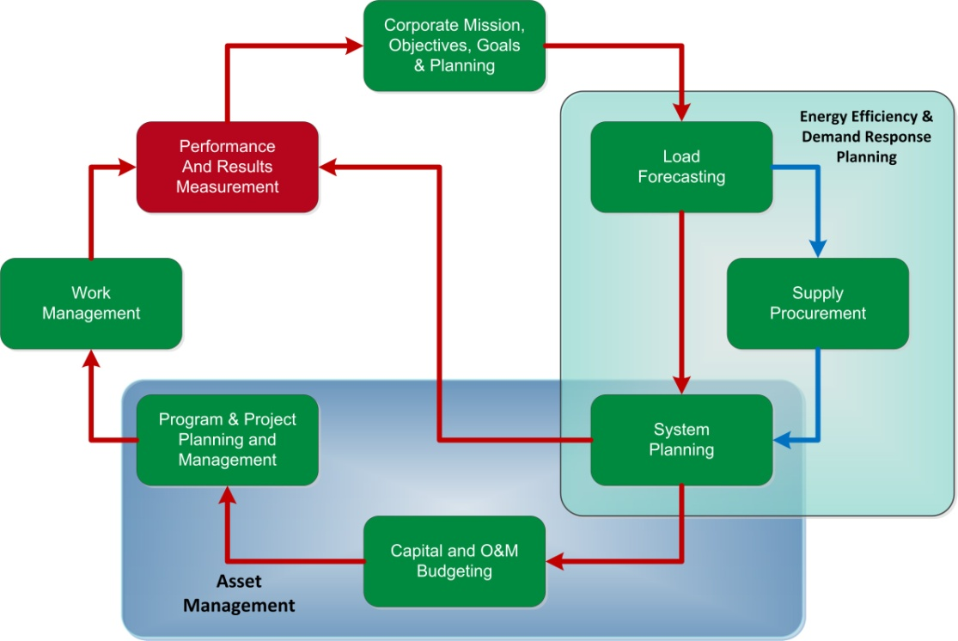
This structured approach includes critical activities meant to evaluate gaps in current operational performance, define key objectives and targeted improvement opportunities, identify and implement improvement initiatives, and institutionalize a formal framework for continuous improvement. This process, as illustrated in Exhibit IV-3, answers the four key questions.
EXHIBIT IV-3
Performance & Results Management
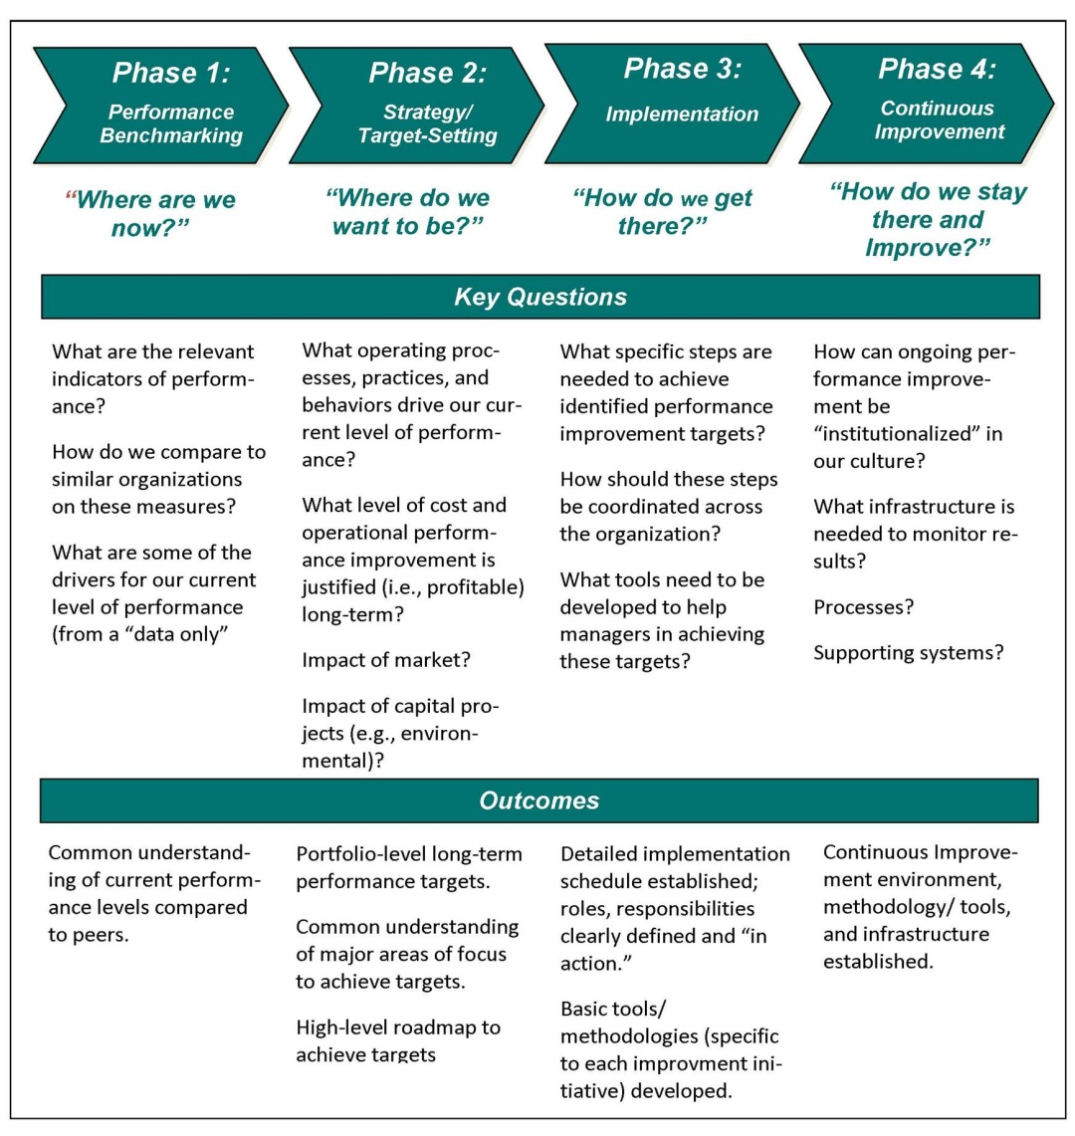

The development of a cascading performance measure blueprint is a key tool for effective performance management. RCG contends that a select few key performance indicators (KPIs) must drive the overall performance of the organization, and all operational and supporting metrics must link back to these KPIs, as shown in Exhibit IV-4.

EXHIBIT IV-4
Illustrative KPI and Metric “Blueprint”
Mission Statement
Strategic Objective 1
Strategic Objective 2
Strategic Objective 3
Strategic Objective 4
Strategic Objective 5
KPI and Target 4.1
KPI and Target 4.2
Annual Target 4.1
Operational Metric 4.1.1
Operational Metric 4.1.2
Operational Metric 4.1.1
Operational Metric 4.1.2
“X Corp is dedicated to exceeding our customers’ expectations in producing and delivering environmentally responsible, safe, low- cost and reliable power”
Exceed Customers’ Expectations
Achieve top quartile ranking on JD Powers Customer Satisfaction survey by 2012
Improve ranking on JD Powers Customer Satisfaction survey by 10 percentile points versus 2010 score
Improve customer service portion of JD Powers customer satisfaction survey results by 20 points
Achieve Average Speed of Answer (ASA) of 5 seconds or less
(Roles, Responsibilities, Resources, Milestones, etc.)
Initiatives
Initiatives
One of the most important aspects of results measurement is the linkage between results and personal performance objectives. Targets for personal performance objectives must be realistic and attainable, and they must be in alignment with the corporation’s challenges. NFG’s management personnel should have a clear understanding of how corporate objectives and KPIs relate to their personal performance objectives. RCG would expect to see NFG have corporate and business unit objectives with targets and metrics in all areas, for example: earnings per share; free cash flow; safety (e.g., no more than X incident rate); recruitment (e.g., hiring X percent of planned vital hires); leak management targets for type 1, 2 and 3 leaks; transmission reliability; and customer service (e.g., speed of answer of X seconds).

Commission Evaluation Criteria:
The DPS has clearly defined the critical criteria by which the consultant is to evaluate the Company. RCG embraces the following RFP evaluation criteria as the principal areas of investigation and the foundation for this element’s chapter in the final report.

  - What are the processes for feedback of performance (reliability, productivity, etc.) to the corporate mission, objectives, and goals for the purpose of improving processes, redirecting resources, and changing priorities?
  - What is the role and responsibility of the Board of Directors in this feedback loop?
  - What is management accountability for performance improvements (e.g., cost savings and productivity gains anticipated from specific capital and O&M programs and projects) and specific corporate goals?
  - What goals, key performance indicators, and metrics are applied to the Company?
  - Is there benchmarking for identifying and developing performance targets?
  - How are change management and continuous improvement processes applied to the performance process? How are any impediments that might constrain performance improvements and necessary changes dealt with?
  - What are the compensation and performance metrics?
  - Are there any additional performance measures or indicators needed to facilitate the corporate mission, objectives, and goals, including leading indicators, metrics, key performance indicators and other measures that will help improve performance?
Staffing Assignment:
Audit Area Staff Assignment – Performance and
Results Management
Lead Consultant | Mike McGarry
Consultant(s) | Joe DeVirgilio, Donna Mullinax
Total Hours | 176

RCG Subordinate Criteria:
To enhance the RFP criteria, RCG recommends that the following subordinate criteria be included in the work plan adopted for this audit element:
- Are KPIs defined based on purpose, data source, and owner?
- Are goals set based on benchmarking results, competitive analyses, and performance gaps?
- Are the plans developed for functional and business units designed to help close the gaps detected in the gap analyses?
- Is business plan progress tracked on a timely basis (e.g., monthly, quarterly, annually)?
- Are performance targets for employees or business units established with specific metrics and outcomes determined for each target?
- Does management act in a timely manner to ensure that deficiencies and discrepancies are corrected?
- What does the information gleaned from audit work tasks tell us about how this audit element is enhancing or detracting from the effective operation of the construction feedback loop?

Work Tasks:
- Revise Performance and Results Management process tasks and initial data requests based on feedback from DPS Staff review of proposal and the structured Staff input process.
- Review initial data request responses related to the Performance and Results Management. Identify missing data, evaluate quality and completeness, and engage Management as needed.
- Develop initial high-level interviews to clarify and verify understanding of the Performance and Results Management process in NFGDC.
- Develop Performance and Results Management process chapter outline, and next level of interview guides and data requests.
- Coordinate with all audit teams to determine extent of Company coordination and consistency of assumptions, strategies, and execution of Performance and Results Management.
- Review initial related data request items and develop outline and high-level initial interviews to better understand performance and results management processes within the Company.
- Assess linkage of corporate KPIs and performance measurement efforts with the mission, objectives, and goals of the Company and the extent to which the Company’s senior management and board reviews performance results and makes adjustments to strategic objectives, processes, resources, and priorities.
- Determine if employees at all levels understand their performance objectives, and are held accountable for performance results.
- Assess the adequacy, appropriateness, and timeliness of the performance reporting structure and its ability to provide relevant and actionable information across all levels within the Company.
- Evaluate the use of performance and results data to ensure that deficiencies and discrepancies are corrected.
- Determine if there are impediments that tend to constrain performance improvements and necessary changes.
- Determine if additional performance measures or indicators are required to support the corporate mission, objectives, and goals being met.
- Assess if additional appropriate indicators, metrics, or measures will improve performance.
- Determine how the Company and Performance and Results Management assess the success of the Performance and Results Management process.
- Review the KPIs for Performance and Results Management.
- Review how the Company benchmarks the Performance and Results Management process practices and results with industry and other NY State utilities performance.
- Compare the overall Performance and Results Management process to leading practices.
- Complete analysis of the Performance and Results Management including cost implications where possible.
- Verify facts.
- Prepare the Performance and Results Management Task Report.
- Submit the Performance and Results Management Task Report for RCG quality review.
- Prepare a Task Report for this area.

PROJECT TEAM AND RESPONSIBILITIES
This chapter describes the organizational structure, assignments, personnel, and relationships that will support the performance of the RCG audit team and promote high quality audit outcomes.

Introduction
Because of the complexity associated with the NFGDC management audit assignment, RCG has selected a team of highly qualified, senior, industry professionals to identify the issues and capture the opportunities that should be the end product of this assignment. The RCG Engagement Director, Project Manager, and Lead Consultants offer significant direct experience conducting and leading utility management audits as individuals and as teammates.
The successful execution of the Company management audit requires a project team with the unique blend of capabilities that the RCG team has been specifically designed to provide:
- In-depth knowledge of the emerging utility industry, and the experience to identify and address issues that affect the Company’s ability to provide the highest-quality, lowest-cost service to customers;
- Technical and functional expertise and skills acquired while serving as senior managers in the electric and gas industries; and
- Direct experience with utility management audits that combine the skill-sets and knowledge necessary to produce balanced, cost-effective recommendations, along with the industry know-how to assist with implement recommendations.
All RCG team members have been selected specifically for their deep understanding of each of the audit elements that they have been assigned to evaluate; many are performing leading-edge work in that field. Together, the RCG team provides the strongest and most experienced team available at a cost that eliminates the overhead burden associated with larger, equally experienced firms.

B. Organizational Structure
Exhibit V-1 is an organization chart for the RCG team; it shows how each of RCG’s inter-disciplinary team members has been assigned to ensure the successful execution of the NFGDC management audit.
EXHIBIT V-1
RCG Organizational Chart
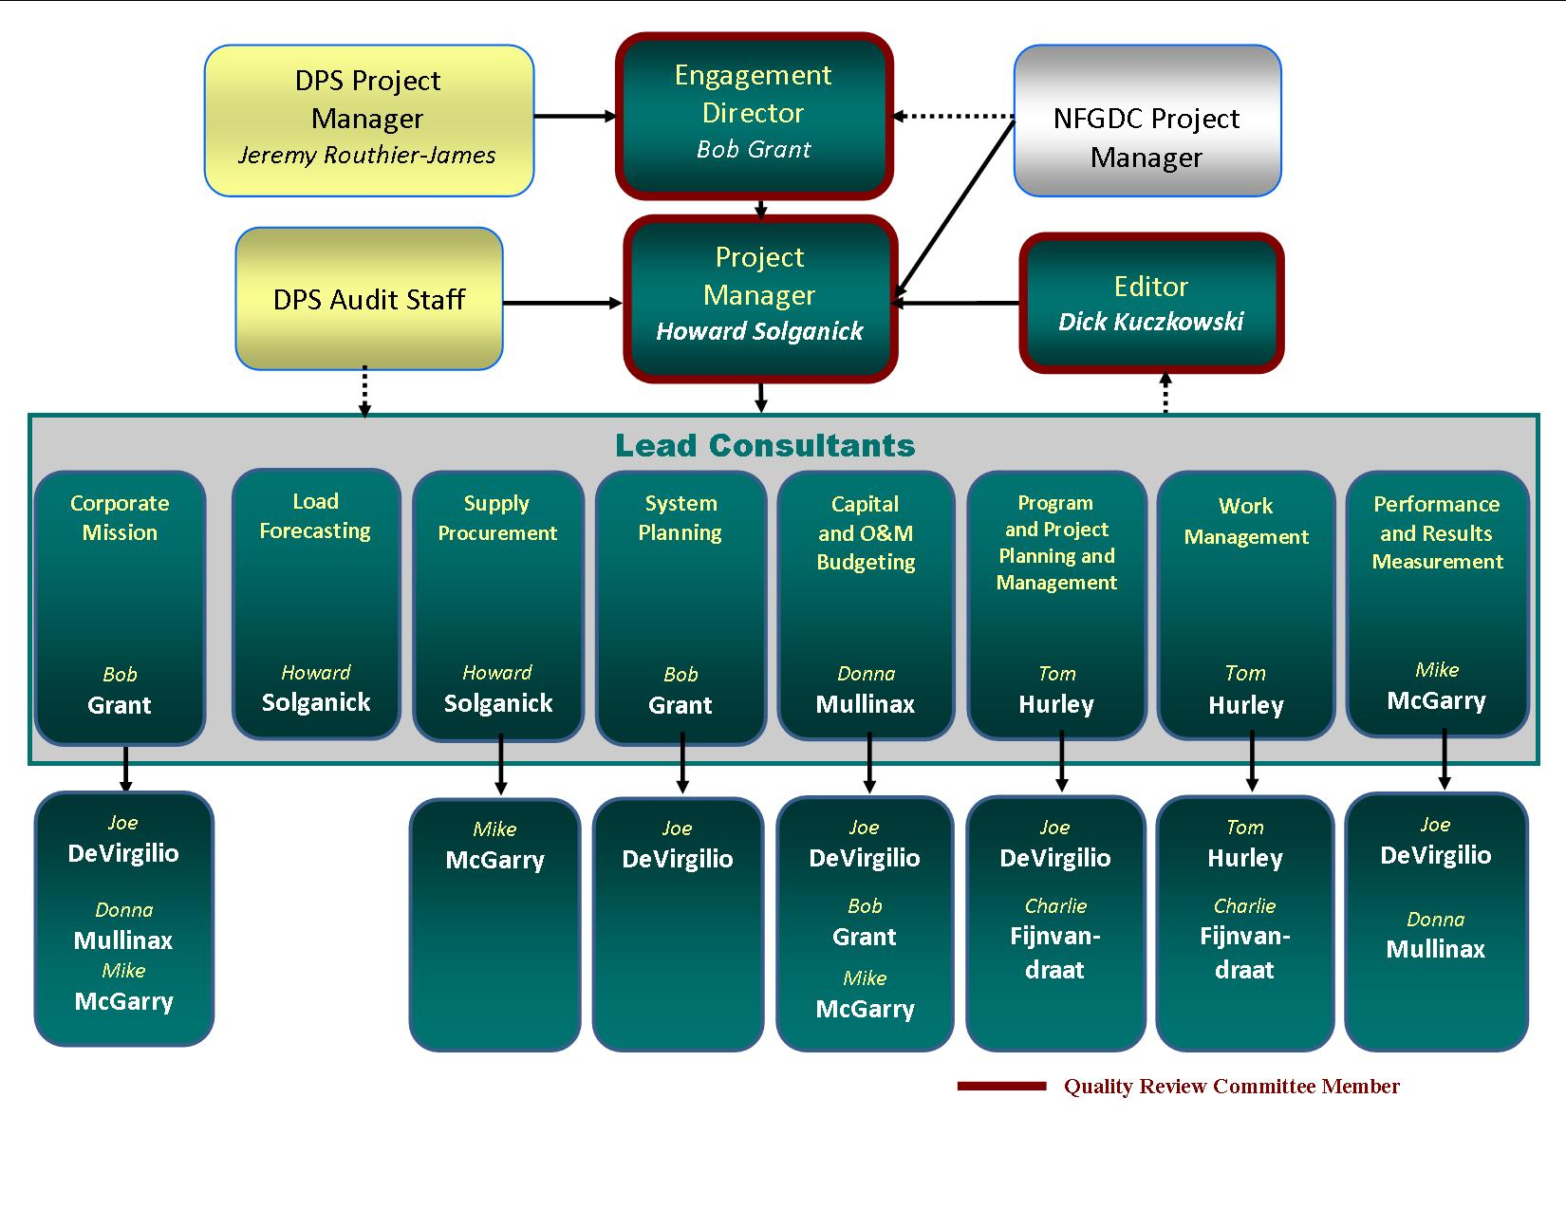
A Quality Review Committee has been assembled and given responsibility for reviewing all work products with the sole objective of verifying the accuracy and appropriateness of conclusions and recommendations that will be produced by team members. The Quality Review Committee and Project Manager are also responsible for ensuring that the construction feedback loops is being carefully evaluated throughout the duration of the audit.
Exhibit V-1 shows that the Engagement Director and the Project Manager will be undertaking lead and supporting consultant roles within some contexts due to their considerable experience in those areas. In particular, Engagement Director Bob Grant will act as Lead Consultant for the Corporate mission, objectives, goals, and planning; and System Planning. Likewise, Project Manager Howard Solganick will act as Lead Consultant for the Load Forecasting and Supply Procurement audit elements.
Another key consultant has been assigned to more than one audit element as a Lead Consultant: Tom Hurley will manage the evaluation of the Program and Project Planning and Management, and the Performance and Results Measurement elements. Donna Mullinax will lead the Capital and O&M budgeting element, while McGarry will lead the Performance & Results Management element. As clearly shown in Exhibit V-1, supporting consultants have been assigned to more than one task area. In all cases, work plan elements will be assigned so that only one Lead Consultant supervises the requesting and reviewing data and/or interviews for that element.

C. Team Member Qualifications
The following paragraphs present summary information on each of the RCG team members assigned to each audit element task area, as reflected in Exhibit V-I above. (Full resumes for team members are presented in Appendix B.) Detailed information on hours allocated to team members in each of the eight audit elements and the final reporting tasks is included in Exhibit VI-2, which appears in Chapter VI.

RCG Audit Managers
Robert M. Grant, president of RCG, will serve as Engagement Director for the RCG audit team. He also has been assigned Lead Consultant responsibility for the Corporate Mission, Objectives, Goals and Planning, and System Planning audit elements, and serves on RCG’s three-person Quality Review Committee for this audit. Over the past two decades, Bob has preformed eight comprehensive management audits of utilities and ten company pre-audits, including two companies that have engaged him for pre-audit services multiple times. He is highly qualified to act in the role of Engagement Director for this audit and will lend his significant experience to all parties throughout the audit effort.
- Bob began his career with Boston Edison (NStar), where he gained valuable insights into utility operations, system planning, marketing, and the complex requirements of T&D assignments. Since leaving Boston Edison, Bob has managed the North American utility practice for two large consulting firms, and has served as an officer and/or senior executive consultant for KEMA, Inc., AT&T Solutions, Stone & Webster, and Booz Allen Hamilton.
Howard Solganick, P.E., principal of Energy Tactics & Services, Inc., has been working in the utility industry for over 35 years. He will serve as Project Manager for this audit assignment as well as Lead Consultant responsible for the Load Forecasting and Supply Procurement elements of the audit scope. During the past decade, Howard has participated as Project Manager or a Lead Consultant in conducting management or regulatory audits in Connecticut, Ohio, and Oregon, and provided pre-audit support in New York and Pennsylvania. He has also been a senior manager, officer, and/or senior management consultant for Atlantic Electric, Cogeneration Partners of America, and AT&T Solutions. His areas of expertise as a utility executive and consultant include: management audits, load forecasting, load research, supply procurement for utilities and industry, rate design and cost allocation, and performance management and process improvement, among others.
Richard Kuczkowski, PhD, Editor and specialist on municipal matters, has 40 years of extensive, multifaceted experience in communications/corporate communications, a very broad range of editorial/writing assignments, training, and consulting in utility industry and environmental/low-level radioactive waste areas. Highlights and significant projects include: technical writing in medical research and other areas, many reports for utilities, and articles for Public Utilities Fortnightly; business seminar and continuing professional education program development in product tampering, utility issues, R&D management, and development and overall management of Stone & Webster’s 3-week Utility Management Development Program for promising utility managers; safety analysis reports, health physics reports, environmental impact statements, etc.; CEO speeches and reports on storm restoration and 9/11 terrorist recovery for New York City’s Metropolitan Transportation Authority, as well as public reports on a range of metropolitan transportation and related issues. He was most recently Associate Chief, Editorial Services at New York City's Metropolitan Transportation Authority, and has been Assistant Vice President at Stone & Webster Management Consultants, and Senior Project Administrator for Dames & Moore. He has spoken on utility issues at North East Power Association’s Certificate Program, Iowa Utility Association Management Conference, training programs for General Electric’s and IBM’s utility practice staffs, the World Energy Council’s Regional Forum in Romania, and in a video produced to guide utilities in their preparations for management audits. He holds a PhD (with Distinction) and MA (with High Honors) in English from Columbia University, and BA (Summa Cum Laude in Cursu Honorum) in English from Fordham University, and is a member of Phi Beta Kappa.

RCG Lead Consultants
In addition to Bob Grant and Howard Solganick, whose Lead Consultant roles are described above, the following professionals have been selected to lead teams charged with the evaluation of each of the eight audit elements.
Thomas Hurley is proposed for the role of Lead Consultant for both the Program and Project Planning and Management, and Work Management audit elements. Tom has over 25 years of consulting and management experience with a range of domestic and international utility companies and has completed many assignments as part of an RCG team. His areas of expertise include program and project management, business planning, performance metrics and measurement, organizational and process design, customer care, supply chain management, operational and process improvement, and outsourcing strategy and implementation support.
Michael J. McGarry, Sr., proposed lead consultant for Performance & Results Management audit element, is President and Chief Executive Officer of Blue Ridge Consulting Services, Inc. (Blue Ridge) and has been working in the utility industry for over thirty years within the private and public sectors. He has been a project manager of numerous rate case and management audit reviews for commissions and public advocates in addition to testifying in a number of jurisdictions. Mr. McGarry has conducted over 25 management audits, including both operational audits and prudency reviews. Topics of these include affiliate transactions, performance review, fuel procurement and hedging, environmental compliance strategy, customer service and others His regulatory auditing and affairs experience includes managing rate case audits and managing rate cases for commissions, attorney general offices, and consumer advocates.
Donna H. Mullinax, CPA, CIA, CFP, proposed lead consultant for Capital and O&M Budgeting, is Vice President and Chief Financial Officer of Blue Ridge and has over thirty-one years of financial, management, and consulting experience. She has extensive experience in financial and management audits, affiliate transactions, and systems implementation; regulatory and litigation support; financial, administrative, and project management.
Mrs. Mullinax is a recognized financial and management auditor. She has performed numerous financial and compliance audits for governmental entities, businesses, and public utilities. She has also conducted several detailed revenue requirements filing audits. She has analyzed financial information and budget projections, performed risk identification, and evaluated industry benchmarking. Her extensive professional experience allows her to effectively analyze and evaluate methods and procedures and to thoroughly document her findings. She has successfully testified to her audit findings.

RCG Supporting Consultants
Joseph J. DeVirgilio, Jr., P.E. recently retired as a senior utility executive with CH Energy a New York State public utility after a career in the utility industry that spanned 37 years. Because of his instate knowledge and wide experience in a variety of executive positions, Joe has been recruited to support a number of audit teams, including: Corporate Mission, Objectives, Goals and Planning; Capital and O&M Budgeting; Program and Project Planning and Management; and Performance and Results Measurement. He has been responsible for preparation, management and response to several focused management audits ordered by the NY Commission, and has extensive experience with the operation of both gas T&D and unregulated energy assets.
Charlie Fijnvandraat, P.E., proposed senior consultant, has been working in the utility industry for over 25 years as an engineer, supervisor, and consultant; he also served two utilities (Northeast Utilities and NSTAR) in these roles. His management consulting experience includes work with SCE, PacifiCorp, AEP, Con Edison, Exelon, Entergy, PPL, and others. His direct T&D management experience (further detailed in Appendix B) includes consulting experience as well as direct electric utility management in both operations and engineering including maintenance, project management, performance, planning, design, and FERC/NERC reliability compliance. He has also been involved in over 50 emergency events, including leading field crews in storm restoration efforts and various back office-support roles. As a consultant, he has assisted clients to optimize restoration processes, rank T&D budgets, create reliability standards and metrics, and increase field force utilization and performance. Recent consulting engagements involve supporting regulatory reviews of capital trackers for natural gas utilities, leveraging his experience of the planning process, scheduling, and measuring the efficiency of field operations in removing/replacing underground assets.
Exhibit V-2 provides a list of key team members and the management audit assignments they have participated in together with other members of the RCG team.
EXHIBIT V-2
Audit Assignments Shared by Key Team Members
 | Proposed Project Consultants
Project | Grant | Solganick | Hurley | McGarry | DeVirgilio | Mullinax | Fijnvandraat
CNP Post Ike Restoration Audit | ED | PM
CH Energy Audit Prep | ED | PM |  |  | PC
CL&P Management Audit |  | LC |  | PM |  | APM/LC
NW Natural Gas Affiliate Transaction |  | LC |  | PM |  | APM/LC
Utility Emergency Prep. Conferences | LC |  |  |  |  |  | LC
Ameren Emergency Restoration Audit | ED | LC
CPS of San Antonio ERP Build | ED |  |  |  | LC
Northern Utilities Cast Iron Replacement |  | TR |  | PM
Duke Energy - Rate Case Audit |  | LC |  | PM |  | APM/LC
Columbia Gas- Rate Case Audit |  | LC |  | PM |  | APM/LC
PSE Emergency Restoration Audit | ED | LC
ENCO Customer Service Review | ED |  | PM
Hydro Quebec Call Center Optimization | ED | PM | LC
Rate Cases / Fuel Adj. Clause Reviews |  | LC & TW |  | PM & TW |  | APM/LC/TW
Projects over 10 years old | ♦ | ♦ | ♦ | ♦
Customer Retention | ED | LC | PM
Organization Redesign | PM | PC | LC
Customer System Review Project | PM | PC | LC
Regulatory Project |  | TR |  | LC
Generation, Energy, Fuel Mgt. & Procurement |  | TR |  | C
Legend: C- Consultant, ED – Engagement Director, LC – Lead Consultant, PC - Principal Client, PM – Project Manager, TW – Testifying Witness, TR – Technical Resource, APM – Assistant PM

SCHEDULES AND BUDGETS
This chapter provides a schedule for implementation and completion of the NFGDC management audit. It also discusses the factors that support and facilitate RCG’s proposed not-to-exceed cost for completing the management audit in conformance with the requirements outlined in the RFP.

Introduction
In addition to providing a first-class team of highly effective consulting professionals, RCG is proud of its reputation for completing projects on schedule and within budget. The company consistently completes its assignments ahead of the client’s requested schedule, and is absolutely confident that it has assembled a team with the appropriate expertise and experience to perform the highest quality job possible in the time frame allotted by the Commission. The DPS Staff can rely on the same competent delivery standards that RCG routinely provides to clients.
RCG is also pleased that it can provide the unique and comprehensive level of expertise embodied in its proposed audit team to this management audit at a not-to-exceed price that is highly competitive. In so doing, RCG can deliver real benefits to the Company’s customers by producing what RCG contends will be extremely high-quality recommendations at the lowest reasonable cost.

Schedule
The anticipated start date for this management audit is June 2012 based on information contained in the RFP. RCG’s proposed schedule is to deliver the requested draft work plan in June 2012, and the draft and final reports to the DPS Staff in February 2013 and June 2013. In order to achieve an efficient transfer of information between audit stakeholders and the RCG team, a staggered schedule for the commencement of audit activities for each of the eight audit elements is strongly recommended.
By adopting the recommended staggered approach, RCG is able to achieve its information- transfer goals while at the same time providing the DPS Staff with adequate time to digest and discuss RCG’s observations thoroughly. This approach also minimizes any disruptions that may accompany the audit work relative to the Company and its normal operations.
Exhibit VI-1 provides RCG’s initial, recommended schedule for the completion of a comprehensive management audit that conforms to the DPS Staff’s overall schedule objectives, as set forth in the RFP.

Exhibit Vl-1 Proposed Schedule
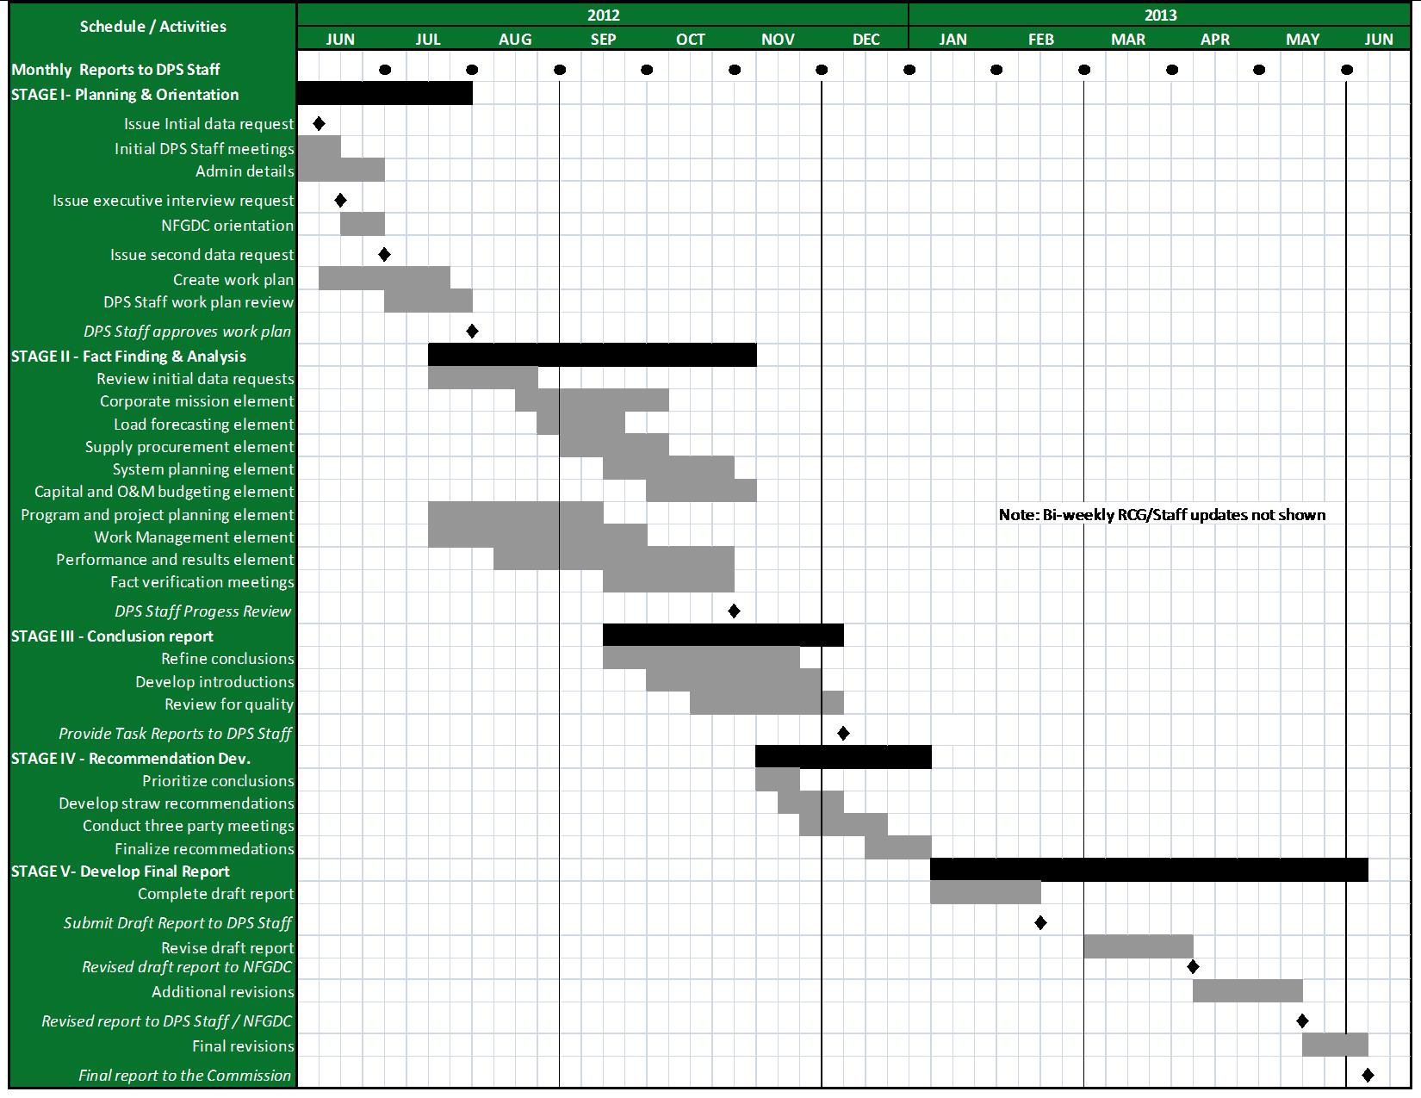

The schedule presented in Exhibit VI-1 is intended to provide the DPS Staff with a comprehensive overview of RCG’s proposed approach and does not contain the increased level of detail that will accompany the audit work schedules produced for this project.

Budget
RCG’s proposed not-to-exceed cost for performing a comprehensive management audit of NFGDC management and operations is $678,391. This price includes professional fees of $602,700 and expenses totaling $75,691 that are associated with performing the assignment and creating the deliverables described in Chapters III and IV. Details of RCG’s proposed project budget, including estimated hours assigned to each consultant by task, are provided in Exhibit VI-2.
The costs for printing and delivery associated with all draft audit reports, and the printing the required number of hardcopies of the final audit report, are included in our price.
In preparing the proposed budget, RCG has made every effort to develop reasonable travel cost estimates recognizing that airline fees are subject to wide swings over a period as long as the one prescribed for the NFGDC audit. All communications, mailing, copying, and miscellaneous expenses have been budgeted at their estimated costs, and will be invoiced with appropriate documentation.
Generally, we expect RCG team members to conduct all initial interviews in person to facilitate the greatest transfer of information possible while allowing RCG to observe the Company’s operations first-hand.
Costs associated with the preparation and presentation of testimony, or any additional post-audit meetings requested by the DPS Staff or the Commission, will be billed at the individual hourly rates provided in Exhibit VI-2. RCG’s fees are based on standard hourly rates associated with assignments of this type despite the very high level of professional experience that will be provided by the RCG team members. The travel, lodging, and other expenses are estimated but will be billed at their direct cost.
Details of RCG’s proposed project expenses are provided in Exhibit VI-2.

EXHIBIT VI-2
RCG’s Project Hours, Fees and Expenses
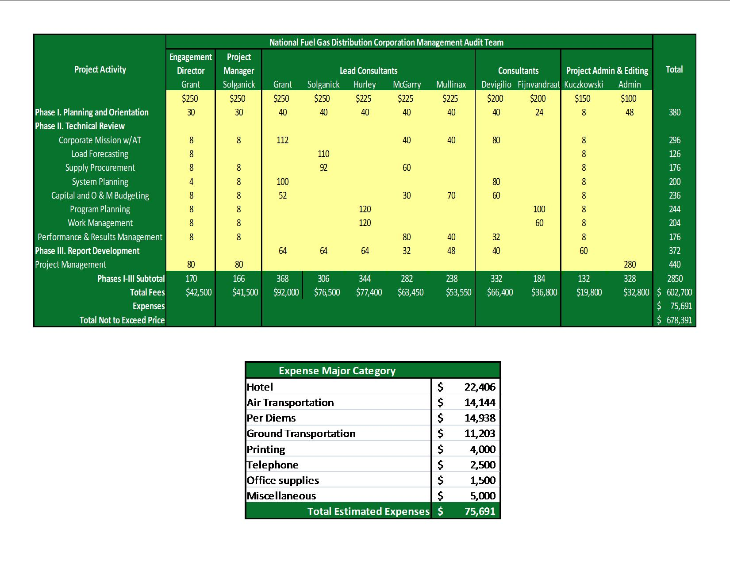

Invoices
RCG’s policy is to invoice monthly for services and expenses rendered during the previous month, and invoices are due within 20 calendar days of delivery. Invoices will include professional fees for hours worked, and expenses that have actually been incurred by RCG and its team members. These fees and expenses will not exceed the limits shown in Exhibit VI-2.
Invoices will include backup information, as set forth below:
- Expenses for personnel will be presented in a report that lists those expenses and hours by audit element or another major category, such as project management or editor work;

- Personal mileage to/from home and audit work sites, or to/from home and local airports, will be charged at the rate allowed by the Internal Revenue Service; and

- Copies of all receipts for expenses that exceed $25.

EXPERIENCE AND QUALIFICATIONS
This chapter introduces RCG and its team partners. We begin with thumbnail introductions of individual team members through summaries highlighting their capabilities and experience relevant to the tasks for which they are proposed. (Fully detailed resumes of all individual team members are found in Appendix B.) Information on individual team members is followed by descriptions of the capabilities and experience of the firms partnering to offer their services on this assignment: River Consulting Group, Blue Ridge Consulting Services, Inc., and Energy Tactics & Services, Inc; this material includes summaries of engagements relevant to and consistent with the scope of work presented in the RFP, and client reference information.

Introduction
The RCG team is no ordinary team of management auditors. Because the overall quality of audit results is inextricably tied to the overall quality of the auditors assigned to the team, RCG has specifically recruited and selected team members who are widely known for their expertise and understanding of the areas that they will be assigned to evaluate.
All RCG team members have been guiding utility and regulatory management through the rapidly evolving markets and environment of the modern U.S. utility industry for many years. As a result, the RCG team brings proven and unprecedented skill sets to this audit that align specifically with the audit element areas defined in the RFP. In fact, many RCG team members are performing leading-edge work in their specific specialties. RCG’s role is to provide its extensive experience in the performance of management audits to the team, the Company, and DPS Staff in order to cost-effectively capture all the benefits that can be gleaned from such an experienced team of professionals.

Experience and Qualifications of Individual Consultants
RCG strives to produce the highest quality work product possible, one that accurately and concisely reflects the Company’s current work environment, and provides clear direction for moving forward. Management audits, in general, and this audit in particular, are extremely complex with many interrelated and evolving parts. Managing an engagement of the magnitude of the NFGDC audit takes a highly-experienced Engagement Director, Project Manager, and Lead Consultants, all of whom share a strong record of delivering quality, complex projects on schedule and on budget to the satisfaction of the client.
RCG’s team has been specifically structured to meet the requirements of this audit in a manner that embraces audit goals for an evaluation of the eight audit elements identified in the RFP. This team is made up of firms and individuals that are highly qualified to achieve the outcomes set forth in this proposal and possess the knowledge and tools required to support a superior outcome.
A summary of the experience and qualifications of all proposed consultants, including the specific areas to which each will be assigned, is provided below in alphabetical order as a quick overview. Detailed professional résumés are provided for each RCG team member in Appendix B.
- Robert M. Grant, president of RCG, will serve as Engagement Director for the RCG audit team. He also has been assigned Lead Consultant responsibility for the Corporate Mission, Objectives, Goals and Planning, and System Planning audit elements, and serves on RCG’s three-person Quality Review Committee for this audit. Over the past two decades, Bob has preformed eight comprehensive management audits of utilities and ten company pre-audits, including two companies that have engaged him for pre-audit services multiple times. He is highly qualified to act in the role of Engagement Director for this audit and will lend his significant experience to all parties throughout the audit effort.
Bob began his career with Boston Edison (NStar), where he gained valuable insights into utility operations, system planning, marketing, and the complex requirements of T&D assignments. Since leaving Boston Edison, Bob has managed the North American utility practice for two large consulting firms, and has served as an officer and/or senior executive consultant for KEMA, Inc., AT&T Solutions, Stone & Webster, and Booz Allen Hamilton.
- Howard Solganick, P.E., principal of Energy Tactics & Services, Inc., has been working in the utility industry for over 35 years. He will serve as Project Manager for this audit assignment as well as Lead Consultant responsible for the Load Forecasting and Supply Procurement elements of the audit scope. During the past decade, Howard has participated as Project Manager or a Lead Consultant in conducting management or regulatory audits in Connecticut, Ohio, and Oregon, and provided pre-audit support in New York and Pennsylvania. He has also been a senior manager, officer, and/or senior management consultant for Atlantic Electric, Cogeneration Partners of America, and AT&T Solutions. His areas of expertise as a utility executive and consultant include: management audits, load forecasting, load research, supply procurement for utilities and industry, rate design and cost allocation, and performance management and process improvement, among others.
- Richard Kuczkowski, PhD, proposed Editor and specialist on municipal matters, has 40 years of extensive, multifaceted experience in communications/corporate communications, a very broad range of editorial/writing assignments, training, and consulting in utility industry and environmental/low-level radioactive waste areas. Highlights and significant projects include: technical writing in medical research and other areas, many reports for utilities, and articles for Public Utilities Fortnightly; business seminar and continuing professional education program development in product tampering, utility issues, R&D management, and development and overall management of Stone & Webster’s 3-week Utility Management Development Program for promising utility managers; safety analysis reports, health physics reports, environmental impact statements, etc.; CEO speeches and reports on storm restoration and 9/11 terrorist recovery for New York City’s Metropolitan Transportation Authority, as well as public reports on a range of metropolitan transportation and related issues. He was most recently Associate Chief, Editorial Services at New York City's Metropolitan Transportation Authority, and has been Assistant Vice President at Stone & Webster Management Consultants, and Senior Project Administrator for Dames & Moore. He has spoken on utility issues at North East Power Association’s Certificate Program, Iowa Utility Association Management Conference, training programs for General Electric’s and IBM’s utility practice staffs, the World Energy Council’s Regional Forum in Romania, and in a video produced to guide utilities in their preparations for management audits. He holds a PhD (with Distinction) and MA (with High Honors) in English from Columbia University, and BA (Summa Cum Laude in Cursu Honorum) in English from Fordham University, and is a member of Phi Beta Kappa.
- Thomas Hurley, Senior associate, is proposed for the role of Lead Consultant for both the Program and Project Planning and Management, and Work Management audit elements. Tom has over 25 years of consulting and management experience with a range of domestic and international utility companies and has completed many assignments as part of an RCG team. His areas of expertise include program and project management, business planning, performance metrics and measurement, organizational and process design, customer care, supply chain management, operational and process improvement, and outsourcing strategy and implementation support.
- Michael J. McGarry, Sr., proposed lead consultant for Performance & Results Management audit element, is President and Chief Executive Officer of Blue Ridge Consulting Services, Inc. (Blue Ridge) and has been working in the utility industry for over thirty years within the private and public sectors. He has been a project manager of numerous rate case and management audit reviews for commissions and public advocates in addition to testifying in a number of jurisdictions. Mr. McGarry has conducted over 25 management audits, including both operational audits and prudency reviews. Topics of these include affiliate transactions, performance review, fuel procurement and hedging, environmental compliance strategy, customer service and others His regulatory auditing and affairs experience includes managing rate case audits and managing rate cases for commissions, attorney general offices, and consumer advocates.
- Donna H. Mullinax, CPA, CIA, CFP, proposed lead consultant for Capital and O&M Budgeting, is Vice President and Chief Financial Officer of Blue Ridge and has over thirty-one years of financial, management, and consulting experience. She has extensive experience in financial and management audits, affiliate transactions, and systems implementation; regulatory and litigation support; financial, administrative, and project management.
Mrs. Mullinax is a recognized financial and management auditor. She has performed numerous financial and compliance audits for governmental entities, businesses, and public utilities. She has also conducted several detailed revenue requirements filing audits. She has analyzed financial information and budget projections, performed risk identification, and evaluated industry benchmarking. Her extensive professional experience allows her to effectively analyze and evaluate methods and procedures and to thoroughly document her findings. She has successfully testified to her audit findings.
- Joseph J. DeVirgilio, Jr., P.E. recently retired as a senior utility executive with CH Energy a New York State public utility after a career in the utility industry that spanned 37 years. Because of his instate knowledge and wide experience in a variety of executive positions, Joe has been recruited to support a number of audit teams, including: Corporate Mission, Objectives, Goals and Planning; Capital and O&M Budgeting; Program and Project Planning and Management; and Performance and Results Measurement. He has been responsible for preparation, management and response to several focused management audits ordered by the NY Commission, and has extensive experience with the operation of both gas T&D and unregulated energy assets.
- Charlie Fijnvandraat, P.E., proposed senior consultant, has been working in the utility industry for over 25 years as an engineer, supervisor, and consultant; he also served two utilities (Northeast Utilities and NSTAR) in these roles. His management consulting experience includes work with SCE, PacifiCorp, AEP, Con Edison, Exelon, Entergy, PPL, and others. His direct T&D management experience (further detailed in Appendix B) includes consulting experience as well as direct electric utility management in both operations and engineering including maintenance, project management, performance, planning, design, and FERC/NERC reliability compliance. He has also been involved in over 50 emergency events, including leading field crews in storm restoration efforts and various back office-support roles. As a consultant, he has assisted clients to optimize restoration processes, rank T&D budgets, create reliability standards and metrics, and increase field force utilization and performance. Recent consulting engagements involve supporting regulatory reviews of capital trackers for natural gas utilities, leveraging his experience of the planning process, scheduling, and measuring the efficiency of field operations in removing/replacing underground assets.

Experience and Qualifications of the Partner Firms
As discussed earlier in Chapter V, RCG has assembled a world-class set of partners who are dedicated to delivering a high-quality product that will encourage NFGDC to better position itself for the future and for the benefit of the Company’s New York customers. RCG’s team of professional consulting firms is pleased to be able to collaborate once again – this time to meet the objectives of the NFGDC management audit RFP, and those of the Commission and DPS Staff on behalf of the consumers.
RCG team firms are also proud of their independent and collective reputations for professionalism and excellence, and on our joint and practiced ability to deliver on the promises we make to our clients. A description of each of the three partner firms, and our combined statement of conflict and ethical conduct, are presented below.

River Consulting Group, Inc.
RCG’s principals assist electric, gas and water companies to address the challenges of operating a utility business in today’s competitive environment. Our principals cover a broad spectrum that ranges from strategic planning to tactical operations with a clear focus on preparing for tomorrow. Over the years, RCG principals have helped clients identify and eliminate waste in their organizations, and prepare for the future by taking advantage of technological enhancements to their physical T&D systems and IT solutions. Recent work preparing a storm restoration analysis has aided both the utilities and their regulators to better understand emergency restoration planning and execution during major system outage events.
The company, incorporated in the State of Georgia, was founded in 1999 by the firm’s principal consultant, Bob Grant. Since that time, RCG has provided a broad range of consulting services to over 100 utilities, commissions, and municipal utilities. RCG’s consultants have combined work experience of over a century assisting regulated electric utilities, and state and municipal government agencies to better understand the complexities of the changing utility landscape and capture the efficiencies that allow our utility clients to remain competitive. Today, RCG focuses primarily on:
- Management Audits - Comprehensive audits of electric and water utilities designed to improve the overall operational efficiency and effectiveness of the business. These evaluations included in-depth reviews of areas such as executive management, financial management, customer services, engineering, system planning, construction, T&D operations, and supply chain and support services.
- Work Force Management- Designed to improve the effectiveness, safety and efficiency of the work force, RCG’s approach looks not only at supervisory tools, policies, processes, performance reporting, training, and systems to identify cost reductions, but also at the impact of new technology on how the crafts perform their routine and diagnostic work.

- Planning and Design – RCG is guiding companies through a process of streamlining their planning process -- the core of a successful capital program -- by ensuring that the right business functions are integrated into the process at an early enough stage to accurately plan and control costs. We also work to help our clients enhance the prioritization process to allow all projects an equal and fair level of attention during the selection process. We are also promoting the use of equipment and construction standards to facilitate improved cost control, scheduling, and construction.

- Construction Management - RCG identifies proven methods for controlling construction costs and schedules through a series of tools that include incentivized contracting, enhanced project management, focused supervision, and sound industrial engineering practices designed to identify and eliminate waste.

- Supply Chain Management – RCG helps clients lower inventory costs while improving material availability. Our supplier valuation services (SVS) helps clients control costs on major equipment purchases while addressing quality control issues throughout the suppliers value chain.

- Operations Management – Aside from the traditional operating improvement activities embraced by many utilities, RCG focuses on helping clients to understand and plan for the impacts of new technology on their T&D systems and resource requirements.
Representative RCG engagements include:
- Centerpoint Energy (CNP) – Led an in-depth review of CNP’s post-Ike restoration activities. As a result of our review, we made a number of recommendations to improve emergency restoration planning and processes. While the Company did an outstanding job of restoring 1.9-million of its 2.1-million customer outages in 18 days, there were a number of suggestions that could aid the restoration process. In addition, the RCG team evaluated CNP’s distribution design and maintenance practices to confirm they complied with generally accepted industry practices. Our team prepared formal testimony that was included in a commission hearing. Neither our report nor our testimony was challenged.
- AmerenUE/Missouri Commission – Ameren experienced major back-to-back wind events that required the utility to pursue restoration activities. As a result of an RCG review, we made a number of recommendations to improve emergency restoration planning and processes. The RCG team also evaluated Ameren’s distribution design and maintenance practices to confirm they complied with generally accepted industry practices. As part of this review, the Missouri commission’s staff participated in an ongoing progress review of the project and commended the work of the RCG team. After the final report was submitted to the commission and its staff, RCG provided an oral review of the conclusions and recommendations to the commissioners and answered questions.
- Bonneville Power Administration (BPA) – RCG led an in-depth review of BPA’s transmission plan-design-build process. The net result was a $47-million reduction in overall costs. It led to the formation of a standards group and the complete redesign of BPA’s planning function. Further, the engineering function was redesigned to produce higher quality designs using more standard equipment and designs.
- For a major Midwestern combination utility – RCG led an evaluation of a major utility’s $800-million environmental generation construction program at six of its coal-fired plants. After an extensive review of practices, RCG made a number of recommendations (fully agreed to and adopted by management) that, when taken together, produced a savings of $81-million. Recommendations included enhanced contracting tools, focused project management with strong feedback processes, enhanced supervision, and the application of industrial engineering techniques to eliminate waste and improve safety.
Management audits conducted by RCG principals include:
- Bermuda Electric Light Company, Ltd. - Confidential
- Public Utility District No. 1 of Chelan County - Confidential
- Groton Department of Public Utilities - Confidential
- Electricity Authority of Cypress - Confidential
- Central Electric Generating Board, Great Britain - Confidential
- Louisville Gas & Electric Company - Public
- Orange & Rockland Utilities – Public
- Kansas –Nebraska Natural Gas – Confidential

Blue Ridge Consulting Services, Inc.
Blue Ridge Consulting Services, Inc. provides utility regulatory and management consulting services to regulatory commissions, attorney generals, consumer advocacy groups, and other interested stakeholders. The company focuses its efforts in utility management, operational, and rate case audits; utility regulatory affairs support; and utility rate case analyses.
Blue Ridge is dedicated to providing exceptional value-added services using a cost-effective and a straightforward approach. Blue Ridge provides independent objective assessments, developing defendable positions that are supported by the facts and verifiable and acceptable industry analysis.
Blue Ridge's regulatory experience covers a wide range of auditing and rate case functions; a sampling is included below:
- Management, Operational, and Rate Case Audits - Blue Ridge provides its clients with a full range of management and operational audit services. These audits are rigorous and comprehensive as defined by the client. In addition, Blue Ridge is well versed in rate cases with the skills to conduct thorough, detailed examinations of a utility's rate case filings to ensure an accurate and fully supported filing.
Today's resource-constrained environment may require the use of independent auditors to determine the effectiveness and efficiency of a utility's management and operations, especially in relation to compliance directives. Commissions and interested stakeholders sometimes have difficulty obtaining answers to questions that would assist them in fully understanding the underlying information, analyses, assumptions, and management and operating practices that are affecting utility costs.
Blue Ridge’s expertise covers most management and operational aspects of a utility including: Corporate mission and organization, strategic planning, affiliate transactions (potentially including cost allocation, customer service, financial systems, human resources, information management, supply chain management, capital program planning, and implementation). In addition, Blue Ridge auditors have audited transmission and distribution operations and maintenance, internal controls, risk management, ethics, and workforce management. As part of its regulatory experience, Blue Ridge has audited fuel procurement, power supply and purchased gas adjustments, power and natural gas hedging and energy trading.
- Regulatory Affairs Support - Blue Ridge's expertise in utility regulatory affairs includes many of the ongoing and current issues affecting electric, gas, and water utilities, as well as the regulators and interested stakeholders that oversee the utilities.

Blue Ridge offers a broad range of cost-effective solutions such as:
Providing expert consulting services, research, and analyses on current regulatory issues with regulatory agencies, their staffs, and intervenors. Recent assignments have addressed the following issues:
      - Renewable energy,
      - Energy conservation,
      - Recovery mechanisms,
      - Integrated Resource Planning,
      - Natural gas distribution main infrastructure, and
      - Power supply contract reviews.

Additionally, Blue Ridge provides strategic and analytical support to clients' attorneys in regulatory proceedings; assistance to clients with developing regulatory strategies to comply with federal, state, and local jurisdictional mandates and initiatives; and with managing the information and document request process including status and compliance reporting.

- Rate Case Expertise – Clients choose Blue Ridge to provide expert analyses and recommendations regarding utility rate requests. When called upon, Blue Ridge will defend its analyses and recommendations in expert testimony before regulatory commissions. Blue Ridge and its team of subject-matter experts have proffered expert witness testimony pertaining to many utility-related subject matters, including:
      - Affiliate transactions and cost allocation,
      - Revenue requirements,
      - Shared services costs,
      - Net operating income and rate base pro forma adjustments,
      - Depreciation,
      - Cost of service and rate design,
      - Power supply and gas cost recovery factors,
      - Cost of capital and return on equity,
      - Rate design and tariffs,
      - Rate decoupling, and
      - Power and natural gas hedging and energy trading.

Blue Ridge does support all aspects of a regulatory or rate case proceeding, including:
      - Developing or evaluating revenue requirements and rate base models;
      - Providing a custom revenue requirements model that allows the client to see results from what-if scenarios;
      - Evaluating cost of service analyses/studies and issues;
      - Reviewing rate design and tariffs;
      - Preparing technical analyses for submission to the regulatory agencies and intervening parties;
      - Providing project management and analytical subject-matter expertise to respond to data requests;
      - Providing defendable expert witness testimony and exhibits;
      - Assist client's attorneys with cross examination of other positions; and
      - Using a relational database and secure web-based document repository as tools to administer and manage the data request process effectively.

Energy Tactics & Services, Inc.
Energy Tactics & Services, Inc. (ET&S) has been supporting its regulatory commission, utility clients, and their customers since 1994. ET&S’s clients span the gamut of the utility industry, including electric, gas, water, sewer, and thermal energy. By serving a range of industry sectors, ET&S has been able to assist its clients to understand the positions, wants, and needs of the other parties engaged in regulatory processes, contract negotiations or operational situations that have an impact upon their interests. It is ET&S’s philosophy that our primary goal should be to pursue the repeat business that is generated by satisfied clients. Our ability to meet that objective is represented by the fact that over 80% of ET&S’ work now originates from past clients or referrals.
Representative ET&S engagements include:
- Central Hudson Energy Pre-Audit Review – ET&S recently assisted RCG with the completion of a pre-audit review for Central Hudson Energy in preparation for their current 2010 management audit.
- Management Audits of Ameren, Puget Sound Energy, and CenterPoint Energy – ET&S recently partnered with RCG’s partner (Then a KEMA) to complete three major, focused audit projects for Ameren, Puget Sound Energy, and CenterPoint Energy. Final recommendations led to the redesign of major emergency processes and plans for all three major electric utilities, and to reports for their respective state commissions.
- Presentation of Expert Testimony – ET&S prepared testimony supporting emergency rate relief for storm damages for CenterPoint Energy and Jamaica Public Service (West Indies). ET&S principal consultant Howard Solganick has also provided testimony for electric, gas, water, sewer, and district heating rate cases for clients that include utilities, commission staff, consumer advocates, municipalities, public entities, and commercial customers. Topics have included load forecasting, load research, capacity planning, construction, emergency restoration, cost allocation, rate design, and other issues.
- Understanding Deregulation – ET&S has led or participated in a number of deregulation proceedings or other related assignments for clients in the financial, petroleum marketing, and other industries.
- Management or Regulatory Audits – ET&S has managed or participated in management or regulatory audits in the states of Connecticut, New Jersey, Ohio, and Oregon, and has provided pre-audit support to utilities located in New Jersey, New York and Pennsylvania.

Conflicts of Interest and Ethical Conduct
RCG does not have a conflict of interest or the appearance of a conflict of interest with respect to performing a management audit of the Company. RCG, its principals, partners, or subcontractors, has not previously performed any work for NFG or its affiliates in the last 15 years, and does not have any existing contracts or agreements with them.
RCG, its principals, partners, or subcontractors have not performed work for other tangential organizations of NFG, such as the Energy Association of New York State during the five-year period preceding the date of this proposal. In addition, RCG, its partners and subcontractors have no contracts with organizations representing the Company’s workforce.
It is the policy of RCG, its partners, and subcontractors to adhere to the highest business, professional, and ethical standards. Further, RCG, its partners, and subcontractors shall not offer any gift, favor, or gratuity of any value, or make any offer of employment to any officer or employee of NFGDC, or to any Commissioner or DPS Staff member either during the audit or within two years following its completion. We understand that violation of this restriction may result in immediate termination of services, and may ban RCG, its principals, partners, or subcontractors from future consideration by the Commission.
Finally, RCG, on behalf of its partners and any subcontractors engaged by it on this project, will enter into a three-party contract (RCG, NFG, and the DPS). RCG, its partners, and subcontractors agree that neither it nor any of its affiliates, or any of its principals ,or employees, will perform any work for NFGDC or its affiliates during the course of the audit, and for two years after completion of the audit, without the written authorization of the Commission.

Sample Audit Work Product
RCG will provide a document entitled CenterPoint Energy Storm Adequacy Review, dated March 25, 2009 (produced under the KEMA banner and submitted as part of Commission testimony in a cost recovery proceeding) as a sample work product,. The work was designed, sold and led by RCG’s proposed Engagement Director Bob Grant. He was responsible for all aspects of the engagement from project planning analyses to report design and presentation. Our proposed Project Manager, Howard Solganick, participated in the review prepared the testimony. Because of the size of this document, however, we are emailing it to the DPS Staff Program Manager under separate cover.
The general format of the report was dictated by KEMA standards. RCG’s standards will meet or exceed those of KEMA. It should also be noted here that Bob Grant worked on the completion of this audit with RCG’s proposed Project Manager Howard Solganick. Both are clearly key members of RCG’s proposed team for the Company audit. As a function of this engagement, Bob developed KEMA’s “no-surprises approach,” which allowed the client to adjust to and collaborate through a series of frank and open discussions during the development of the recommendations. As a result, significant changes were made to the emergency restoration plan and the overall management process.
On behalf of the Connecticut Department of Public Utility Control (Docket 07-07-01), Blue Ridge Consulting Services conducted a diagnostic management audit of Connecticut Light and Power. This audit included all facets of the utility's management and operations including Executive Management, System Operations, Financial Operations, Marketing Operations, Human Resources, Customer Service, External Relations and Support Services. In addition, Blue Ridge provided an in-depth review and analysis of the utility's development and implementation process for CL&P customer information system CustomerCentral (C2). A copy of final report for the management audit is provided with this proposal.

APPENDIX A

INITIAL DATA REQUEST
INITIAL DATA REQUEST

Data Request Number | Data Request Description
 | General Background
1 | Provide list of NFGDC office locations including; headquarters, service centers, control centers, call centers.
2 | Provide all audited financial reports for past five years (2007-2011) NFGC.
3 | Provide listing of the Internal Audit plan and actual audits completed for 2007 through 2011.
4 | Provide External Auditor’s communications for 2007 through 2011.
5 | Provide copies of NFGDC’s work stoppage and business continuity emergency plans (both strategic and tactical).
 | Element No. 1: Corporate Mission, Objectives, Goals & Planning
6 | Provide most recent Strategic Plan for NFGC and NFGDC.
7 | Provide a narrative describing in detail the strategic planning process and committee charter.
8 | Provide strategic plan progress reports and committee minutes for the last three years (2008-2011).
9 | Provide list of the strategic planning committee members.
10 | Provide list of members of the BOD for NFGC and NFGDC including board committee assignments, contact information and capsule resumes.
11 | Provide detailed organization charts for NFGC, NFGDC and all subsidiary companies.
12 | Provide list and description of major NFGDC organizational changes in the since 1/1/2006.
13 | Provide list of key NFGDC executives responsible for operations with contact information and capsule resumes.
14 | Provide list of key NFGC and NFGDC executives with contact information and capsule resumes.
15 | Provide list of key management personnel for NFGDC and its NYS operations with contact information and capsule resumes.
16 | Provide mission and objectives for each department or division NFGDC.
17 | Provide the mission statement for the strategic planning function.
18 | Provide the Key Performance Indicators (KPI) and goals (and results) for the Strategic Planning department/function.
19 | Provide the budget versus actual for the Strategic Planning department/function for the years 2006 through 2011.
20 | Provide a history (manning table) for the NFGDC’s Strategic Planning department/function for 2006 through 2011, if none, NFGC’s.
21 | Provide job descriptions for all employees involved in strategic planning.
22 | Company and affiliate organizational structure (to include NFGC charging business units, if any)
23 | Policy and procedure manuals regarding sharing or allocation of costs (labor and resources) between business unit entities at NFGC
24 | The Company’s time allocation policies, guidelines, procedures and training materials particularly between NFGC and NFGDC
25 | Documentation and accounting records for all transactions in past three years (2008 -2011) where costs were allocated between business unit entities, This includes payroll records
26 | Regulatory filings related to affiliate transaction cost allocation policy and methods
27 | Internal audit reports and annual audit plans
28 | SOX documentation of the processes by which expenses associated with affiliate transactions are identified, accumulated, and assigned
 | Element No. 2: Load Forecasting
29 | Provide a narrative that describes the gas supply and peak day forecasting process and any changes made since 1/1/2006. Include process flow diagrams and organizations involved.
30 | Provide a narrative that describes any pipeline and/or storage forecast requirements for gas supply and peak day forecast.
31 | Provide a narrative describing how non-traditional forecasting techniques such as sensitivity studies, para-analytics, environmental scanning and emerging trends are considered in the gas forecasting process.
32 | Provide a narrative that describes all models used for gas supply and peak day forecasting and any changes made since 1/1/2007.
33 | Provide a narrative that describes all data/information inputs used in the gas forecasting process.
34 | Provide a narrative that describes how customer choice and fuel switching is estimated and integrated into the gas forecasting process.
35 | Provide a narrative that describes customer research such as load research and/or appliance saturation for each gas customer class.
36 | Provide a narrative that describes how energy efficiency and demand measures are integrated within the gas supply and peak day forecast.
37 | Provide a narrative that describes how distributed generation and other customer measures are integrated within the gas supply and peak day forecast.
38 | Provide a narrative that describes the gas demand side management programs (including distributed generation) since 1/1/2007.
39 | Provide a narrative that describes the gas energy efficiency programs since 1/1/2007.
40 | Provide a narrative that describes the review and approval process (including titles or positions involved) for gas supply and peak day forecasting and any changes made since 1/1/2007.
41 | Provide a narrative that describes all statistical testing and validation of the models used for gas supply and peak day forecasting.
42 | Provide a narrative that describes any backcasting or other validation of the models used for gas supply and peak day forecast.
43 | Provide a narrative that describes the weather normalization process for the gas supply and peak day forecast.
44 | Provide a monthly comparison by forecast class (rate, customer, region or other) of the gas supply and peak day forecast to actual. This should be provided for each forecast starting 1/1/2007.
45 | Provide the mission statement for the gas forecasting function.
46 | Provide the KPI and goals (and results) for the Gas Forecasting department/function.
47 | Provide the budget versus actual for the Gas Forecasting department/function for the years 2006 through 2011.
48 | Provide a history (manning table) for the Gas Forecasting department/function for 2006 through 2011.
49 | Provide job descriptions for all employees involved in gas supply and peak day forecast.
 | Element No. 3: Supply Procurement
50 | Provide a narrative that describes the gas supply procurement process and any changes made since 1/1/2006. Include process flow diagrams and organizations involved.
51 | Provide a narrative that describes the gas supply procurement environment which impacts NFGDC operating in New York. Specifically address Federal and State regulatory (utility, environmental, FERC, etc) constricts as well as physical aspects.
52 | Provide a narrative that describes the Company involvement and interactions with FERC, AGA, and Interstate pipeline companies (committee memberships etc.).
53 | Provide the Company Risk policy governing gas supply procurement. Describe any changes since 1/1/2006.
54 | Provide a narrative that describes all data/information inputs used in the gas supply procurement process.
55 | Provide a narrative that describes the current and expected impact of energy efficiency and demand measures on gas supply procurement.
56 | Provide a narrative that describes the current and expected impact of distributed generation and other customer measures including demand side management on gas supply procurement.
57 | Provide a narrative that describes the gas procurement process for day ahead and current day.
58 | Provide a narrative that describes the review and approval process (including titles or positions involved) for gas supply procurement and any changes made since 1/1/2006.
59 | Provide a narrative that describes the process by which customers may migrate from and or return to Iberdrola as their provider of natural gas y including the current and expected impact on supply procurement.
60 | Provide the annual number (2008-2011) of gas customers, their load and demand by class migrating to or from Company natural gas supply in Excel.
61 | Provide gas customer counts and sales (by month) from 1/1/2006 to present and as forecast through 2015 in Excel.
62 | Provide a description of any gas supply procurement functions performed by outside contractors or firms. Note any changes since 1/1/2006.
63 | Provide the Company gas supply hedging guidelines and regulatory requirements. Note any changes since 1/1/2006.
64 | Provide monthly average gas hedge cost vs. average NYMEX or period 2006 to present. If the Company uses a different index for comparison please provide that also.
65 | Provide list of all gas hedge positions, including date executed, period covered, supply quantity and cost for period 1/1/2006 through current.
66 | Provide any benchmarking or gas supply procurement comparisons performed from 1/1/2006 through present.
67 | Provide Service territory maps for each Utility showing major gas supply points and facilities.
68 | Provide a list of gas pipeline, and storage contracts including volumes, delivery point, rates and contract expiration dates. Provide 2005 through 2011 history of actual annual volumes and cost paid for each contract with fixed and variable costs identified.
69 | Provide a list of gas Operational Flow Orders and or Curtailments issued to each Utility from 2005 thought 2011. Provide date, cause and duration.
70 | Provide a list of gas Operational Flow Orders, Curtailments or supply interruptions, issued by the Company to gas customers from 2005 thought 2011. Provide date, cause and duration.
71 | Provide 2005 though 2011 monthly history of gas storage utilization (injection and withdrawal) by contract in Excel.
72 | Provide a list of all pipeline open season notices (2006 through current) and describe the Company's evaluation, response and participation in each.
73 | Provide details of any gas pipeline penalties assessed.
74 | Provide the mission statement for the gas supply procurement function.
75 | Provide the KPI and goals (and results) for the Gas Supply Procurement department/function.
76 | Provide the budget versus actual for the Gas Supply Procurement department/function for the years 2006 through 2011.
77 | Provide a history (manning table) for the Gas Supply Procurement department/function for 2006 through 2011.
78 | Provide job descriptions for all employees involved in gas supply procurement.

 | Element No. 4: System Planning
79 | Provide five years (2006-2011) of systems planning studies for the gas business and provide a narrative that describes how they have been integrated with the capital plans.
80 | Provide a narrative that describes the asset management strategy and process for NY gas properties.
81 | Provide three years (2008-2010) of gas asset management plans and results.
82 | Provide a narrative that describes the gas equipment repair-replace decision process.
83 | Provide a narrative that describes NFGDC’s policy, plan and process for gas system knowledge management.
84 | Provide 5-year (2006-2011) history of any gas pipeline operating penalties assessed.
85 | Provide 5-year (2006-2011) history of filed pipeline incident or safety related condition reports.
86 | Provide 5-year (2006-2010) history of Safety Performance Measures including infrastructure enhancement, leak management, damage prevention, and emergency response.
87 | Provide Service territory maps for NFGDC’s noting the NY area and showing major facilities.
88 | Provide the mission statement for the System Planning function.
89 | Provide the KPI and goals (and results) for the System Planning department/function.
90 | Provide the budget versus actual for the System Planning department/function for the years 2006 through 2011.
91 | Provide a historical manning table for the System Planning department/function for 2006 through 2011.
 | Provide job descriptions for all employees involved in system planning.
 | Element No. 5: Capital and O&M Budgeting
92 | Provide five-year (2006-2011) history of NFGDC annual capital budgets w/assumptions (in Excel).
93 | Provide five-year (2006-2011) history of NFGDC annual O&M budgets w/assumptions (in Excel).
94 | Provide five-year (2006-2011) history of NFGDC annual capital actuals w/ variance & description (in Excel).
95 | Provide five-year (2006-2011) history of NFGDC annual O&M actuals w/ variance & description (in Excel).
96 | Provide a narrative that describes the capital budgeting variance management process.
97 | Provide a three-year (2008-2011) history of capital budgeting variance driven corrective actions.
98 | Provide description of financial planning models currently used.
99 | Provide a narrative that describes NFGC’s and NFGDC’s capital planning processes.
100 | Provide copies of Board approvals of the last five years (2006-2011) capital expenditures.
101 | Provide list of capital planning process participants and a description of their role and the “committee’s” charter.
102 | Provide three-year (2008-2011) history of the capital planning “committee” minutes.
103 | Provide list of capital projects by year, value (original estimate and as built cost) and whether contracted or built with Company labor for 2006 through 2010 above $100,000.
104 | Provide a narrative that describes the outsourced capital work broken down by planning, engineering and construction.
105 | Provide a narrative that describes the capital project management process.
106 | Provide the mission statement for the capital budgeting function.
107 | Provide the mission statement for the O&M budgeting function.
108 | Provide the KPI and goals (and results) for the capital Budgeting department/function.
109 | Provide the KPI and goals (and results) for the O&M Budgeting department/function.
110 | Provide the budget versus actual for the capital Budgeting department/function for the years 2006 through 2011.
111 | Provide the budget versus actual for the O&M Budgeting department/function for the years 2006 through 2011.
112 | Provide a historical manning table for the capital Budgeting department/function for 2006 through 2011.
113 | Provide a historical manning table for the O&M Budgeting department/function for 2006 through 2011.
114 | Provide job descriptions for all employees involved in capital budgeting.
115 | Provide job descriptions for all employees involved in O&M budgeting.
116 | Provide a three year history (2008-2011) of total spend by supplier.
117 | Provide a list of orders which were placed under the stipulated lead time for the last three years (2008-2011).
118 | Provide total value by year for the last three years (2008-2011) for expedited orders.
119 | Provide a list of inventory turns by spend category.
 | Element No. 6: Program and Project Planning and Management
120 | Provide a narrative that describes NFGDC’s management process for outsourced engineering and build services.
121 | Provide a narrative that describes the decision-making process for determining outsourced work.
122 | Provide a narrative that describes the capital project close-out process.
123 | Provide list of all gas O&M programs by Company for the last three years (2008-2010) with annual budget and spend trimming (Gas leak survey, gas emergency response and repair, cathodic protection, regulator and gate station,) and whether contracted or own labor.
124 | Provide a narrative that describes all gas O&M quality control or assurance programs.
125 | Provide five-year (2006-2010) history and forecast (2011-2015) of gas main replacement projects cast iron and other with budgeted and actuals cost in Excel. Provide projection of remaining cast iron pipe, by size, after forecast period.
126 | Provide the mission statement for the program and project planning and management function.
127 | Provide the KPI and goals (and results) for the Program and Project Planning and Management department/function.
128 | Provide the budget versus actual for the Program and Project Planning and Management department/function for the years 2006 through 2011.
129 | Provide a historical manning table for the Program and Project Planning and Management department/function for 2006 through 2011.
130 | Provide job descriptions for all employees involved in program and project planning and management.
 | Element No. 7: Work Force Management
131 | Provide a narrative that describes the O&M contracting and contractor management process.
132 | Provide a narrative that describes the work force management process for both capital and O&M work.
133 | Provide a narrative that describes the reporting requirements for work force management.
134 | Provide one year’s (2011) copies of all work force management reports.
135 | Provide a narrative that describes how work force management is integrated with the overall performance management process.
136 | Provide list the recipients of the work force management reports.
137 | Provide a list of all organizations with “field crews” assigned. Include the number of employees in each organization. Provide current payroll budget (both capital and O&M) for each organization.
138 | Provide list of all information systems used for work force management. Provide contact information for a person responsible for administration of each system.
139 | Provide a service territory map with the location of each facility where “field crews” are assigned.
140 | Provide a narrative description of all work shifts by department or entity (day, evening, graveyard, 24 X 7 coverage, and weekend coverage) and whether they vary by facility.
141 | Provide the mission statement for the work force management function.
142 | Provide the KPI and goals (and results) for the work force management department/function.
145 | Provide the budget versus actual for the work force management department/function for the years 2006 through 2011.
146 | Provide a history (manning table) for the work force management department/function for 2006 through 2011.
147 | Provide job descriptions for all employees involved in work force management budgeting.
 | Element No. 8: Performance and Results Measurement
148 | Provide a narrative that describes the overall corporate performance management process as it pertains to the audit elements.
149 | Provide list of Key Performance Indicators (KPIs) for NFGDC and each department.
150 | Provide the trend in KPI targets over five years (2006 -2011) in Excel.
151 | Provide five-year (2006 -2011) history of KPIs (actual versus target) in Excel for each entity.
152 | Provide list and description of information and/or support systems used in conjunction with performance management process.
153 | Provide three-years (2008 – 2011) sample of other management performance reports.
154 | Provide KPI variance reports submitted (2006 through 2011).
155 | Provide a narrative description of the process improvement initiatives over the last five years (2006-2011).
156 | Provide five-year (2006-2011) history of gas leak management by types 1, 2, 3 by main and service.
157 | Provide copy of last 5 years (2006-2011) of Federal DOT annual gas transmission and distribution reports and pipeline integrity related reports.
158 | Provide the mission statement for the performance and results measurement function.
159 | Provide the KPI and goals (and results) for the Performance and Results Measurement department/function.
160 | Provide the budget versus actual for the Work Force Management department/function for the years 2006 through 2011.
161 | Provide a historical manning table for the Work Force Management department/function for 2006 through 2011.
162 | Provide job descriptions for all employees involved in performance and results measurement.
 | Miscellaneous
163 | Provide a narrative history of any major personnel and/or staffing initiatives for NFGDC.
164 | Provide a five-year (2006-2011) history employee count for NFGDC’s NY business units, break each down by department and union and non-union in Excel.
165 | Provide a five-year (2006-2011) history of employee safety performance: OSHA severity, OSHA incident, auto accident rates, and any other employee safety data that is used to measure safety performance.
166 | Provide a narrative description of the supply chain process, including bidding and sole source policies.
167 | Provide five-year history (2006-2011) of spend by major category (in Excel).
168 | Provide five-year spending analysis (2006-2011) by vendor (in Excel).
169 | Provide a narrative description of the engineering computer systems (GIS, AM/FM, CAD) in use.
170 | Provide a narrative description of the operating systems used for the business and system control computers, such as, SCADA, distribution management, meter reading, cathodic protection monitoring, system planning, leak tracking, AMI/AMR, outage management, crew scheduling or other computer aided dispatch.
 | Provide a list of common services between NFGC business units.
171 | Provide a narrative that describes how NFGC services are allocated and charged back.

INITIAL HIGH-LEVEL INTERVIEWS R2
Interview Request No. | Position or Person
1 - 2 | 2 Outside Members of NFGC’s Board of Directors
3 | Chief Executive Officer
4 | Chief Operating Officer
5 | President of NFGDC
6 | Senior VP of Transmission & Business Development
7 | VP Regulatory Strategy
8 | VP Operations
9 | VP Finance & Control
10 | VP Engineering & Asset Management
11 | VP Electric Distribution
12 | VP Gas Operations (NY)
13 | VP – Customer Service
14 | VP – General Services
15 | VP – Information Technology
16 | Director – Internal Audit
17 | VP Controller & Treasurer
Notes: Board members can be members of more than one board.
All interviews in this initial round will cover broad topic and will be designed to get an overall sense of the NFGC’s and NFGDC’s business models.

APPENDIX B

RCG Team Résumés

Robert M. Grant
Position: | President  Engagement Director
Years of Experience: | 40
Education: | B.S./1970/Electrical Engineering/Lowell Technological Institute, Lowell, MA  American Management Association for Marketing and Planning, Finance, and Strategic Planning
Key Qualifications:
Bob Grant has been working in the utility industry for over 40 years. His experience spans a wide variety of consulting engagements, audit, business management and strategy development. He has also helped numerous major utilities redesign their business organizations to reflect the changing regulatory environment. He just completed preparing CH Energy for their 2010 management audit as he did twice before. Mr. Grant has led or participated in a number of full management audits and led numerous more focused management engagements. Between 2008 and 2009 led three major audits of utility performance during major storm events. These audits were all submitted to commissions for review. In one case answered questions posed by the Commissioners. He has also been an officer and/or senior executive consultant for KEMA, Inc., AT&T Solutions, Stone & Webster and Booz, Allen, & Hamilton.
Selected Professional Experience:
Management Audits
Management audits provide a window into the business and operations of a utility. Some audits are required by State Commissions or other government agencies, while others are at the request of executive management as a matter of understanding how to improve its business model.
- Bermuda Electric Light Company, Ltd. - Confidential
- Public Utility District No. 1 of Chelan County - Confidential
- Groton Department of Public Utilities - Confidential
- Electricity Authority of Cypress - Confidential
- Central Electric Generating Board, Great Britain - Confidential
- Louisville Gas & Electric Company - Public
- Orange & Rockland Utilities – Public
- Kansas –Nebraska Natural Gas - Confidential
Pre-Management Audit Counsel
This value-added work typically consists of audit training sessions, high-spot reviews, formulating needed audit policies and procedures, developing audit strategies. Managed pre-management audit engagements with the following companies:
  - United Illuminating Company
  - Pennsylvania Power & Light Company
  - Columbia Gas Company
  - Gulf States Utilities
  - Central Hudson Gas & Electric Company (three times)
  - National Fuel Gas Company
  - Central Illinois Public Service Company
  - Philadelphia Gas Works (twice)
  - Los Angeles Department of Water & Power
  - Atlantic Electric Company
  - South Jersey Gas Company
Major Emergency Restoration Planning Comprehensive Audits
- For a major Northwestern combination utility, performed an in-depth investigation of its restoration activities as a result of a major winter storm event which impacted a significant portion of its customers for over 11 days. The final report offered recommendations to improve the plan and enhance transmission right of way maintenance. Some of the technology enhancements around metering proved to be problematic at the onset of the restoration effort. The report was used in the very next rate case.
- For a major mid-Western combination utility performed an in-depth review of its restoration activities as a result of a unique set of summer wind events which caused significant outages to a major portion of their system. Working in conjunction with the Commission Staff and the utility, it was determined that the overall strategy was reasonable but there were a number of tactical improvements necessary. Further, it was determined that ARM solutions were less practical during the onset of the restoration effort, but beneficial during the final stage. An oral presentation was made to the PSC Commissioners. The Commission staff and company executives were appreciative of the presentation.
- For a major Texas combination utility led the comprehensive review of the Company’s post Ike hurricane restoration efforts. Ike had caused 98% of the Company’s customers to be without power for up to 18 days. The final report was used as evidence in the Commission approval of $650M in capital expense recovery. In addition the report addressed design and maintenance standards.
Planning
- Directed an island utility in developing its first strategic plan. The plan evolved out of our previously conducted management audit, which I managed. As a result, the plan focused the management team on improving quality and making major improvements in the way it does its business. In addition, the planning efforts led to the formation of two new entities -- an energy services company (ESCO) and a local telephone company. Led their planning efforts for four years.
- Directed the development of an aggressive strategic plan for a major New England municipal electric and water utility. While the plan dealt with improving certain internal processes, its major focus was expansion of its service territory and finding customers for its services. As a result, the Company purchased the last independent electric utility in the state, effectively increasing its revenue by a factor of 1.5. Current planning efforts are directed at creating new sources of revenue. As a result of planning, management has purchased a bottled water business. A key initiative underway is to enter the broadband business. Have led their strategic planning for over ten years.
- Directed the development of a strategic plan for a western combination electric and gas utility. This was an aggressive plan designed to pre-position the utility for open access. In addition, the plan addressed moving into related non-utility businesses.
- Designed a successful strategic plan to aid in reducing the need for additional new generation capacity. This plan enabled the utility to redirect access loads that aggravated its peak load.
- Prepared several energy management plans (EMP) to permit clients to respond appropriately to the changing energy supply situation. For a national retail chain, the EMP permitted the selection of the most effective energy opportunities for reducing operating costs.
- Led a team that evaluated the impact of distribution design and maintenance practice to determine the impact on the level of storm damage. As a result the Company is making changes to their maintenance practices.
- Determined for a major secondary network utility the cause of insufficient response to a major outage restoration. Recommended significant changes to their ERP to promote quicker management restoration decisions. Redesigned the entire underground restoration analysis process.
Business Transformation & Reengineering
- Managed an engagement to develop a comprehensive set of policies and procedures for a medium sized water and electric utility. As part of this engagement, the team related all policies and procedures to corporate goals and regulations. Developed and built a format database of related policies and procedures to specific regulations at the local, state and federal level. The system also provides a means for tracking proposed legislation and all permitting processes.
- Reengineered a medium-sized municipal utility's entire organization. The company provides natural gas, electric and water service to its customers. As a result, management has been able to reduce its management complement by 35%.
- Managed the reengineering of the operations organization for a major mid-western, combination gas and electric utility. Reduced the number of district offices by 45% while improving overall response time to the customer and eliminating 30% of the management positions. Several customer processes were also reengineered leading to a 30% reduction in clerical personnel.
- Managed an organization redesign of a major island utility's engineering function to be more customer/project driven. The final organization was delivered and now has a wider more effective span of control. In addition, we redesigned the process for estimating generation and T&D projects.
- Managed an in-depth audit of a major Southeastern utility's Environmental Department. This review included the legal function, since the environmental group was part of their legal department.
- Designed a functional organization structure to combine 20 utilities into a single company in Western Saudi Arabia and is now known as SECO in the Western Region.
Operational Engagements
- Completed an assessment of a major first PWR nuclear construction program for Great Britain’s government-owned nuclear power generation business.
- Managed a PSC-mandated phase-two management audit for a major combination utility. We focused on the potential economic savings and improved service created by centralizing the customer service function.
- Managed an industrial engineering study to improve a transmission and distribution department’s trouble and dispatching operations. Results included consolidation of five dispatching centers into one with more efficient trouble crew operations.
- Managed engagements to identify opportunities for several major gas distribution companies to improve their customer service and marketing activities, resulting in more efficient and cost-effective operations.
- Designed and implemented a reliability-based budgeting system for two large urban electric utilities, one in California and the other in Texas, to improve T&D maintenance and system reinforcement project planning.
Transmission & Distribution
- Managed the development of a major storm restoration plan for a large east-coast utility. The plan focused on storms, which would cause loss of power to 50% of the company's customers for more than 72 hours. It also allows the utility to handle up to 300 foreign crews.
- Led the review of the T&D business unit a major Midwestern combination utility that had been cutting costs for eight years. As a result of this $500,000 engagement we were able to identify an additional $13M in savings by restructuring non-core activities of the 740 plus line organization.
- Directed the development of a multi-level storm plan for a major southwestern electric utility. The emergency restoration plan was designed to handle any level of storm that might be experienced by the company. Every role and key decision process was clearly defined. All three divisions and upper management accepted the resulting plan.
- Provided technical and strategic advice for the emergency plan developed for a combination gas and electric utility located in the Mid-West.
- Managed a benchmarking effort for a Canadian utility's transmission maintenance function. Resulted in a reduction of its maintenance costs by $15M annually.
- Developed a transportation model to estimate the appropriate fleet size for a major utility in Saudi Arabia, which was incorporated into their annual planning exercise.
Work Management
- Managed the development of a uniform work management process for an island utility. The process is now being used in both T&D and generation. It allows for the formal planning and scheduling of work, as well as the monitoring of the work performed.
- For a major Midwestern combination utility, identified business practice improvements to the generation capital budget yielding an eighty-one million dollar savings in construction costs on an eight hundred million dollar construction plan.
- Developed and implemented a simple work management system for a generation department. The system was built in Microsoft Access and designed to be extremely user friendly so that non-technical foremen and management can easily use the system.
Supply Chain
- Directed the first global supplier evaluation effort to help a major utility client select the transformer vendor with the lowest qualified price equipment. The evaluation looked at 18 international vendors and recommended the two that offered the least risk to the utility. This evaluation prepared the utility to address its vendor selections for a new 500kV transmission line in front of the state commission.
- Directed a $100,000 engagement to assist a medium sized gas LDC on the East Coast to gain control over its supply chain operations. In this engagement we identified a 33% reduction in inventory levels. The second work stream helped management better align with its major suppliers and form alliance programs.
- Managed a review of the material management function for a major Fortune 100 energy company. The results of the study identified savings approaching $44M annually.
- Designed a Materials organization for a major Western Saudi Arabia utility. As part of this assignment, designed the material forecasting process and inventory management methodology.
- Directed an engagement to install a mainframe (D&B) materials system in Saudi Arabia. Directed the set-up and implementation of a full-scale training program for all aspects of the system. In addition, we developed all the policies and procedures necessary for using the system.
- Directed an inventory reduction engagement for a major Northeast generation and transmission company that led to recommending a 17% reduction in a $68M inventory. We developed a custom software-modeling tool to identify slow and obsolete material. In addition, provided direction on how to minimize excess inventory.
- Managed an engagement for a mid-western combination utility that identified a 27% inventory reduction in T&D related materials. As part of this effort, provided the tools needed to reduce the inventory through aggressive inventory practices.
Customer Care & Multimedia Call Centers
- Supported the installation of a new CIS/CRM solution for the deregulated environment for a major Texas utility. Reviewed and modified procedures and processes to reflect the significant changes due to the new software. Developed policies consistent with the regulations and the needs of the business as defined by marketing and customer service functions.
- Directed the transformation of a combination gas and electric Northeast utility’s traditional call center into a multimedia contact center for the coming deregulated environment. The company wanted to be more customer-centric while ensuring appropriate controls over cost and quality. Designed high-level architecture for a fully integrated operation using computer telephony integration (CTI) and interactive voice response (IVR) technologies to more efficiently serve the customer. Recommended significant changes to supervisory and agent training efforts and a strategy for web enabling the call center.
- Directed a significant effort to create the first multi-media call center for a Dutch combination distribution utility. This utility had scattered walk-in and small call centers located throughout their service territory and were trying to adequately serve 2,000,000 customers. Our efforts helped them define the future of customer care and provided them with a plan to achieve the desired results using a virtual- multi-media contact center, while saving $1M annually. The system is now designed to yield a level of customer service, which will become the cornerstone of their differentiation strategy.
- Directed an engagement to help a major Canadian electric utility consolidate 54 call center operations into 6 centers. As part of this effort, we developed a transition plan to move the existing call center operation from a cost centered, inbound operation to a strategic asset providing both inbound and telemarketing services. We identified the most appropriate staffing levels to ensure that customer-driven metrics can be met with a well-managed small work force. The project saved $2.5M.
- Managed the preparation of a detailed plan for converting a traditional customer service operation into a 21st century, customer-centric operation for a major mid-western gas and electric utility. The plan includes operational and process changes as well as a detailed Change Management program. The Company implemented all the recommendations. According to the CFO, the resulting savings are estimated to improve earnings per share by 20%.
- Managed a centralization of a customer phone contact function for a major western electric utility. The company had 55 phone centers located throughout the state. This consolidation resulted in a 55% reduction in staff with more efficient and effective phone coverage.
- Developed a long-range plan for the Consumer Business Function of a major Northeastern natural gas LDC. The plan detailed the mission, objectives, and goals to be achieved which included the consolidation of several remote offices. The resulting savings exceeded $20M annually.
Professional Experience:
River Consulting Group, Inc.: Present
President

KEMA, Roswell, Georgia: 2005 to 2010
Vice President Operational Excellence 2008 to Present
Director Field Force Effectiveness & Global Supply Chain 2005 to 2008

River Consulting Group, Inc.: 1999 to 2005
President

James Martin & Company: 1998 to 1999
Vice President, North American Utilities Practice

AT&T Solutions, Utility and Energy Practice: 1996 to 1998
Client Partner, North American Utilities Practice Leader

EDS Management Consulting Services: 1995 to 1996
Principal

Stone & Webster Management Consultants, Inc.: 1980 to 1995
Vice President

Booz, Allen & Hamilton, Inc.: 1978 to 1980
Senior Consultant

Boston Edison Company: 1970 to 1978
Senior Engineer
Professional Affiliations:
Editorial Advisory Board of Hart’s Energy Markets Magazine
Institute of Electrical and Electronic Engineers
American Management Association for Marketing and Planning
North American Society for Corporate Planning, Inc.
Professional Publications:
“From Brick & Mortar To Technology Enabled Strategy,” presented at the EEI Annual Convention, June 15, 1999, in Long Beach.
“Using Technology as a Strategy Driver,” presented at the EEI Semi-annual Strategic Planning Conference, March 1999, in Tampa.
“Competitive Marketing Strategies for Utility Companies,” presented at the International Quality & Productivity Center conference, May 1997, in Chicago.
“Performance Audits As An Improvement Tool,” presented at the Tenth Annual Regulatory Educational Conference, April 1996, in Canada.
“The Future of Customer Service” Presented at the Reengineering Utility Call Centers Conference, August 1995 in Chicago.
"Benchmarking- The Second Generation" - Stone & Webster Management Consultants, Utility Executive Course, 1994.
"Benchmarking Purchasing Case Study" - Stone & Webster Management Consultants, Utility Executive Course, 1994.
"Planning for Resource Allocation,” Stone & Webster Management Consultants, Utility Executive Course, 1993-4
“AMI’ Role in Emergency Restoration,” Automation 2008 Conference, Atlanta, GA
“Incorporating Public Communications into your Business Continuity Plan,” EUCI, St. Louis, October 2008
“Why Forensic Analysis?” 2008 Energy Connections Conference, Florida Municipal Electric Association, Orlando, November 2008
“Utility Experience Shows AMR Could Support Outage Management,” KEMA publication, April 2008
Industry Expert – Quotes:
Public Utilities Fortnightly (1999) Subject area Customer Information And Data Warehousing
Electric Light & Power (1999) Subject Summer of 1999 blackouts and brownouts and how e-commerce solutions can help manage the publics better.
Chicago Daily Herald (August 14, 1999) Subject on the ComEd Blackout and what utilities should be doing to man
Howard Solganick P.E.
Position: | Project Manager
Years of Experience: | Utility Industry 37; Design and Manufacturing 5
Education: | M.S./1978/Engineering Management (minor Law)/Drexel University, Philadelphia, PA  B.S./1971/Mechanical Engineering (minor Economics)/Carnegie Mellon University, Pittsburgh, PA  Essentials of Emergency Preparedness—PA AWWA  Planning, Zoning and Land Use Courses  Rutgers University,  PA Governor’s Center for Local Government Services  Lorman Education Services  Arbitration and Mediation Training Courses—American Arbitration Association
Professional Licenses | Professional Engineer – Pennsylvania (active) & New Jersey (inactive)  Professional Planner – New Jersey (inactive)
Key Qualifications:
Howard Solganick has been actively engaged in the utility industry for over 35 years. His experience spans consulting engagements, business development and significant utility operating positions. As a Principal at Energy Tactics & Services, Inc. he is responsible for business development, engagement management, and execution. He has led and/or participated in consulting projects to develop, design, optimize and implement both traditional utility operations and e-commerce businesses. Mr. Solganick has structured operating elements and business ventures, negotiated high value medium and long-term contracts, and implemented business systems, operating functions and profit centers. He has assisted new entrants to develop products and services for introduction to the utility and energy marketplace. He has also acted as an expert witness and arbitrator in a number of utility and regulatory areas and has extensive experience in regulatory relations.
Areas of Expertise
- Operating responsibility and expert testimony in utility planning and operations including energy supply, transmission, distribution and customer service operations, capacity and system planning, and regulatory issues such as rate design and cost of service, revenue decoupling, tariff administration
- Operational reviews and expert testimony for outage management and preparation, customer communications, material and support logistics, restoration effectiveness and associated costs
- Regulatory and media relations and management for high profile situations – transmission line siting and approvals, powerplant siting and certificate of need processes and potential mass outages
- Pre-audit counseling, management audit planning and implementation and post audit tracking and regulatory relations
- Arbitration and mediation for high dollar value energy dispute resolution

Selected Professional Experience:
Management Audits
Management audits provide a window into the business and operations of a utility. Some audits were required by State Commissions or other government agencies, while others are at the request of executive management as a matter of understanding how to improve its business model.
- CT - Connecticut Light & Power Company (2008)
- OR - Northwest Natural Gas (2005)
- OH – Columbia Natural Gas (2008)
- OH – Duke Energy (2008)
- NJ - Atlantic Electric Company (1985) Project Manager

Pre-Management Audit Counsel
This value-added work typically consists of audit training sessions, high spot reviews, formulating needed audit policies and procedures, developing audit strategies. Managed pre-management audit engagements with the following companies:
- NJ - Atlantic Electric Company (1985) Project Manager
- PA - Philadelphia Gas Works (2000)
- NY - Central Hudson Gas & Electric (2009)

Major Emergency Restoration Planning Comprehensive Audits
- For a major Northwestern combination utility, performed an in-depth review of its restoration activities as a result of a major winter storm event which impacted a significant portion of its customers for over 11 days. The final report offered recommendations to improve the plan and enhance transmission right of way maintenance. Some of the technology enhancements around metering proved to be problematic at the onset of the restoration effort. The report was used in the next rate case.
- For a major mid-Western combination utility performed an in-depth review of its restoration activities as a result of a unique set of summer wind events which caused significant outages to a major portion of their system. Working in conjunction with the Commission Staff and the utility, it was determined that the overall strategy was reasonable but there were a number of tactical improvements necessary. Further, it was determined that ARM solutions were less practical during the onset of the restoration effort, but beneficial during the final stage. Made an oral presentation to the PSC Commissioners. The Commission staff and company executives were appreciative of the presentation.
- For a major Texas utility managed and participated in the comprehensive review of the Company’s post hurricane Ike restoration efforts. Ike had caused 98% of the Company’s customers to be without power for up to 18 days. Provided testimony supporting the final report that was used as evidence in the Commission approval of $650M in capital expense recovery. In addition the report addressed design and maintenance standards. Project Manager
- For an electric utility developed and justified the conversion of emergency operations from a decentralized to a centralized model that funded a company-wide digital communications system entirely from operating savings and efficiency.
Rates & Regulatory
- As a consultant for a New England Public Utilities Commission performed regulatory audits of an electric utility and a focused audit of a new customer service and billing installation. Covered system operations, engineering, capital budgeting, construction management, demand side management programs, marketing and community relations.
- As a consultant for a Midwestern Public Utilities Commission performed regulatory audits related to a filed ratecase for three investor owned gas utilities. Covered load and revenue forecasting, capital budgeting and construction management.
- As a consultant for a Caribbean utility examined the utility’s performance and costs and provided expert testimony for a regulatory appeal of the costs and rate recovery for a major hurricane under a performance based ratemaking environment. Project Manager
- As an electric utility’s special projects manager created the utility’s process for responding to the state’s first legislatively mandated management audit. Developed a series of processes to coordinate, track, document, and respond to sensitive issues on an expedited basis. Coordinated the pre-audit process throughout the utility. Project Manager
- For a major electric and gas utility assisted senior and operating management to prepare for a mandated management audit. Provided a confidential assessment of the major focus areas, interview training and other support.
- For a major municipal gas utility assisted senior and operating management to prepare for a mandated management audit. Provided interview training and other support.
- As an operating manager for a Eastern utility obtained regulatory approvals for a 230 kV transmission line and three major substations during a period of high public concern over EMF.
- As a utility’s operational planner coordinated and had significant impact on load forecasting, demand side management, customer generation and its application to utility operations, utility owned and independent generation, transmission and distribution planning, and customer service performance levels. Consulted and provided expert testimony on these interrelated areas.
- As a consultant to the Comissioners and Staff of the Public Service Commission provided analysis, and support covering cost of service, revenue allocation, rate design, the impact of a revenue decoupling mechanism, and considerations needed when equalizing rate of return between classes and other issues for an electric utility. [Three engagements]
- As a consultant to the Staff of the Public Service Commission of an Eastern state provided analysis, rate case testimony and settlement negotiation support covering cost of service, revenue allocation, rate design, the impact of a revenue decoupling mechanism, and considerations needed when equalizing rate of return between classes and other issues for a gas/electric utility. [Three engagements]
- As a consultant to the People’s Counsel of an Eastern state provided analysis, rate case testimony and settlement negotiation support covering cost of service, miscellaneous revenue, the impact on risk of revenue normalization, considerations needed when equalizing rate of return between classes and other issues for a gas utility.
- As a consultant to the Office of Consumer Advocate of an Eastern state provided analysis, rate case testimony and settlement negotiation support covering cost of service, demand analysis, considerations needed when equalizing rate of return between classes and other issues for a water utility.
- As a consultant to the Public Advocate of a New England state analyzed the economic impact and operational aspects of a cast iron gas main replacement program including the development of an economic model and participation in a technical conference proceeding.
- As a consultant to the Attorney General of a Midwestern state provided analysis and testimony addressing the proposed sale of a utility owned cogeneration facility and the long term implications of the sale on customers.
- As a consultant to the Attorney General of a Midwestern state provided analysis and rate case testimony covering cost of service modeling, considerations needed when equalizing rate of return between classes and other issues.
- As regulatory manager for a New Jersey utility was responsible for regulatory liaison and rate design for all customer classes including cost of service and tariff design. Provided expert testimony on rate design, load research, economic impacts, and all PURPA issues. Project Manager
- As a consultant to the Staff of the Public Service Commission of an Eastern state provided analysis and support covering a sales adjustment for price elasticity and the impact of a revenue decoupling mechanism for an electric utility.
- As a consultant to the Attorney General of a Midwestern state provided support in a Commission ordered collaborative addressing cost of service modeling and filing requirements.
- As a utility’s project manager led the filing of New Jersey’s first Notice of Intent for a Certificate of Need for a combined cycle powerplant. Working with the regulatory commission, the utility developed its filing as the commission was simultaneously developing its procedures and processes. Project Manager
Operations and Customer Service
- For a million+ customer North American public power company managed (and acted as a subject matter expert) a call center performance review leading to a major consolidation of 28 sites into 4 physical call centers. A follow-on engagement developed the implementation plan covering emergency response issues, human resources, customer care, new infrastructure, and network integration. Project Manager
- As a lead consultant for an Eastern electric utility supported a two year effort to maintain and grow large key commercial and industrial accounts. Allied responsibilities included the development of business models, negotiating positions, operations and support services for field forces, and regulatory support. This project resulted in the long-term retention of a significant majority of the client’s top 20 customers for periods of from 5 to 12 years.
Energy Supply
- For four years performed a process review and developed and executed a procurement process for electric supply in a deregulated environment for a residential real estate holding company. Project Manager
- For a commercial real estate management company performed an evaluation of a distributed generation proposal including a site survey, cost benefit analysis and detailed operational and contract review.
- For an independent power producer developed new projects and acquisitions, negotiated power purchase agreements, energy services agreements, fuel supply issues, site leases and analyzed project financial positions. Successfully negotiated one of the first competitively bid power sales agreements with a public power entity and obtained the first IRS private letter ruling for a tax-exempt independent power financing. Project Manager
- As operating manager for a New Jersey utility negotiated over 800 MW of power purchase agreements with an aggregate value of over $9 billion, including developing significant dispatchability provisions. Obtained required regulatory approvals in record time. Project Manager
- As an operating manager for a utility managed PJM Interconnection power purchase (interchange) pricing, performance testing of power plants and contract management of the company's unregulated cogeneration contract with the DuPont Company.
- Working in conjunction with a major energy producer and refiner acted as project manager for a cogeneration facility study for a major refinery, which led to the construction of a 60 MW facility. Project Manager
- For a public power utility consortium examined forward looking marketing and financial plans, confirmed direction with the Board of Directors, assisted senior management to revise its strategic and operational plans and presented a recommendation for the future actions of the enterprise for consideration by the Board of Directors. Specific results included the revitalization of the existing management team, the Board of Directors’ adoption of that team’s strategic plan with a commitment to move forward and the immediate authorization of bonuses for the management team for its efforts.
Arbitration
- As the sole arbitrator presided over an issue of energy price escalation with a value of over $1,000,000 annually. The arbitration included case management, discovery, depositions, extensive document exchange, six witnesses and a full briefing process. As defined in the parties’ initial power purchase agreement, the arbitrator had to render a fully detailed decision in order for the parties to continue their business relationship for the eight years remaining under the agreement.
- As chairman of a panel of three arbitrators was instrumental in the parties resolving a landlord tenant dispute over electrical submetering. The amount in question exceeded $750,000.
Business Planning and Implementation
- For two utility clients acted as project manager and subject matter expert on a joint client-consultant team comprised of 40 people. The engagement included customer management systems, contact (call) centers, new products and services, technology planning, and financial modeling of the venture. This project resulted in the creation of a new business entity for the energy industry. Project Manager
- For an energy conservation company assisted the internal staff in defining their business model, implementing their Internet based marketing and service delivery platform, defining the relationship with key allies, negotiating performance contracts and performing design reviews as needed. Key issues included a timely implementation plan.
Vendor Services
- For the export development agency of a European government developed and presented a symposium on the North American utility industry and means and methods to approach and succeed in the marketplace. Project Manager
- For an Asian utility developed and presented a symposium on the valuation and acquisition of North American generation assets and means and methods to approach and succeed in the marketplace.
- For a high technology transmission and distribution equipment supplier supported an effort to accelerate market acceptance of the product. Analyzed the technology, application and marketing approach. Results included an in-depth analysis of a key stumbling block inhibiting early entry into a key candidate utility. Project Manager
- For a major financial institution acted as project manager and subject matter expert to refine and implement a new inclusive consumer billing medium for energy retailers. The engagement included the definition of the value chain, regulatory impacts, and the development of a marketing strategy and marketing implementation plan. Project Manager
- For a major call center provider acted as the liaison with energy retailers seeking to outsource their call and contact center function. Also established business models, performance standards, fulfillment arrangements, pricing, emergency operating response and contractual arrangements.
Professional Activities:
- Past member of New Jersey Board of Regulatory Commissioners Advisory Council on Electricity Planning and Procurement
- Past member of the Electric Power Research Institute’s Planning Methods Committee
- Commercial Arbitrator - American Arbitration Association
- Past President of the Mid Atlantic Independent Power Producers, a trade organization
- Chairman (past) Middletown Township (PA) Planning Commission
- Chairman (past), Egg Harbor Township (NJ) Zoning Board of Adjustment
- Member (past), Raritan Township (NJ) Zoning Board of Adjustment
- Author, Energy Pulse Article – Why Won’t You Listen to the Actresses?

Professional Experience:
Energy Tactics & Services, Inc: 1994 to Present
President/Principal

James Martin & Company: 1998 to 1999
Consultant, North American Utilities Practice

AT&T Solutions, Utility and Energy Practice: 1996 to 1998
Managing Consultant, North American Utilities Practice

Cogeneration Partners of America: 1990 to 1994
Vice President Business Development

Atlantic City Electric Company: 1978 to 1990
Manager Contract Capacity
Manager Corporate Planning and Performance
Manager Corporate Performance
Manager Rates Design
Supervisor Production Technical and Economic Services
Senior Engineer

DeLaval Turbine: 1975 to 1978
Senior Engineer

Bickley Furnaces: 1974 to 1975
Senior Engineer

Soabar: 1973
Engineer

Univac: 1971 to 1973
Engineer
Testimony:

Arizona Corporation Commission
Case – Arizona Public Service Company Docket No. E-01345A-11-0224 (November 2011)
Client - Staff of the Arizona Corporation Commission
Scope - Testimony covered cost of service, revenue allocation, rate design and other related issues including revenue stabilization (decoupling).

Public Service Commission of Delaware
Case - Delmarva Power & Light Company Docket No. 09-414 (February 2010)
Client - Staff of the Delaware Public Service Commission
Scope - Testimony covered cost of service, revenue allocation, rate design and other related issues including revenue stabilization and weather normalization.

Case - Delmarva Power & Light Company Docket No. 09-277T (November 2009)
Client - Staff of the Delaware Public Service Commission
Scope - Testimony covered an analysis of a straight fixed variable rate design for small gas customers and implementation issues.

Case - Delmarva Power & Light Company Docket No. 06-284 (January 2007)
Client - Staff of the Delaware Public Service Commission
Scope - Testimony covered cost of service, revenue allocation, rate design and other related issues including revenue stabilization or normalization.

Georgia Public Service Commission
Case – Atlanta Gas Light Company Docket No. 31647 (August 2010)
Client – Public Interest Advocacy Staff of the Georgia Public Service Commission
Scope - Testimony covered revenue forecast, cost of service, revenue allocation, rate design and other related issues.

Case – Atmos Energy Corporation Docket No. 27163 (July 2008)
Client – Public Interest Advocacy Staff of the Georgia Public Service Commission
Scope - Testimony covered rate design and other related issues.

Jamaica (West Indies) Office of Utility Regulation
Case - Electricity Appeals Tribunal (August 2007)
Client - Jamaica public Service Company, Ltd.
Scope - “Witness Statement” on behalf of the Jamaica Public Service Company Limited. This Statement covered issues relating to recovery of expenses incurred due to Hurricane Ivan.

Maine Public Utilities Commission
Case - Northern Utilities, Accelerated Cast Iron Replacement Program Docket No. 2005-813 (2005)
Client - Public Advocate of the State of Maine
Scope - Testimony covered an analysis of the program’s economics and implementation.

Public Service Commission of Maryland
Case - Chesapeake Utilities Corporation Case No. 9062 (August 2006)
Client - Office of the Maryland People’s Counsel
Scope - Testimony covered cost of service, rate design and other related issues.

Case - Baltimore Gas & Electric’s (1993)
Client - As president of the Mid Atlantic Independent Power Producers
Scope - Testimony covered BG&E’s capacity procurement plans.

Michigan Public Service Commission
Case - Consumers Energy Company Case No. U-15245 (November 2007)
Client - Attorney General Michael A. Cox (Don Erickson, Esq.)
Scope - Testimony covered cost of service, rate design and revenue allocation.

Case - Consumers Energy Company Case No. U-15190 (July 2007)
Client - Attorney General Michael A. Cox (Don Erickson, Esq.)
Scope - Testimony covered issues related to Consumers Energy’s gas revenue decoupling proposal.

Case - Consumers Energy Company Case No. U-15001 (June 2007)
Client - Attorney General Michael A. Cox (Don Erickson, Esq.)
Scope - Testimony covered issues related to Consumers Energy and the MCV Partnership.

Case - Consumers Energy Company Case No. U-14981 (September 2006)
Client - Attorney General Michael A. Cox (Don Erickson, Esq.)
Scope - Testimony covered issues relating to the sale of Consumers interest in the Midland Cogeneration Venture.

Case - Consumers Energy Company Case No. U-14347 (June 2005)
Client - Attorney General Michael A. Cox (Don Erickson, Esq.)
Scope – Testimony covered cost of service and revenue allocation.

Missouri Public Service Commission
Case – AmerenUE Storm Adequacy Review (July 2008)
Client – KEMA/AmerenUE
Scope – Oral testimony covered KEMA’s review of AmerenUE’s system major storm restoration efforts.

New Jersey Board of Public Utilities
Case - Cogeneration and Alternate Energy Docket # 8010-687 (1981)
Case - PURPA Rate Design and Lifeline Docket # 8010-687 (1981)
Case - Atlantic Electric Rate Case - Phases I & II Docket # 822-116 (1982)
Case - Power Supply Contract Litigation – Wilmington Thermal Systems Docket # 2755-89 (1989)
Case - NJBPU Atlantic Electric Rate Case - Phase II (1980-81) Docket # 7911-951 (Before the Commissioners of the New Jersey Board of Public Utilities)
Client - Employer was Atlantic City Electric Company.
Scope - The cases listed above covered load forecasting, capacity planning, load research, cost of service, rate design and power procurement.

Public Utilities Commission of Ohio
Case - The Application of Ohio Edison Company, The Cleveland Electric Illuminating Company, and The Toledo Edison Company Case 07-551-EL-AIR (January 2008)
Client - Ohio Schools Council
Scope - Testimony covers issues related to rate treatment of schools.

Case - The Application of the Columbus Southern Power Company 08-917-EL-SSO and the Ohio Power Company Case 08-918-EL-SSO (October 2008)
Client - Ohio Hospital Association
Scope - Testimony covers issues related to rates for net metering and alternate feed service and related treatment of hospitals.

Pennsylvania Public Utilities Commission
Case - York Water Company Docket No. R-00061322 (July 2006)
Client - Pennsylvania Office of Consumer Advocate
Subject - Testimony covered cost of service, rate design and other related issues, also supported the settlement process.

Case – Pennsylvania- American Water Company Docket No. R-2008-232689 (August 2010)
Client – Municipal Sewer Group
Subject - Testimony covered capacity planning, construction, treatment of future load and associated revenue, cost of service, rate design, capacity fee and other related issues.

Case – Pennsylvania- American Water Company Docket No. R-2008-232689 (August 2008)
Client – Municipal Sewer Group
Subject - Testimony covered cost of service, rate design, capacity fee and other related issues, also supported the settlement process.

Public Utilities Commission of Texas
Case – Determination of Hurricane Restoration Costs Docket No. 36918 (April 2009)
Client – CenterPoint Energy Houston Electric, LLC
Subject – Testimony covered the reasonableness of the client’s Hurricane Ike restoration process for an outage covering over two million customers and a restoration period of 18 days.

Thomas S. Hurley
Profession: | Consultant
Years of Experience: | 27
Education: | M.B.A. Finance / Saint Louis University  B.S. Finance / Saint Louis University, Magna Cum Laude
Key Qualifications:
Tom Hurley has over 27 years of consulting and management experience working with domestic and international utility and energy companies. Tom has significant expertise in the areas of program and project management, strategic and business planning, performance metrics and measurement, organizational and process design, customer care, supply chain management, operational and process improvement, and outsourcing strategy and implementation support.
Key Areas of Expertise:
Program and Project Management:
- Served as Program Manager overseeing over thirty Cisco Intelligent Call Management (ICM) software deployment engagements and ongoing hosting and support over a two-year period. The ICM software managed the routing of all inbound “1-800” phone numbers for our client companies. Hired and developed three internal implementation teams and managed a host of third-party software, hardware, and communications vendors. Developed a standardized implementation framework and methodology, including standardized project scheduling and budget tools, risk management process, communications plan, issue tracking, and a dashboard reporting system. Also responsible for providing ongoing post-deployment support for our clients including a help desk operation and hosting client servers in our data management facility. My Program Office was responsible for managing inbound call traffic for the following corporations:

Access Health American Century Amer. Home Shield Apple Computers
AT&T Blue Cross/Shield Chase Manhattan Cheap Tickets
Citigroup FedEx Franklin Resources Geico Insurance
Hilton Japan Telecom Marriott MBNA Bank
NTT Japan Norwest Protection One Rosenbluth Travel
Staples Starwood Hotels T. Rowe Price TIAA-CREF
United Airlines United Healthcare West Telemarketing Worldnet

- Led over twenty business process reengineering (BPR) and outsourcing reviews for a wide range of functions ranging from hydropower operation and maintenance to Information Technology. These projects involved working with executive management to identify candidate functions with the greatest potential for outsourcing and then facilitating the “make or buy” decision process. This included the development of a detailed Statement of Work and Quality Assurance Plan to be included in a Request for Proposal to solicit third-party bids. These engagements also involved reengineering the in-house performance of the selected functions to develop and cost a streamlined in-house organization for comparison against external bidders. Staffing requirements were typically reduced in excess of 30 percent on average.
- Served as Program Manager for a two-year initiative to reengineer the budget development, execution, and monitoring methodology for the $1.7 billion U.S. Army Corps of Engineers (CoE) Civil Works Operations and Maintenance appropriation. A critical component of this new budgetary process was a methodology to level-set the funding of detailed O&M project requirements at disparate CoE projects including hydropower operations, flood control and recreation projects, and navigation operations. Wrote the budget development guidance for the program, developed a communication and implementation plan, and provided extensive field training to assist in the implementation and acceptance of the new guidance.
- Managed an outsourcing study of the 261 position Information Resource Management organization for the Bonneville Power Administration; developed streamlined in-house organizational design, staffing requirements and operating procedures; wrote a statement of work for a request for proposal for the data center operations, applications management, customer service, and communications functions.
Supply Chain Management:
- Performed numerous Supply Chain Management engagements to identify specific opportunities for the clients’ supply chain management programs to improve their ability to meet the procurement and material handling needs of internal customers at the lowest cost, highest quality, and minimum risk. These engagements provided an external perspective on “best practice” supply chain management in the power industry and other industries. A key aspect of these engagements was an assessment of the degree to which existing supply chain performance metrics, data sources for these metrics, and performance levels effectively support the overall goals of the utility. Recommendations for improvements were developed along with a cost/benefit estimates to assist in the prioritization for implementation for the following areas:
  - Purchase Order Transaction Support: Work Management / Supply Chain Interface
  - Strategic Sourcing: Supplier Qualification, Selection, and Contracting
  - Contract Administration and Management: Technical and Commercial
  - Inventory Management and Control
  - Performance Monitoring and Metrics
  - Policy, Process and Procedure Development
  - Staff Development and Training
- Performed an audit of the supply chain operations for a major utility in support of their fossil and nuclear generation, and transmission organizations. The assessment identified gaps in their current practices and identified specific actionable recommendations for improvements. Estimates as to the expected costs and benefits of each recommendation were developed to facilitate the evaluation and prioritization process.
- Performed an assessment of supply chain processes and activities in support of the fossil and wind generation operations for a large multi-state utility. The particular focus was to identify standard supply chain processes and activities that were not being performed and identify the resources required to support a fully-functioning supply chain function. Additional requirements included the development of an organizational structure to best support the supply chain requirements of the company’s various operating groups. Key concerns included a lack of standardized supply chain practices and staffing levels across their fossil fleet as a result of piecemeal acquisitions over time. In addition a new supply chain organization and procedures needed to be developed to support wind generation operations as the warranty support period from the initial vendor/installer expired.
Customer Care:
- Lead a Customer Care Research Consortium (CCRC) engagement to define the role of core customer service operations in successfully developing and delivering energy management and environmental programs. The CCRC is an executive forum consisting of fifteen leading utilities for discussing strategy, co-funding research and acting collectively on select issues. Members include AEP, APS, ComEd, Dominion, Duke, Entergy, First Energy, PECO, Pepco Holdings, PSE, and Xcel Energy. This engagement identified a framework for customer operations, marketing/Energy Efficiency/product development, and IT services to collaborate on new service offerings. This study made the case that the new generation of EE/DR/Smart Grid programs will transform the utility customer service model and necessitate difficult decisions regarding the acquisition of back-office systems that can handle production-scale delivery of the new programs. High-level “process maps” were developed which showcased the role of—and impacts on—customer operations in the development and delivery of these new services. This effort also highlighted the role of third-party solutions providers and the need to determine their role in a production-scale delivery environment for new EE/DSM service offerings.
- Led a customer service center consolidation and customer management strategy engagement for a 2 million customer Dutch electric and gas utility. Developed and modeled various consolidation alternatives to drastically reduce the number of service centers. The result was a recommended reduction from 54 contact centers to 3 operating in a virtual fashion. Not only did this generate a considerable reduction in operating cost, but it allowed the company to build a differentiated competitive brand based upon the ability to deliver a consistent high level of customer service across all of its geographic regions.
- Developed the customer segmentation and call routing strategy for a major U.S long distance carrier. High value customer segments were targeted for improved call handling and customer service to protect revenue through reduced customer churn. In addition, customer segments with high repeat call propensities were identified and recommendations were implemented to reduce repeat and transferred call volumes through improved call handling, agent empowerment, and root cause analysis. As a result many non-value-added calls were eliminated entirely resulting in improved customer satisfaction and significant cost savings.
- Managed a U.K. call center integration engagement for Lloyds TSB Bank Card Services following the merger of the two banks. Developed recommendations for operational efficiencies, and developed and implemented high level functional requirements to support infrastructure improvements, including ACDs, IVR, and desktop integration to support future CTI initiatives.
- Launched an offshore Contact Center offering for a leading knowledge processing outsourcing provider seeking to leverage their extensive offshore outsourcing expertise and facilities both in the US and in India. Served as primary subject matter expert in developing all aspects of the new Contact Center business unit, including facilities requirements, operations, staffing and marketing. Lead the successful proposal development team for the firm’s first Contact Center customer. Sourced key contact center management staff to manage the new business unit.
- Developed the requirements and deployment plan for a greenfield customer service/contact center operation to support an online eCommerce trading portal being developed by the Hong Kong branch of a major UK bank. Worked extensively with client to develop their customer contact strategy, the infrastructure requirements to support it, and sourced a local third-party contact center operation for initial turn-up.
General:
- Recently led several American Recovery and Reinvestment Act (ARRA) funding application initiatives for a range of Smart Grid and renewable energy projects. The rigorous ARRA application process required developing detailed project scope narratives detailing the technical requirements, proposed infrastructure, and implementation plan, budgets, and metric and data reporting and compliance plans for each initiative.
- Developed a methodology to integrate the customer satisfaction impact into the capital budgeting process for a large utility client. The resulting capital project ranking process allowed the client to maximize the potential to increase customer satisfaction ratings in addition to the traditional reliability and ROI metrics used in the annual capital budgeting process.
- Developed a Compensation Benchmark Analysis for a major municipal utility. The CEO felt that his pay scale was inflated in comparison to similar functions performed for other like utilities in the region. Functional requirements and compensation comparisons for several positions under study were performed across several similar regional utilities. The study resulted in a mix of recommendations for modifications to the compensation structure for several of the functional positions, including both increases and decreases depending upon the analysis. Served as an expert witness to present the methodology and results of the study during a subsequent hearing before a union dispute board which upheld the results of the analysis.
- Served as President and General Manager for a home services firm with an emphasis on residential and light commercial energy efficiency and maintenance programs. The programmatic approach focused on reducing energy consumption and related costs, while increasing client comfort and safety. Service features included routine inspections and repairs of weather stripping, insulation, doors and windows, filters, ducts, and HVAC equipment, balancing HVAC systems, humidity management, and installing programmable thermostats and compact fluorescent light bulbs. The firm also served as a market aggregator and intermediary between homeowners and preferred contractors for HVAC repairs and equipment upgrades/replacement, window and door replacement, and insulation upgrades.
Professional Experience:
River Consulting Group, Inc.: 2010 to Present
Associate

Navigant Consulting, Inc., Atlanta, Georgia: 2007 to 2010
Associate Director, Utilities and Energy Practice

Home Management Services, LLP: 2003 to 2007
President

KPMG Consulting, Inc.: 2000 to 2003
Director, Customer Management Practice

AT&T Solutions, Utility and Energy Practice: 1996 to 2000
Director

EDS Management Consulting Services: 1995 to 1996
Senior Manager, Utilities and Energy Practice

Professional Presentations and Publications:
- Mr. Hurley is a frequent speaker at industry conferences, including numerous presentations for the American Gas Association, Edison Electric Institute, and the Electric Power Research Institute, the American Council on Renewable Energy, and the Solar Energy Industries Association.
- Authored the “Activity-Based Accounting” chapter for Introduction to Public Utility Accounting, published jointly by the Edison Electric Institute/ American Gas Association.

Michael J. McGarry, Sr.
Position: | President and CEO, Blue Ridge Consulting Services, Inc.
Years of Experience: | 30
Education: | Potsdam College, B.A., Economics, 1981  University at Buffalo School of Management, MBA, 1996
Key Qualifications:
Mr. McGarry’s professional experience spans thirty years within the private and public sectors. He has been a project manager of numerous rate case and management audit reviews for commissions and public advocates in addition to testifying in a number of jurisdictions. He is knowledgeable and well-versed in the issues facing the energy industry with respect to renewable energy resources, alternative rate plans, cost unbundling, rate case management, and regulatory affairs. His regulatory auditing and affairs experience includes managing rate case audits and managing rate cases for commissions, attorney general offices, and consumer advocates. In addition, Mr. McGarry has conducted over 25 management and operational audits which, in most cases, evaluated management decisions and actions in light of information that was known to utility executives and managers at the time decisions were made or actions were taken. Topics of these included fuel procurement, environmental compliance strategy, customer service and others.
Selected Professional Experience:
Utility Management and Operational Audits
Mr. McGarry has conducted comprehensive management and operational audits of investor-owned energy and telecommunications utilities, including audits on most functions within the utility environment including corporate governance, strategic planning, internal auditing, capital and operating budget processes and practices, distribution operations and maintenance, fuel procurement, supply chain management, demand side management, crew operations, affiliates transactions, commodity trading, and construction program practices.
- On behalf of the Staff of the Public Utilities Regulatory Authority of Connecticut Docket #07-07-01 Diagnostic Management Audit of Connecticut Light & Power Company, July 2008-June 2009. Project Manager. Performed overall day to day project management responsibilities to conduct a diagnostic management audit of the Connecticut Light & Power Company (CL&P). Managed a project team of accountants, engineers and industry specialists who were responsible for evaluating the effectiveness of the management and operations of all aspects of the company. In addition, managed a focused prudency review of Northeast Utilities’ (CL&P’s parent company) development and implementation of a $122 million customer information system known as CustomerCentral or C2.
- On behalf of the Massachusetts Department of Public Utilities, Case No. D.P.U. 08-110: Regarding the Petition and Complaint of the Massachusetts Attorney General for an Audit of New England Gas Company, February-August 2010. Project Manager. Managed a project team of accountants and industry specialists who were responsible for evaluating the accuracy of the accounting records, practices and procedures used in the development of the Company’s revenue requirements calculations in the Company’s base rate request.
- As part of a team that conducted a comprehensive management audit of the management and operations of Southern Connecticut Gas, completed the capital budgeting area of the audit.
- On behalf of the Staff of the Public Utilities Commission of Ohio, Case No. 11-5428-EL-RDR: In the matter of the application of Delivery Capital Recovery (DCR) Rider Contained in the Tariffs of Ohio Edison Company, The Cleveland Electric Illuminating Company, and The Toledo Edison Company (collectively, Companies), November 2011-present. Project Manager and Expert Witness. Led a team of consultants engaged to audit and attest to the accuracy and reasonableness of the Companies’ compliance with their Commission-approved DCR Riders with regard to the return earned on plant-in-service since the Companies’ last distribution rate case.
- On Behalf of the Utah Division of Public Utilities, Docket No. 09-035-23: In the Matter of the Application of Rocky Mountain Power for Authority to Increase its Retail Electric Utility Service Rates in Utah and for Approval of its Proposed Electric Service Schedules and Electric Service Regulations, June-December 2009. Project Manager and Testifying Witness. Verified the reasonableness of the revenue requirements as provided by the company in its application and testified before the Public Service Commission of Utah.
- On behalf of the Staff of the Public Utility Commission of Ohio:
- Case #08-0072-GA-AIR: Columbia Gas of Ohio for an increase in gas rates, April-August 2008
- Case #07-0829-GA-AIR: Dominion East Ohio for an increase in gas rates, November 2007-July 2008
- Case #07-0589-GA-AIR: Duke Energy Ohio for an increase in gas rates, November 2007-Februrary 2008
Project Manager. Oversaw multi-discipline team of accountants, auditors, engineers and analysts to conduct a comprehensive rate case audit of the Company’s gas base rate filing. Primary goal of project was to validate information in filing, provide findings conclusions and recommendations concerning the reliability of information and data in the filing and support Staff in its evaluation of the reasonableness of the filing.
- Co-sponsored between NW Natural, Oregon Public Utilities Commission (OPUC) Staff, Northwest Industrial Gas Users, Citizens Utility Board, Docket No. UP205: Examination of NW Natural’s Rate Base and Affiliated Interests Issues, August 2005-January 2006. Project Manager. Led a team that conducted a management audit of NW Natural Gas that included an evaluation of rate base issues for Financial Instruments (gas and financial hedging) Deferred Taxes, Tax Credits, Cost for a Distribution System, Security Issuance Costs and AFUDC calculations as well as Affiliate Transactions for Cost Allocations and Transfer Pricing, Labor Loading, Segregation of Regulated Rate Base and Subsidiary Investments and Properties, and validation of tax paid from/to affiliates are proper. Audit was to ensure Company compliance with orders, rules and regulations of the OPUC, with Company policy and with Generally Accepted Accounting Principles.
- Focused review of the preparedness of Rochester Gas and Electric and Consolidated Edison for competition in the electric industry. Evaluated all aspects of the company’s management actions to prepare for competition including strategic planning, goals and objectives and senior management’s attention to the company operations in a de-regulated industry
- New York Public Service Commission, Case 93-E-0918: Operational Audit of the Demand Side Management Function at RG&E, Commission Staff. Comprehensive operational audit of the demand side management function including program planning, management and energy savings verification. Developed and supervised the implementation of the work plan.
- New York Public Service Commission, Case 92-W-0030: Operational Audit of Jamaica Water Operations and Management, Commission Staff. Comprehensive management audit of company operations. Responsible for work plan development, and specific topics areas including engineering, contracting, and information technology. Findings led to prudence proceeding.
- New York Public Service Commission, Case 92-M-0973: Management Audit of RG&E, Commission Staff. Comprehensive management audit of company operations. Responsible for work plan development, supervision of staff and specific topics areas including purchasing and internal controls.
- New York Public Service Commission, Case 91-C-0613: Operational Audit of the Outside Plant Construction and Rehabilitation Program of New York Telephone Company, Commission Staff. Comprehensive operational audit of the company’s management and implementation of a $150M capital program to rehabilitate the outside plant distribution network. Served as Staff Examiner responsible for crew supervision, goals monitoring, contractor oversight, and report preparation.
- New York Public Service Commission, Operational Audit of the Fuel Procurement and Contracting of LILCO, Commission Staff. Comprehensive operational audit to determine effectiveness of ratepayer funds spent on non-nuclear fuel. Provided research and data evaluation expertise to the project.
- New York Public Service Commission, Operational Audit of the Fuel Procurement and Contracting of Consolidated Edison, Commission Staff. Comprehensive operational audit to determine effectiveness of ratepayer funds spent on non-nuclear fuel. Provided research and data evaluation expertise to the project
- New York Public Service Commission, Case 90007: Operational Audit of the Fuel Procurement and Contracting of Central Hudson Gas and Electric, Commission Staff. Comprehensive operational audit to determine effectiveness of ratepayer funds spent on non-nuclear fuel. Provided research and data evaluation expertise to the project
- New York Public Service Commission, Operational Audit of Fuel Procurement and Contracting of Orange & Rockland Utilities, Commission Staff. Comprehensive operational audit to determine effectiveness of ratepayer funds spent on non-nuclear fuel. Provided research and data evaluation expertise to the project
- New York Public Service Commission, Operational Audit of the Fuel Procurement and Contracting of Rochester Gas & Electric, Commission Staff. Comprehensive operational audit to determine effectiveness of ratepayer funds spent on nuclear fuel. Provided research and data evaluation expertise.
- New York Public Service Commission, Case 88005: Operational Audit of Materials and Supply Function at National Fuel Gas, Commission Staff. Comprehensive operational audit of the materials and supplies function including warehouse operations, inventory control and procurement. Developed and implemented the work plan for this project.
- New York Public Service Commission, Case 87003: Operational Audit of the Homer City Coal Cleaning Plant (HCCCP), Commission Staff. Comprehensive operational audit to determine effectiveness of ratepayer funds spent on the construction of the HCCCP jointly owned by New York State Electric and Gas and Penelec. Responsible for fuel and construction costs analysis, benchmarking costs and alternative methods for meeting EPA Clean air restrictions, contracting practices and report preparation.
- New York Public Service Commission, Case 87003: Operational Audit of the Fuel Procurement and Contracting of NYSEG, Commission Staff. Comprehensive operational audit to determine effectiveness of ratepayer funds spent on non-nuclear fuel. Responsible for fuel cost analysis, benchmarking costs, contracting practices and report preparation.
- New York Public Service Commission, Case 86007: Operational Audit of the Field Crew Supervision and Utilization of NYSEG, Commission Staff. Comprehensive operational audit to determine effectiveness of field crew utilization and supervision. Staff examiner responsible for verifying supervisor activities, reporting, goals attainment and report preparation.
- New York Public Service Commission, Case 86005: Operational Audit of the Fuel Procurement and Contracting of NIMO, Commission Staff. Comprehensive operational audit to determine effectiveness of ratepayer funds spent on non-nuclear fuel. Responsible for fuel cost analysis and benchmarking costs, contracting practices and report preparation.
- New York Public Service Commission, Case 85001: Operational Audit of the Research and Development Function of Consolidate Edison, Commission Staff. Comprehensive operational audit to determine effectiveness of ratepayer funds spent on R&D activities. Staff examiner on the project responsible for reviewing projects documentation and control, outside contracting a report preparation.
Prudence Reviews
- New York Public Service Commission, Case 96-M-0858: Prudence Investigation into the Scrap Handling Practices in the Western Division of Niagara Mohawk Power Company (NIMO), Commission Staff and Testifying Witness. Litigated proceeding as a result of allegations of bribery and corruption in company practices related to a specific vendor who purchased company scrap metal. Lead team of 10 staff examiners to quantify the extent to which the Company paid excessive rates to this vendor. Testified to the findings of the analysis. Case settled with ratepayers receiving a credit to bills
- New York Public Service Commission, Case 91-W-0583: Prudence Proceeding of the Operations and Management of Jamaica Water, Commission Staff and Testifying Witness. Litigated proceeding as a result of audit to determine extent to which management inattention and inappropriate practices resulted in excessive costs to rate payers. Testified on a Staff panel to the excessive costs associated with management’s inattention to sound business practices related to the design, purchase and installation of the Company customer information system.
- New York Public Service Commission, Case 88-E-115: Prudence Proceeding to Investigate the Construction Costs Associated with the Homer City Coal Cleaning Plant (HCCCP), Commission Staff and Testifying Witness. Litigated proceeding as a result of audit to determine extent to which management inattention and inappropriate practices resulted in excessive construction charges related to the HCCCP. Testified on a Staff panel to the fuel price differential costs resulting from the failure of the coal cleaning plant to function as designed as well as surrebuttal testimony on the cost of a flu-gas de-sulfurization plant and ancillary equipment and facilities. Case settled. Customers received $125M credit.
- New York Public Service Commission, Case 86005: Prudence Proceeding to Investigate the Fuel Procurement and Contracting Practices at NIMO, Commission Staff. Litigated proceeding as a result of audit to determine extent to which management inattention and inappropriate practices resulted in excessive fuel charges to customers. Responsible for fuel cost analysis and benchmarking costs, contracting practices, and testimony preparation. Case settled with customers receiving $66M credit.

Hedging
- Before the Utah Division of Public Utilities, Docket No. 09-035-15: In the Matter of the Application of Rocky Mountain Power (RMP) for Approval of its Proposed Energy Cost Adjustment Mechanism (ECAM) - Net Power Cost Evaluation (NPC), RMP 2009 General Rate Case, July-December 2009. Project Manager and Testifying Witness. Analyzed the reasonableness and technical accuracy of the RMP’s NPC request, performed a comprehensive review of the Company’s NPC estimate and developed recommendations to ensure an accurate baseline for the ECAM, analyzed special issues addressed in the NPC portion of the case, analyzed the Company’s fuel price hedging policies and provided recommendations appropriate for the ECAM, and reviewed intervener NPC issues as well as analyzing additional issues as raised by the Company and testified to hedging issues.
- On behalf of the Staff of the Delaware Public Service Commission, Docket No. 07-239F: In the matter of the application of Delaware Power & Light for approval of modifications to its gas cost rates, October 2007-April 2008. Project Manager and Testifying Witness. Oversaw review of DPL gas hedging program.
- On behalf of the Staff of the Delaware Public Service Commission, Docket No. 06-287: In the matter of Chesapeake Gas Corporation’s implementation of a Gas Hedging program, June-August 2007. Project Manager. Provided industry expertise and suggestions to the Commission on a proposal plan to implement a gas hedging procurement program at the Company.
Regulatory and Rate Case Management
Mr. McGarry has worked with clients to manage all aspects of the regulatory and rate case process. He has developed efficient processes to prepare supporting analyses and testimony for submission to the regulatory bodies and interveners. He is a seasoned project manager and has analytical expertise to respond to interrogatories and data requests from all rate case interveners in a timely manner. Mr. McGarry has assisted a number of clients in preparing revenue requirement and cost of service analyses. He has also developed rate structure and billing determinant information analyses, time of day and interruptible rates analyses, fuel and purchased power reports, and annual wholesale rates for member cooperatives. He has developed complex revenue requirement models to present alternative positions to a utility’s proposed rate request.
- On behalf of the Staff of the Delaware Public Service Commission (DEPSC), Docket No. 11-528: in the matter of the application Delmarva Power & Light Company (DPL) for approval of modifications to its electric base rates, January 2012-present. Project Manager. Oversaw rate case analysis and assessment of company’s proposed inter-company allocations.
- On Behalf of the District of Columbia Public Service Commission (DCPSC), Formal Case No. 1087: In the Matter of the Application of the Potomac Electric Power Company (PEPCO) for Authority to Increase Existing Retail Rates and Charges for Electric Distribution Service, September 2011-present. Project Manager and Lead Consultant. Advised Commissioners and Staff on proposed revenue requirements, rate base, rate design, reliability projects, and cost recovery mechanism.
- Before the Arizona Corporation Commission, Docket No. 11-0224, Arizona Public Service Company Rate Case, July 2011-present. Project Manager and Testifying Witness. Analyzed the Company’s proposed Infrastructure Tracking Mechanism, power supply adjustor, and tariffs. Testimony filed in November 2011.
- On behalf of the North Dakota Public Service Commission, Case No. PU-10-657/PU-11-55: Northern States Power Company (NSP) 2011 and 2012 Request for Authority to Increase Electric Rates in North Dakota, April 2011-present. Project Manager and Testifying Witness. Led a team of consultants engaged to review NSP’s proposed adjustments, rate base, revenues and expenses, affiliate transactions and allocations, revenue requirement, cost of capital, and cost of service and rate design. Evaluated NSP’s proposed revenue requirement and testified before the NDPSC to proposed adjustments to the revenue requirements filed by the company in its application.
- On behalf of the City of Kansas City, Case No. HR-2011-0241: Veolia Energy Company 2011 and 2012 Request for Authority to Increase Electric Rates in Missouri, July-September 2011. Project Manager and Testifying Witness. Led a team of consultants engaged to review Veolia’s proposed adjustments, rate base, revenues and expenses, affiliate transactions and allocations, revenue requirement, cost of capital, and cost of service and rate design. Evaluated Veolia’s proposed revenue requirement and testified before the Missouri Public Service Commission to proposed adjustments to the revenue requirements filed by the company in its application.
- On behalf of the Attorney General of the State of Michigan, Case No. U-16472: In the matter of the application of Detroit Edison for authority to increase its rates, amend its rate schedules and rules governing the distribution and supply of electric energy, and for miscellaneous accounting authority, February-June 2011. Project Manager and Testifying Witness. Review of Advanced Metering Infrastructure program cost benefits and tariffs filed and testifying witness to same.
- On behalf of the Public Utilities Regulatory Authority of Connecticut, Docket #10-02-13: Application of Aquarion Water Company to Amend its Rate Schedules, April-August 2010. Project Manager. Oversaw rate case analysis and assessment of company’s proposed revenue requirement specifically related to cash working capital and test year expenses. Assisted with analysis of specific issues and preparation of Commission’s recommended decision.
- On behalf of the Staff of the DEPSC, Docket No. 09-414: in the matter of the application of DPL for approval of modifications to its electric base rates, September 2009-May 2010. Project Manager. Oversaw rate case analysis and assessment of company’s proposed revenue requirement. Assisted with analysis of specific issues and preparation of witness testimony.
- On Behalf of the DCPSC, Formal Case No. 1076: In the Matter of the Application of PEPCO for Authority to Increase Existing Retail Rates and Charges for Electric Distribution Service, July 2009-June 2010. Project Manager. Advised Commission Staff on the Company’s and intervener’s filings and testimony regarding revenue requirements, rate base, cost of service, rate design, bill stabilization, and depreciation.
- On behalf of the Staff of the Maryland Public Service Commission, Case No. 9092/9093 (Phase II): Base Rate Proceeding for PEPCO and Delmarva Power & Light Company December-March 2008. Project Manager and Testifying Witness. Provided rebuttal testimony on behalf of the Commission related to the reasonableness of the costs and charges of Pepco Holdings, Inc. Service Company.
- On behalf of the Ohio Hospital Association, Case No. 08-0917-EL-SSO: In the matter of the Application of American Electric Power of Ohio for authority to increase rates for distribution of electric service. Provided expertise to the association’s attorney in negotiating rate with American Electric Power, September 2008-March 2009. Evaluated revenue and rate impact on member hospitals.
- On behalf of the Attorney General of the State of Michigan, Case No U-15244: In the matter of the application of Detroit Edison for authority to increase its electric base rates, September 2007-October 2008. Project Manager and Testifying Witness. Testified regarding revenue requirements.
- On behalf of the Ohio Schools Council, Case No. 07-0551-EL-UNC: In the matter of the Application of FirstEnergy Ohio (and its operating companies Ohio Edison, Cleveland Electric and Toledo Edison) for authority to increase rates for distribution service, modify certain accounting practices and for tariff approval, August 2007-April 2008. Project Manager. Hired by Ohio Schools Council’s attorney for utility matters (Bricker and Eckler, LLP) to provide industry expertise in reviewing FirstEnergy’s application with respect to cost of service and rate design and the resulting impact on Council’s member school systems’ energy costs.
- On behalf of the Attorney General of the State of Michigan, Case No. U-15245: In the matter of the application of Consumers Energy Company for authority to increase its rates for the generation and distribution of electricity and for other relief, July 2007-April 2008. Project Manager and Testifying Witness. Provided expert testimony on partial and interim rate relief, CECO’s decision to acquire Zeeland Power Company from Broadway Gen Funding, LLC. Provided testimony in permanent phase to reduce company’s net operating income to more closely reflect the expected costs in 2008.
- On behalf of the City of Cincinnati, Case No. 06-0986-EL-UNC: In the matter of the Application of Duke Energy Ohio, Inc., to modify its market-based standard service offer, May-August 2007. Project Manager. Hired by City of Cincinnati’s Water and Sewer District attorney for utility matters (Bricker and Eckler, LLP) to provide industry expertise in reviewing the Company’s proposal and impact on City’s project energy costs.
- On behalf of the Attorney General of the State of Michigan, Case No U-15190: In Base Rate Proceeding for Consumers Energy Company, March-September 2007. Project Manager. Reviewed the revenue decoupling proposal and supported the witness testimony.
- Technical consultant for the DCPSC in the matter of PEPCO’s request for a $50.4 million increase in base rates (Formal Case No. 1053), February 2007-June 2008. Project Manager. Provide technical expertise to Commission in evaluating the Company’s rate case filing. Commission accepted adjustments which reduced the allowed increase by a significant percentage.
- On behalf of the Staff of the Maryland Public Service Commission, Case No. 9092: Base Rate Proceeding for PEPCO, January-June 2007. Project Manager. Reviewed and analyzed company’s base increase request and all pro formas, adjustments to test year revenue requirement and supported witness testimony. Commission approved less than 20% of Company’s original request.
- On behalf of the Consumer Advocate of the Province of Nova Scotia, Case No. P-888: Base rate proceeding of Nova Scotia Power, December 2006-March 2007. Project Manager and Testifying Witness. Provided an evaluation of a management audit of Nova Scotia Power and that report’s usefulness to assess the Company’s management performance and operational efficiency within the context of that proceeding.
- On behalf of the Staff of the DEPSC, Docket No. 06-284: in the matter of DPL’s request for a $15M increase in gas base rates, October 2006-March 2007. Project Manager and Testifying Witness. Testified on several rate base and revenue requirement issues. Recommended Commission reduce proposed rate increase request to $8.4M (56%).
- On behalf of the Staff of the Maryland Public Service Commission, Case No. 9062 : In the matter of the application of Chesapeake Utilities Corporation for authority to revise its rates and charges for gas service, May-October 2006. Project Manager. Managed a project team responsible for providing expert witness testimony in the areas of revenue requirements, rate base, cost of service, revenue allocation, rate design, revenue normalization, and cost of capital.
- On behalf of the Attorney General of the State of Michigan, Case No. U-14547: In the matter of the application of Consumers Energy Company for authority to increase rates for the distribution of natural gas and for other relief, December 2005-April 2006. Expert Witness and Project Manager. Provided analysis, recommended adjustments, and filed testimony for the Attorney General on CECO’s proposed increase to base rates.
- On behalf of the Illinois Citizens Utility Board, Cook County States Attorney’s Office and City of Chicago, Case: 05-0597, November 2005-May 2006. Project Manager and Testifying Witness. Provided analysis and recommended adjustments in the general rate increase of 20.1% or $320 million filed by Commonwealth Edison Company.
- On Behalf of the DCPSC, Formal Case No. 1032: In the Matter of the Investigation into PEPCO’s Distribution Service Rates, January-March 2005. Project Manager. Review and evaluation of PEPCO compliance filings for class cost of service and revenue requirements for distribution service pursuant to a settlement approved in May 2002. Provided analysis and recommended adjustments to Staff on 23 designated issues and 13 Company proposed adjustments. Proceeding was settled in anticipation of a full rate case for rates to be effective August 8, 2007.
- On Behalf of the DCPSC, Formal Case No. 1016: In the Matter of the Application of Washington Gas Light Company (WGL), District of Columbia Division, for Authority to Increase Existing Rates and Charges for Gas Service, June-December 2003. Project Manager and Consultant to Commissioners and Staff. Project Manager for the analysis of WGL’s rate filings. Provided analysis and recommended adjustments to the DCPSC Staff on WGL’s proposed increase to base rates. Advised the Commission during deliberations on party positions and possible recommendations.
- Consultant to Ameren UE. Conducted revenue requirement analysis in preparation of Missouri Public Service Commission compliance filing to un-bundle utility’s rate tariffs. Prepared the filing requirements and all support schedules analysis to justify allocations of generation, transmission and distribution.
- Advised South Carolina State Senator on regulatory process for requesting States Public Service Commission for a comprehensive review of Duke Power Company’s storm and restoration and right of way management. Reviewed and advised Senator of results of report finding.
- New York Public Service Commission, Case: 97-M-0567, Commission Staff. Litigated proceeding to determine the benefits of a proposed merger of Long Island Lighting Company (LILCO)/Brooklyn Union Gas. Analyzed proposed synergy savings.
- New York Public Service Commission, Case: 96-E-0132, Show Cause Proceeding Regarding Rate Relief for Ratepayers of LILCO, Commission Staff and Testifying Witness. Litigated proceeding where Staff proffered testimony containing a benchmark study showing that LILCO’s operations and maintenance expenses were excessive compared to a peer group of 24 utilities. Panel testimony concerning the findings and conclusions resulting from the benchmark study.
- Before the Hawaii Public Utilities Commission, Docket No. 05-0075: In the matter of a proceeding to investigate Kauai Island Utility Coop’s Proposed Revised Integrated Resource Plan and Demand Side Management Framework, June-November 2005. Project Manager. Managed a team of consultants responsible for evaluating the impact of the changes proposed by the Company.
Power, Fuel & Gas Cost Recovery
- On behalf of the Attorney General of the State of Michigan, Case No. U-16892: In the matter of the application of The Detroit Edison Company (DetEd) for reconciliation of its power supply cost recovery (PSCR) plan for 2010, November 2011-present. Project manager and Testifying Witness. Reviewed PSCR plan requirements and testified to appropriateness of specific components of that factor.
- On behalf of the Attorney General of the State of Michigan, Case No. U-16047-R: In the matter of the application of DetEd for its PSCR plan for 2011, December 2011-present. Project Manager and Testifying Witness. Reviewed PSCR plan requirements and provided analysis and testimony concerning prior year under-recovery of power supply costs, under-recovery of cumulative Pension Equalization Mechanism costs, and the over-refund of the company's residual Self-Implementation Refund.
- On behalf of the Attorney General of the State of Michigan, Case No. U-16432: In the matter of Consumers Energy Company's (CECO) Application to Implement a PSCR Plan for 2011, February-June 2011. Project Manager and Testifying Witness. Reviewed cost recovery plan requirements and provided analysis and testimony concerning prior year under-recovery, generation dispatch and purchased power, purchased power agreements, emission control expenses including appropriateness of mercury filter expenses as part of PSCR process.
- On behalf of the Attorney General of the State of Michigan, Case No. U-16434: In the matter of DetEd Application to Implement a PSCR Plan for 2011, February-June 2011. Project Manager and Testifying Witness. Reviewed PSCR plan requirements and provided analysis concerning prior year under-recovery, generation dispatch and purchased power, purchased power agreements, emission control expenses including appropriateness of coal refinement expenses as part of PSCR process.
- On behalf of the Attorney General of the State of Michigan, Case No. U-15675-R: In the matter of the application of CECO for the reconciliation of PSCR costs and revenues for the calendar year 2009, October 2010-January 2011. Project Manager and Testifying Witness. Reviewed PSCR plan requirements and testified to transfer price, replacement power costs, and reasonableness of including excess fuel and variable O&M expenses proffered by various intervenors.
- On behalf of the Attorney General of the State of Michigan, Case No. U-15677-R: In the matter of the application of DetEd for reconciliation of its PSCR plan for the calendar year 2009, September-December 2010. Project Manager and Testifying Witness. Reviewed PSCR reconciliation and testified with respect to the transfer price for renewable energy source flowing into the PSCR proposed by the Company.
- On behalf of the Attorney General of the State of Michigan, Case No. U-16047: In the matter of the application of DetEd for authority to implement a PSCR Plan in its rate schedules for 2010 metered jurisdictional sales of electricity, January-May 2010. Project manager and Testifying Witness. Reviewed PSCR plan requirements and testified to appropriateness of specific components of that factor.
- On behalf of the Attorney General of the State of Michigan, Case No. U-15415-R: In the matter of the application of CECO for the reconciliation of PSCR costs and revenues for the calendar year 2008 and for other relief related to pension and OPEB costs, May-November 2009. Project Manager and Testifying Witness. Reviewed PSCR reconciliation, provided analysis of potential issues, and developed recommendations including basis, past precedence, and/or industry expertise.
- On behalf of the Attorney General of the State of Michigan, Case No. U-15677: In the matter of the application of DetEd for authority to implement a PSCR plan in its rate schedules for 2009 metered jurisdictional sales of electricity, January 2009-June 2010. Project manager. Reviewed PSCR plan requirements and testified to appropriateness of specific components of that factor.
- On behalf of the Attorney General of the State of Michigan, Case No. U-15415: In the matter of the application of CECO for approval of a PSCR plan and for authorization of monthly PSCR factors for the year 2008, January-March 2008. Project Manager. Reviewed PSCR plan requirements and provided summary briefing to Michigan Attorney General.
- On behalf of the Attorney General of the State of Michigan, Case No U-15040: In Michigan Gas Utilities’ Gas Cost Recovery 2007/08 Plan proceeding, March-August 2007. Project Manager and Testifying Witness. Reviewed GCR plan requirements and provided analysis of the potential benefits of gas procurement hedging program.
- On behalf of the Attorney General of the State of Michigan, Case No. U-15001: In CECO’s PSCR 2007/08 Plan proceeding, November 2006-August 2007. Project Manager and Testifying Witness. Reviewed PSCR plan requirements and testified to appropriateness of specific components of that factor.
- On behalf of the Attorney General of the State of Michigan, Case No. U-14701-R: In CECO’s PSCR 2006/07 reconciliation proceeding, June-November 2007. Project Manager and Testifying Witness. Reviewed PSCR reconciliation and testified to eliminate some expenses used in the company’s calculation of its under-recovery PSCR reconciliation for 2006.
Testimony and Witness Preparation
Mr. McGarry has proffered and/or supported testimony in Arizona, Colorado, Delaware, Illinois, Maine, Maryland, Michigan, Missouri, New York, North Dakota, Nova Scotia, Ohio, Pennsylvania, and Utah. These proceedings included testimony involving management decision and prudence impacts, operations and maintenance expenses, capital investments, revenue requirements, project management, and others.
Testimony proffered
- Before the Arizona Corporation Commission
- Arizona Public Service Company - Docket No. E-01345A-11-0224
- Before the Delaware Public Service Commission
- Delmarva Power and Light Company - Docket No. 07-239F
- Delmarva Power and Light Company - Docket No. 06-284
- Before the Illinois Commerce Commission
- Commonwealth Edison - Case: 05-0597
- Before Maine Public Utilities Commission
- Northern Utilities Inc. - Case No. 2008-151
- Northern Utilities Inc. - Case No. 2004-813
- Before the Maryland Public Service Commission
- PEPCO and Delmarva Power and Light Company - Case No. 9092/9093
- Before the Michigan Public Service Commission
- Detroit Edison Company - Case No. U-16047-R
- Detroit Edison Company - Case No. U-16434
- Detroit Edison Company - Case No. U-16472
- Michigan Consolidated Gas Company - Case No. U-16407
- Detroit Edison Company - Case No. U-16356
- Consumers Energy Company - Case No. U-16300
- Detroit Edison Company - Case No. U-16047
- Detroit Edison Co. and Michigan Consolidated Gas - Case No. U-15806/U-15890
- Consumers Energy Company - Case No. U-15805/15889
- Detroit Edison Company - Case No. U-15677-R
- Consumers Energy Company - Case No. U-15675-R
- Consumers Energy Company - Case No. U-15415-R
- Consumers Energy Company - Case No. U-15245
- Detroit Edison Company - Case No. U-15244
- Michigan Gas Utilities, Corporation - Case No. U-15040
- Consumers Energy Company - Case No. U-15001
- Consumers Energy Company - Case No. U-14701-R
- Consumer Energy Company - Case No. U-14547
- Before the Missouri Public Service Commission
- Veolia Energy Company - Case No. HR-2011-0241
- Before the New York Public Service Commission
- Long Island Lighting Company - Case: 96-E-0132
- Niagara Mohawk Power Company - Case: 96-M-0858
- Jamaica Water - Case: 91-W-0583
- New York State Electric & Gas Homer City Prudence Review - Case: 88-E-115
- Before the North Dakota Public Service Commission
- Northern States Power Company - Case Nos. PU-10-657 and PU-11-55
- Before the Nova Scotia Utility and Review Board
- Nova Scotia Power - Case No. P-888
- Before the Utah Division of Public Utilities
- Rocky Mountain Power - Docket No. 09-035-23
Restructuring, Unbundling, and Cost Allocation
Mr. McGarry has developed the supporting analyses and regulatory filing requirements needed to support unbundling rates for utilities. This has included detailed studies where the company’s plant-in-service and depreciation reserve was allocated to each unbundled function. He has assessed utility management actions to prepare the company for competition, including the processes and practices used by the utility to prepare to enter new markets and offer new services.
- Consultant to Illinois Power Company. Conducted mandated compliance filing to un-bundle utility’s rate tariffs. Prepared filing requirements and all support schedules analysis to justify allocation of generation, transmission and distribution. Prepared testimony on behalf of the Company’s Controller.
- Consultant to Illinois Power Company. Prepared 2001 required update filing for the ILCC compliance filing to un-bundle utility’s rate tariffs. Prepared filing requirements and all support schedules analysis to justify allocation of generation, transmission and distribution. Prepared testimony on behalf of the Company’s Controller.
Natural Gas Cast Iron Main Replacement
- On behalf of the Attorney General of the State of Michigan, Case No. U-16407: In the matter of the application of Michigan Consolidated Gas Company for approval of a detailed plan for gas main renewal, including a long-term plan to significantly reduce the amount of cast iron main in its system. Nov 2010-May 2011. Project Manager and Testifying Witness. Reviewed Company’s proposed plan with respect to whether a cost recovery mechanism can be designed to minimize the impact on ratepayers. Testified as to the reasonableness of cost benefit of replacements as well as to the capital cost recovery as it affects future rate cases.
- On behalf of Maine Public Advocate, Case No. 2008-151: Maine Public Utilities Commission (MEPUC) Investigation into Maintenance and Replacement Program for Northern Utilities Inc.’s Cast Iron Facilities (Phase II), July 2008-July 2010. Project Manager and Testifying Witness. Litigated proceeding and led a consultant team to assist the State of Maine Public Advocate to follow-up on investigation for the need for the program and the Company’s management of the repair or replacement of its cast iron facilities.
- On behalf of Maine Public Advocate, Case No. 2004-813: MEPUC Investigation into Maintenance and Replacement Program for Northern Utilities Inc.’s Cast Iron Facilities (Phase I), November 2004-March 2005. Project Manager and Testifying Witness. Litigated proceeding and led a consultant team to assist the State of Maine Public Advocate to investigate the need for the program and the company’s management of the repair or replacement of its cast iron facilities.
Renewable Energy and Energy Conservation
- On behalf of the Attorney General of the State of Michigan, Case No. U-16300: In the matter of the application of Consumers Energy Company for authority to reconcile its renewable energy plan (REP) costs associated with the plan approved in Case No. U-15805, November 2010-January 2011. Project Manager and Testifying Witness. Reviewed the Company’s REP Cost Reconciliation for 2009 to ensure the adherence to approved processes and reasonable and prudent costs. Testified as to significant concerns with respect to the transfer price for renewable energy resources proposed by the Company.
- On behalf of the Attorney General of the State of Michigan, Case No. U-16356: In the matter of the application of Detroit Edison for authority to reconcile its REP costs associated with the plan approved in Case No. U-15806-RPS, October 2010-March 2011. Project Manager and Testifying Witness. Reviewed the Company’s REP Cost Reconciliation for 2009 to ensure adherence to approved processes and reasonable and prudent costs.
- Independent Third-Party Evaluation of Puget Sound Energy’s (PSE) Conservation Incentive Mechanism (ECIM) under the co-direction of PSE and the WUTC Staff, Phase I: July-October 2009; Phase II: October 2009-September 2010. Project Manager. Assess the extent to which the design and implementation of the incentive mechanism addressed key issues and objectives required by the Commission: accuracy of implementation in calculations of incentives or penalties, compliance with the conditions and requirements of the pilot program, proper use of the calculation methodology, and which assumptions or methods were used to calculate and verify the savings report.
- On behalf of the Attorney General of the State of Michigan, Case No. U-15805/15889: In the matter of CECO to comply with Public Acts 286 and 295 regarding its REP and EOP, March-June 2009. Project Manager and Testifying Witness. Reviewed the EOP of CECO and provided analysis of issues and shortcomings concerning the plans in relation to the specifications of the Act and the benefit to customers.
Telecommunications
- Before the New York Public Service Commission, Case: 94-C-0657, Commission Staff. Proceeding to evaluate the compliance of NYNEX with Commission rules and orders related to operational support system costs to competitors. Part of staff panel to facilitate discussion between company and potential competitors (i.e., users of operational support systems) and report back to Commission.
Training and Public Speaking
Mr. McGarry has presented topics before Commission staff groups, NARUC sub-committee groups, and as a program faculty member (2010 & 2011) for the Institute of Public Utilities at Michigan State University. Topics presented include management auditing and prudence reviews, service company costs and allocations, forecasting methodology and modeling, revenue requirements, rate base, and price regulation theory.
- Institute of Public Utilities, Michigan State University, East Lansing, MI. Presented a training session on Management Audits and Prudency Reviews to the attendees at the Institute of Public Utilities, Fall 2010 Advanced Regulatory Studies Program. Presented September 30, 2010.
- National Association of Regulatory Utility Commissioners. Presented, before the NARUC sub-committee on Accounting and Finance, a talk on service company costs and allocations to regulated entities. Presented September 15, 2010.
- Special Case Study: Public Service Company of New Mexico, NM PRC Docket No. 10-00086-UT, June 2010. Worked with QSI Consulting, Inc. to conduct a training session for the New Mexico Public Service Commission Staff and to develop training materials for presentation to Staff on the basic elements of future test year proceedings, how those may differ from traditional rate cases, and how to apply and interpret the forecasting methodologies and modeling that will come into play; and analyze the company’s pending rate case and provide an analytic framework for Staff to apply to the forecasting issues in the case.
Professional Experience:
Blue Ridge Consulting Services, Inc.: 2004 – Present
President and CEO

Hawks, Giffels & Pullin, Inc.: 2003 – 2004
Vice President of East Coast Operations

2001-2003
Independent Consultant

Denali Consulting, Inc.: 2000 - 2001
Senior Consultant

Navigant Consulting, Inc.: 1997 - 2000
Senior Consultant

New York State Department of Public Service: 1985 - 1997
Utility Operations Examiner

Seminole Electric Cooperative: 1983 to 1985
Rate Analyst II

Orange and Rockland Utilities: 1981 - 1983
Associate Rate Analyst

Donna H. Mullinax, CPA, CIA, CFP
Position: | Vice President and CFO, Blue Ridge Consulting Services, Inc.
Years of Experience: | 31
Education: | Clemson University, B.S. Administrative Management with honors, 1978  Clemson University, M.S. in Management, 1979  College for Financial Planning, 1994  NARUC Utility Rate School, 32nd Annual Eastern
Key Qualifications:
Mrs. Mullinax has over thirty-one years of financial, management, and consulting experience. She has extensive experience in financial and management audits analysis, and systems implementation; regulatory and litigation support; financial, administrative, and human resources management; and project management.
Mrs. Mullinax is a recognized financial and management auditor. She has performed numerous financial and compliance audits for governmental entities, businesses, and public utilities. She has also conducted several detailed revenue requirements filing audits. She has analyzed financial information and budget projections, performed risk identification, and evaluated industry benchmarking. Her extensive professional experience allows her to effectively analyze and evaluate methods and procedures and to thoroughly document her findings. She has successfully testified to her audit findings.

Selected Professional Experience:
Financial and Management Auditing
Mrs. Mullinax is a skilled financial and management auditor. She has performed financial and compliance audits for county governments, utilities, and non-public businesses. Mrs. Mullinax has served as project manager for numerous due diligence reviews in connection with various mergers and/or acquisitions. She has reviewed financial information and budget projections, performed risk identification, and industry benchmarking. Her extensive professional experience allows her to effectively analyze and evaluate methods and procedures and to thoroughly document her findings. Additionally, she has successfully testified to her audit findings.
- On behalf of the Staff of the Public Utilities Commission of Ohio, Case No. 11-5428-EL-RDR: In the matter of the application of Delivery Capital Recovery (DCR) Rider Contained in the Tariffs of Ohio Edison Company, The Cleveland Electric Illuminating Company, and The Toledo Edison Company (collectively, Companies), November 2011-present. Assistant Project Manager and Expert Witness. Led the review of the Rider DCR calculations and the supporting documentation which included developing sensitivity analysis and PPS sampling techniques to isolate specific plant work order for further testing. Drafted the report and coordinated the accumulation of work papers.
- On behalf of the Massachusetts Department of Public Utilities, Case No. D.P.U. 08-110, regarding the Petition and Complaint of the Massachusetts Attorney General for an Audit of New England Gas Company (NEGC), Retained by NEGC, February-August 2010. Senior Technical Consultant and Assistant Project Manager. Conducted a management audit on how NEGC manages its accounting and financial reporting functions and whether sufficient controls are in place to ensure that the information included in the company’s filings can be reasonably relied upon for setting rates – areas reviewed included general accounting, financial reporting, and internal controls; plant accounting; income tax; accounts receivable; accounts payable; cash management; payroll; cost allocations; and capital structure.
- Before the Public Service Commission of Utah (UTPSC), Docket No. 09-035-23: In the Matter of the Application of Rocky Mountain Power for Authority to Increase its Retail Electric Utility Service Rates in Utah and for Approval of its Proposed Electric Service Schedules and Electric Service Regulations, June-December 2009, On behalf of UTPSC Staff, June-February 2010. Senior Technical Consultant and Assistant Project Manager. Analyzed the Company’s revenue requirement filings and provided analytical support to testifying witness.
- Before the Connecticut Public Utilities Regulatory Authority (PURA), Docket 07-07-01: Diagnostic Management Audit of Connecticut Light and Power Company, On behalf of the Staff of the PURA, July 2008-June 2009, Lead Auditor and Assistant Project Manager. Performed an in-depth investigation and assessment of the company’s business processes, procedures, and policies relating to the management operations and system of internal controls of the company’s executive management, system operations, financial operations, marketing operations, human resources, customer service, external relations, and support services. In addition, supported an in-depth review of the development and implementation process of the company’s new customer information system.
- Before the Public Utilities Commission of Ohio (OHPUC), On behalf of the Staff of the OHPUC:
- Case # 08-0072-GA-AIR Columbia Gas of Ohio for an increase in gas rates, April-August 2008;
- Case # 07-0829-GA-AIR Dominion East Ohio for an increase in gas rates, November 2007-July 2008; and
- Case # 07-0589-GA-AIR Duke Energy Ohio for an increase in gas rates. November 2007-Februrary 2008.
Auditor, Section Lead, and Assistant Project Manager. Lead auditor in a comprehensive rate case audit of company’s gas rate filing to validate the companies’ filings, provide conclusions and recommendations concerning the reliability of the information, and support Staff in its evaluation of the reasonableness of the filing
- Before the Oregon Public Utilities Commission (ORPUC), Docket No. UP 205: Examination of NW Natural’s Rate Base and Affiliated Interests Issues, Co-sponsored between NW Natural, ORPUC Staff, Northwest Industrial Gas Users, Citizens Utility Board, August 2005-January 2006, Lead Auditor and Assistant Project Manager. Examined NW Natural’s Financial Instruments, Deferred Taxes, Tax Credits, and Security Issuance Costs to ensure Company compliance with orders, rules, and regulations of the ORPUC and with Company policies.
Regulatory Support
She has presented or supported civil or regulatory testimony in Colorado, Connecticut, Delaware, Illinois, Maryland, Michigan, New York, North Carolina, South Carolina, Utah, and Texas. She has also served as an advisor to public service commissioners in the District of Columbia and Connecticut. In addition to providing analytical support, she has served as an expert witness and routinely works with other highly specialized expert witnesses. She has developed defendable analyses and testimony in connection with rate cases, audit findings, and other regulatory issues. She has also supported various civil litigations including delay and disruption construction claims and financial fraud. She has supported counsel with interrogatories, depositions, and hearings/trials support.
- Before the District of Columbia Public Service Commission (DCPSC), Formal Case No. 1087: In the Matter of the Application of the Potomac Electric Power Company (Pepco) for Authority to Increase Existing Retail Rates and Charges for Electric Distribution Service, On Behalf of the Commissioners and Staff of the DCPSC, September 2011-present. Lead Consultant and Assistant Project Manager. Advised Commissioners and Staff of the Office of Technical and Regulatory Analysis regarding Company’s proposed revenue requirements and rate base, developed revenue requirement model used during Commission deliberations to analyze the impact of various adjustments, and supported the Commissioners’ legal team in the drafting of the final order and addressing motions for reconsideration.
- Before the Missouri Public Service Commission, Case No. HR-2011-0241: Veolia Energy Company 2011 and 2012 Request for Authority to Increase Electric Rates in Missouri, On behalf of the City of Kansas City, July-September 2011. Senior Technical Consultant. Analyzed Company’s proposed net operating income, rate base, and revenue requirements. Supported testifying witness with drafted testimony and development of a model to calculate an alternative revenue requirement incorporating recommended adjustments.
- Before the North Dakota Public Service Commission, Case No. PU-10-657/PU-11-55: Northern States Power Company (NSP) 2011 and 2012 Request for Authority to Increase Electric Rates in North Dakota, April 2011-present. Lead Consultant and Assistant Project Manager. On behalf of the Commission Staff, led the analysis of NSP’s rate increase filings and supported adjustments for the Commission’s consideration. Developed a model to calculate the appropriate revenue requirements and exhibits to support Staff recommended adjustments.
- Before the Connecticut Public Utilities Regulatory Authority (PURA), Docket 10-02-13: Application of Aquarion Water Company to Amend its Rate Schedules, On behalf of the PURA, April-August 2010. Senior Technical Consultant and Assistant Project Manager. Reviewed the expense component of the company’s revenue requirement and recommended adjustments for Staff consideration.
- Before the Delaware Public Service Commission (DEPSC), Docket No. 09-414: On behalf of the Staff of the Delaware Public Service Commission in the Matter of the Application Delmarva Power & Light Company for Approval of Modifications to its Electric Base Rates, On behalf of the Staff of the DEPSC, September 2009-May 2010. Expert Witness and Assistant Project Manager. Analyzed the company’s rate increase filings and provided testimony offering adjustments for the Commission consideration related to the rate base and revenue requirements.
- Before the DCPSC, Formal Case No. 1076: In the Matter of the Application of Pepco for Authority to Increase Existing Retail Rates and Charges for Electric Distribution Service, On Behalf of the Commissioners and Staff of the DCPSC, July-December 2009. Senior Technical Consultant and Assistant Project Manager. Advised Commissioners and the Staff of the Office of Technical and Regulatory Analysis regarding Company’s proposed revenue requirements and rate base, developed revenue requirement model used during Commission deliberations to analyze the impact of various adjustments, and supported the Commissioners’ legal team in the drafting of the final order and addressing motions for reconsideration.
- Before the Michigan Public Service Commission (MIPSC), Case No. U-15506: In the matter of the Application of Consumers Energy Company (CECO) for Authority to Increase its Rates for the Distribution of Natural Gas and for Other Relief, On behalf of the Michigan Attorney General (MIAG), May-November 2008. Expert Witness and Assistant Project Manager. Analyzed the company’s rate increase filings and provided testimony offering adjustments for the Commission consideration related to the rate base and revenue requirements – proceeding was settled through negotiations.
- Before the MIPSC, Case No U-15244: In the Matter of the Application of Detroit Edison (DetEd) for Authority to Increase its Electric Base Rates, On behalf of the MIAG, September 2007-October 2008. Senior Technical Consultant and Assistant Project Manager. Analyzed the Company’s filings, checked the mathematical accuracy of the Company’s revenue requirements calculations, and provided analytical support to testifying witness.
- Before the MIPSC, Case No. U-15245: In the Matter of the Application of CECO for Authority to Increase its Rates for the Generation and Distribution of Electricity and for Other Relief, On behalf of the MIAG, July 2007-April 2008. Senior Technical Consultant and Assistant Project Manager. Analyzed the Company’s filings, checked the mathematical accuracy of the Company’s revenue requirements calculations, and provided analytical support to testifying witness.
- Before the DCPSC, Formal Case No. 1053: In the Matter of the Application of Pepco for Authority to Increase Existing Retail Rates and Charges for Electric Distribution Services, On Behalf of the Commissioners and Staff of the DCPSC, February 2007-June 2008. Senior Technical Consultant and Assistant Project Manager. Advised Commissioners and the Staff of the Office of Technical and Regulatory Analysis regarding Company’s proposed revenue requirements and rate base, developed revenue requirement model used during Commission deliberations to analyze the impact of various adjustments, supported the Commissioners’ legal team in the drafting of the final order and addressing motions for reconsideration.
- Before the Maryland Public Service Commission (MDPSC), Case No. 9092: In The Matter of the Application of Pepco for Authority to Revise Its Rates and Charges for Electric Service and for Certain Rate Design Changes, On behalf of the Staff of the MDPSC, December 2006-June 2007. Expert Witness and Assistant Project manager. Analyzed Company’s rate increase filings and provided direct and rebuttal testimony offering adjustments for the Commission consideration related to the rate base and revenue requirements.
- Before the DEPSC, Docket No. 06-284: In the matter of Delmarva Power and Light Company’s Request for an Increase in Gas Base Rates, On behalf of the Staff of the DEPSC, October 2006-March 2007. Senior Technical Consultant and Assistant Project Manager. Analyzed the Company’s filings, checked the mathematical accuracy of the Company’s revenue requirements calculations, and provided analytical support to testifying witness.
- Before the MDPSC, Case No. 9062: In the Matter of the Application of Chesapeake Utilities Corporation for Authority to Increase its Existing Natural Gas Rates and Services, On Behalf of the Maryland Office of People’s Counsel, May 2006-August 2006. Expert Witness and Assistant Project Manager. Analyzed Company’s rate increase filings and provided testimony offering adjustments for the Commission consideration related to the rate base and revenue requirements – participated in settlement negotiations that were ultimately accepted by all parties.
- Before the MIPSC, Case No. U-14547: In the matter of the Application of CECO for Authority to Increase Rates for the Distribution of Natural Gas and for Other Relief, On Behalf of the MIAG, December 2005-April 2006. Expert Witness and Assistant Project Manager. Analyzed Company’s rate increase filings and provided testimony offering adjustments for Commission consideration related to the rate base and revenue requirements.
- Before the Illinois Commerce Commission, Case No. 05-0597, On behalf of the Illinois Citizens Utility Board, Cook County State Attorney’s Office and City of Chicago, November 2005-May 2006. Senior Technical Consultant and Assistant Project Manager. Analyzed the Company’s filings, checked the mathematical accuracy of the Company’s revenue requirements calculations, and provided analytical support to testifying witness.
- Before the Hawaii Public Utilities Commission (HPUC), Docket No. 05-0075: Instituting a Proceeding to Investigate Kauai Island Utility Cooperative’s Proposed Revised Integrated Resource Planning and Demand Side Management Framework, On behalf of the Staff of the HPUC, June-November 2005. Senior Technical Consultant and Assistant Project Manager. Conducted and reported on the results of an industry survey of other cooperatives and Commissions to obtain an overview of how other entities approach the specific issues identified within this docket.
- Before the DCPSC, Formal Case No. 1032: In the Matter of the Investigation into Pepco’s Distribution Service Rates, On Behalf of the Commissioners and Staff of the DCPSC, January-March 2005. Senior Technical Consultant and Assistant Project Manager. Review and evaluation of Company's compliance filings for class cost of service and revenue requirements for distribution service pursuit to a settlement approved in May 2002. Provided analysis and recommended adjustments to Staff. Proceeding was settled in anticipation of a full rate case for rates to be effective August 8, 2007.
- Before the Public Utilities Commission of the State of Colorado (COPUC), Docket No. 04A-050E: Review of the Electric Commodity Trading Operations of Public Service Company of Colorado, On behalf of the COPUC Staff, March-September 2004. Expert Witness and Assistant Project Manager. Performed a transaction audit of PSCo’s electric commodity trading operations and submitted testimony describing the process used to conduct the investigation, a summary of the audit findings, and discussion on the significance of the findings.
- Before the DCPSC, Formal Case No. 1016: In the Matter of the Application of Washington Gas Light Company, District of Columbia Division, for Authority to Increase Existing Rates and Charges for Gas Service, On Behalf of the Commissioners and Staff of the DCPSC, June-December 2003.
- Senior Technical Consultant and Project Manager. Review and evaluation of company’s depreciation study filed with the Commission.
- Senior Technical Consultant and Assistant Project Manager – analyzed and recommended adjustments regarding the company’s proposed increase to base rates – advised the Commission on party positions during deliberations
- Before the New York Public Service Commission, Case No. 00-E-0612: Proceeding on Motion of the Commission to Investigate the Forced Outage at Consolidated Edison Company of New York, Inc.’s Indian Point No. 2 Nuclear Generation Facility, On behalf of Consolidated Edison Company of New York, Inc., October 2000-September 2003. Project Manager. Supervised cross functional teams to assist scheduling and nuclear engineering experts with responses to interrogatories and the development of three comprehensive rebuttal testimonies on the prudence of extended outages at the Indian Point 2 nuclear power plant. The proceeding settled prior to filing of testimony.
Civil Litigation Support
- ADF Construction vs. Kismet, On Behalf of ADF Construction, December 2003-February 2004. Assistant Project Manager for a delay and disruption construction claim related to a large hotel complex in North Carolina – worked with scheduling experts to determine schedule delay and disruption and calculated related damages.
- On behalf of New Carolina Construction, July 2002-January 2003:
- New Carolina Construction vs. Atlantic Coast
- New Carolina Construction vs. Acousti
Project Manager for a delay and disruption claim related to construction of a large high school complex in South Carolina – worked with scheduling experts to determine schedule delay and disruption and calculated related damages. Claim was settled out of court.
- State of Nevada Bureau of Consumer Protection, September-December 2003. Assistant Project Manager for damage assessment project related to potential litigation regarding the Western Market Manipulation.
- Oakwood Homes, On behalf of Oakwood Homes, February 1999-May 2000. Assistant Project Manager for a delay and disruption claim related to the construction of a large manufacturing facility in Texas – worked with scheduling experts to determine schedule delay and disruption and calculated related damages. Dispute was settlement through mediation.
- McMillan Carter, On behalf of McMillan Carter, June-September 2002. Project Manager for a delay and disruption claim related to construction of a large high school complex in North Carolina – worked with scheduling experts to determine schedule delay and disruption and calculated related damages. Claim was settled out of court.
- Fluor Daniel Inc. vs. Solutia, Inc., On behalf of Fluor Daniel, May 2000-August 2001. Assistant Project Manager for a delay and disruption construction claim related to large chemical processing facility in Texas – worked with scheduling experts to determine schedule delay and disruption and calculated related damages. Dispute proceeded through mediation.
- First National Bank of South Carolina vs. Pappas, On Behalf of First National Bank of South Carolina, 1991-1992. Civil litigation, deposed during pre-trial discovery on analytical findings related to check kiting and fraudulent loan applications. Supported counsel and expert witnesses during civil proceeding.
- First Union vs. Pappas, On Behalf of First Union, 1991-1992. Civil litigation, deposed during pre-trial discovery on analytical findings related to check kiting and fraudulent loan applications. Dispute was settled out of court.
Testimony
- Before the Colorado Public Utilities Commission
- Public Service Company of Colorado - Docket No. 04A-050E
- Before the Delaware Public Service Commission
- Delmarva Power & Light Company - Docket No. 09-414
- Before the Maryland Public Service Commission
- Potomac Electric Power Company - Case No. 9092
- Chesapeake Utilities Corporation - Case No. 9062
- Before the Michigan Public Service Commission
- Consumers Energy Company - Case No. U-15506
- Consumers Energy Company - Case No. U-14547
Project Management
- Her ability to handle and resolve various viewpoints and establish and maintain effective working relationships has resulted in her assignment to manage numerous cross-functional teams. She has been project manager or assistant project manager with the responsibility of controlling cost, schedule and scope for most of the projects in which she has been involved. These projects included management, financial, and compliance audits, M&A due diligence reviews, economic viability studies, prudence reviews, and litigation/regulatory support for construction claims and regulatory proceedings.
Financial, Administration, and Human Resource Management
- As Chief Financial Officer and Vice President she is responsible for all aspects of financial, administration, and human resources. Her responsibilities include accounting, cash management, tax planning and preparation, fixed assets, human resources, and benefits. Records under her control have been subject to an IRS compliance audit with no findings.
System Implementation
- Mrs. Mullinax has worked with various business and local governmental entities to design and implement accounting and business systems that addressed real world problems and concerns. She has developed accounting policy and procedure manuals for county governments, a library, and a water utility.
Professional Experience:
Blue Ridge Consulting Services, Inc.: 2004 – Present
Vice President and Chief Financial Officer
Senior Technical Consultant / Expert Witness

Hawks, Giffels & Pullin, Inc.: 1993 – 2004
Vice President and Chief Financial Officer
Executive Consultant
Controller

Cherry, Bekaert & Holland, CPAs, 1991 – 1993
Accounting Supervisor
Senior Accountant
Staff Accountant

Smith, Kline and French Pharmaceutical Company, 1988 – 1991
Professional Sales Representative

Milliken & Company, 1980 – 1988
Quality Assurance Manager
Technical Cause Analyst
Department Manager
Professional Certification:
Certified Public Accountant (CPA), State of South Carolina – 1993
Certified Financial Planner (CFP) – 1994
Certified Internal Auditor (CIA) – 2006
Professional Affiliations:
Member of the American Institute of Certified Public Accountants (AICPA)
Member of the South Carolina Association of Certified Public Accountants (SCACPA)
Member of the Institute of Internal Auditors (IIA)
Member of theWestern Carolinas Chapter of the Institute of Internal Auditors (WCIIA)

Joseph J. DeVirgilio, Jr.
Position: | Senior Consultant  Former Utility Executive
Years of Experience: | 37
Education: | B.E./1973/Electrical Engineering/Stevens Institute of Technology, Hoboken, NJ  M.E./1981/ RPI, Troy, NY  EEI Executive Development Program/1990
Key Qualifications:
Joe DeVirgilio is president of Suncoast Management Consultants, is a retired senior utility executive and has been working in the utility industry for over 37 years. His experience spans a wide variety of executive responsibilities in both the regulated electric and natural gas T & D business and the unregulated energy business, including: natural gas T & D operations, construction and maintenance, work management planning and reporting, ERP system implementation, management and critiques, process re-engineering and I/T. For 20+ years he has held the CIO role and lead the Utility I/T Steering Committee including the review and approval of all I/T projects and the capital and expense annual budgets. Several of these proposed projects included gas O&M planning and tracking. Additionally, as the executive responsible for the fuel oil subsidiary, he has 10 years of experience with business plan reviews associated with acquisition proposals. He has formal training in mentoring and mediation. He holds a Professional Engineering license in NY and has a Masters of Engineering.
Selected Professional Experience:
Business Transformation & Reengineering
- Joe has 10+ years experience as the lead executive responsible for utility performance improvement and the work management system. He has training in Q/P Assessment, Q/P Team Leadership and Making Quality Happen at the first supervisory levels. He has extensive operational benchmarking experience.
Transmission & Distribution
- Joe has 9 years utility T&D ( both gas & electric) experience as a field engineer and manager of a T&D operations center. He has also been the executive responsible for a utility customer services organization, which included T&D operations.
Professional Experience:
2011 - Present Suncoast Management Consultants: President

2011 - Present River Consulting Group, Inc.: Senior Consultant

1973 - 2010 CH ENERGY GROUP, INC.
CENTRAL HUDSON GAS & ELECTRIC CORPORATION
CENTRAL HUDSON ENTERPRISES CORPORATION (CHEC)
284 South Avenue, Poughkeepsie, NY 12601

1/05 -12/10 Executive Vice President - Corporate Services and Administration

Senior Corporate Officer and member of the Executive Team of CH Energy Group, Inc. Director of Central Hudson Gas & Electric Corp (“Central Hudson”) and Central Hudson Enterprises Corp (“CHEC”)

Executive Responsibility for the Griffith Energy Services, Inc., a wholly owned fuel oil distribution subsidiary.

Executive responsible for establishing and executing corporate policy and objectives and associated implementation of the related processes for the following areas of responsibility for Central Hudson:

Information Technology; Corporate Communications, Media Relations, Governmental Affairs and Economic Development; Human Resources Purchasing & Stores; Fleet Management; Office Services; Facility Operation & Maintenance; and Corporate Quality and Process Re-engineering.

Corporate Executive Committee membership: Chairperson: I/T Steering Committee. Former member of the Capital Resource Committee.

03/05 -12/10 Director, Central Hudson Gas & Electric Corp

03/02 -12/10 Director and Executive Vice President – CHEC, Griffith Energy Services and SCASCO

11/98 -12/24 Senior Vice President - Corporate Services and Administration
Corporate Executive Committee membership: Chairperson: I/T Steering Committee and the Retirement Income, 401K and VEBA Plans Administrative Committees. Member the Capital Resource Committee.
5/88 -11/98 Vice President - Human Resources and Administration

4/86-5/88 Assistant Vice President – Customer Services and T&D (gas & electric)

6/73-4/86 Various management, supervisory and engineering positions in T&D operations and customer services delivery organizations.

Professional Affiliations:
3/80 - Present Professional Engineer, New York State, License No. 057637

1994 - 2000 Marketing Executives Conference -- member 1994; Executive Committee 1995; Program Chairperson 1997.

1993 -2004 Council of Industry of Southeastern New York -- Board of Directors.

1990 - 2010 Marist College, Business School -- Guest lecturer

1989 - 1996 Stevens Institute of Technology -- Alumni Mentor; Lecturer

1988 -1999 New York State Regional Utility Group -- Central Hudson's Representative

1982 -1998 American Gas Association (AGA) & Edison Electric Institute (EEI)
-- Central Hudson Gas & Electric's Representative; Customer Services Committee (1982-1988); Human Resources Committee (1988 to 1998).

Charles A. Fijnvandraat
Position: | Senior Consultant
Years of Experience: | 25
Education: | B.S./1986/Electrical Engineering/University of Hartford, West Hartford, CT  MBA/1990/Finance/Western New England College, Springfield, MA
Professional License | Professional Engineer, State of Connecticut and Hawaii
Key Qualifications:
Selected Professional Experience:
Charlie Fijnvandraat, P.E., has been working in the utility industry for over 25 years as both a T&D engineer and consultant, including having served in that role for two utilities (Northeast Utilities and NSTAR). His management consulting experience includes work with SCE, PacifiCorp, AEP, ConEd, Exelon, Entergy, PPL, and others. His direct T&D management experience includes not only consulting experience but direct electric utility management in both Operations and Engineering including Maintenance, Project Management, Performance, Planning, Design, and FERC/NERC reliability compliance. He has also led field crews in storm restoration efforts along with being a contributing author to the re-write of storm plans to the Incident Command System (now known as NIMS), for both Underground Network and Overhead systems. As a consultant, he has assisted clients to optimize restoration processes, rank T&D budgets, create reliability standards and metrics, and increase Field utilization and performance.
Direct T&D Operations and Engineering Experience
- Testified before State Regulatory Boards on Storm Performance, Accelerated Distribution Capital Recover and Rate cases for both Gas and Electric asset replacement strategies
- Involved in over 50 plus storm events, in roles such as leading field restoration efforts, performing back office analysis and dispatch, and conducting post storm audits along with responding to regulatory and public inquires
- Working member of the IEEE committees on “Distribution System Design” and “Distribution Networks Task Force”. Including contributing member for writing and publication of P1366 Guide for Electric Power Distribution Reliability Indices, and the IEEE Underground Network Tutorial
- Project management experience for fast track multi-million dollar Transmission, Substation and Distribution upgrades and new construction
- Utility Management experience creating procedures and controls to measure compliance to FERC/NERC/NPCC Protection and Control Reliability Standards
Sample Experience – as a utility consultant
- Served as the Technical subject matter for the State of Massachusetts Attorney Generals office, for
  - Docket 11-03 (2011) NGRID December 26, 2010 Storm Performance audit
  - Docket 11-01 (2011) Unitil Electric Rate Case asking for 2008 Storm Cost recovery
  - Docket 10-79 (2010) Distribution Capital Tracker filing,
  - Docket 11-02 (2011) Unitil Gas Rate Case for Cast Iron Main and Bare Steel accelerated replacement
  - Docket 11-36 (2012) NGRID Capital Tracker for Cast Iron Main and Bare Steel accelerated replacement
- On behalf of PPL’s Emergency Restoration department, improve the accuracy and reach of the Estimated Time of Restoration published during major storm events and outline the process to measure and achieve same
- Served as the technical expert for a review of storm restoration best practices and helped develop a storm mobilization model for a major utility operating in both the Mid Atlantic and the Midwest. The model allows the company to use weather forecasts to more accurately and quantitatively predict damage and resource requirements to mobilize more effectively in the early stages of a storm.
- Served as the Technical and Regulatory subject matter expert to support a client to develop organizational changes and enhanced work process and linked scorecards to improve storm emergency response times and measure and manage community and regulatory communication
- On behalf of the Indiana Utility Regulatory Commission perform an independent technical review and audit of the IPL underground network system, work practices, emergency response and system investment as a result of recent reliability issues.
- Served as the technical subject matter expert for several clients, responsible to implement a decision-analytic model for prioritizing core Transmission/Distribution capital and maintenance expenditures, including load relief, reliability, service connections, relocations, failures, preventive maintenance and information technology
- Served on the Senior Executive team supporting the Long Island Power Authority’s Management Outsourcing Agreement (MSA) with KeySpan Energy. Deliverables include defining systems and performance metrics to optimize and measure expense and capital investment rates of return and ensure compliance to contractual agreements
Sample Experience – as a utility manager
- Served as the Emergency Response Branch Director responsible for the team that creates pre and current Storm Damage estimates, linking Resource and Material requirements to estimated time of restoration and cost. Tools include leveraging GIS technology (asset inventory, topography, prior outage/weather patterns), historical expense and capital investments, SCADA, OMS and System Demand Response Curves
- Co-authored sections of NSTAR’s Emergency Restoration plan to comply to a 2009 regulatory docket requiring annual filing of the Emergency Restoration Plan to the Incident Command System (NIMS) format
- Served as the subject matter expert on the Planned Outage Communication team, implementing tactical changes to the Customer communication outage messages and estimated time of restoration predication algorithms, supporting year over year improvements within the J.D. Powers Customer Satisfaction survey rankings
- Defined and staffed a new Substation Performance and Reliability department. Oversaw the analysis and targeted design changes for control and protection relays, transformers, and circuit breakers/metal clad. Also responsible to support new equipment acceptance testing and updating preventative maintenance procedures
- Created systems and score cards to monitor utilities compliance efforts to FERC/NERC/NPCC Protection and Control (PRC) reliability standards. In particular PRC-002; Regional Disturbance Monitoring and Reporting, PRC-005; Protection System Maintenance and Testing, PRC-008; Under frequency load shedding, and PRC-012; Special Protection Systems
- Led cross organization teams to define, measure and implement, targeted 4kV substation expense and prioritized capital investments, resulting in stepwise improvements in 4kV substation performance (2nd year results: 70% reduction in 4kV Substation class outages, a savings of ~ 2300 labor hours)
- Served as the Divisional Operations Manager responsible for overall substation and underground distribution (including the Network System) performance and reliability standards and environmental compliance
Professional Experience:
Charles Fijnvandraat Management Consulting: Present
Principal

NSTAR Electric: 2006 to 2010
Manager of Substation Performance and Reliability 2007 to 2010
Manager of Underground Network Engineering and Special Projects 2006 to 2007

Navigant Consulting, Utility and Energy Practice: 1999 to 2005
Managing Consultant

Northeast Utilities: 1986 to 1998
Manager of Substation Operations – Springfield Division
Engineer Distribution and Transmission
Engineer – Distribution Planning

Professional Affiliations:
Registered Professional Engineer, State of Connecticut and Hawaii
Working member of IEEE groups on Distribution System Design and on Distribution Networks
Edison Electric Institute (EEI) – Former Executive Board Member Transmission/Substation Group
Professional Publications:
- “Achieving Customer Satisfaction with Outage Communication – Getting Your Estimated Time of Restoration Right” , 6th Annual Emergency Preparedness and Service Restoration Conference, Hosted by O’Neill Management Consulting, Memphis TN, March 2011
- “Underground Network Tutorial ”, Pre-conference workshop at the IEEE T&D conference Calgary, October 2009 and New Orleans, April 2010
- “Life Cycle Costs of High Pressure Fluid Filled (HPFF) Transmission U.G. Cable at NSTAR Electric ”, EEI T&D Conference April 2008
- “Asset Management – Spending Prioritization for the T&D system”, Pre-conference workshop at the T&D World Conference, Indianapolis IN., May 2004
- “Risk and Return on Investment at LIPA”, EPRI Asset Management Conference, June 2003, co-presented with LIPA.
- “LIPA Advances to the Next Level”, Transmission & Distribution World Magazine, March 2002, co-authored with LIPA and KeySpan.
- “T&D Outsourcing Issues at Long Island Power Authority”, T&D World Magazine Outsourcing Conference, December 2001, co-presented with LIPA.
- “Taking Utility Maintenance to the Next Level”, EPRI Substation Diagnostics Conference, February 2001, co-presented with LIPA.
- “Maximizing GIS Benefits for Distribution Reliability”, Smallworld Conference, October 1999.

To help ensure that the standards continue to meet the needs of the audit community and the public it serves, the Comptroller General of the United States appointed the Advisory Council on Government Auditing Standards to review the standards and recommend necessary changes. The Advisory released an exposure draft in August 2010 presenting recommended changes to the previously revised standards established in July 2007. The RCG audit will take the revisions set forth in the August 2010 exposure draft into account anticipating that revisions to the 2007 GAGAS will be adopted in 2011.
State of New York Department of Public Service, The Guide: A Guide for Consultants Submitting Proposals for Management and Operations Audits. January 4, 2012
As stated in the New York Department of Public Service’s RFP 11-G-0580, dated 01-19-2012.
Ibid.
Case 11-G-0580 – The RFP, 1.3 Key Events/Timeline
State of New York, Department of Public Service, The Guide for Consultants Submitting Proposals for Management and Operations Audits, January 4, 2012, page 18-19.
RCG recommends that discussions involving highly sensitive issues take place as independent conference calls scheduled pursuant to the directions of the project manager for the DPS Staff.
RCG’s pricing as quoted in this proposal is based on strict adherence to the work as outlined in our proposal. Any additional reviews not included in the proposal will be negotiated if they are surfaced.

